[TopCoder Direct]
Conceptualization Phase

Conceptualization Document

Template v 1.0

Medicaid Provider Screening Portal:

Screening Rules for Selected Provider Types – Part 4
Table of Contents

1.0 Introduction 3
1.1 Overview of Application 3
1.2 Project Objectives 7
1.3 Assumptions 8
1.4 Limitations 10
1.5 Open Items and Risks 11
2.0 Existing Business Flow 14
3.0 Proposed Workflow 15
3.1 Overview 15
3.2 Context Diagram 20
3.3 High Level Workflow 22
3.4 Use Case Diagrams 75
4.0 Business Requirements 77
4.1 Users 77
4.2 Inputs/Outputs 77
4.3 Dependencies 79
4.4 Task Requirements 81
4.5 Security Requirements 85
4.6 Performance Requirements 85
4.7 Data Migration 86
5.0 Appendix 87
5.1 Tribal Codes 87
5.2 Categories of Service Codes 87
5.3 Specialty Codes 90
5.4 License Codes 96
5.5 Provider codes 99
5.6 Rules on the context in which the provider is required to submit a new provider number 99
5.7 Rules on organization ownership 100
5.8 Rules on accepting a JCAHO certification 101
5.9 Major Program Codes 101

Introduction

Overview of Application

The client for this project is the Minnesota Department of Human Services (MN-DHS). The MN-DHS compensates medical service providers through a healthcare program called Medicaid. Medicaid is funded by the United States government, and it is operated by individual states (including the MN-DHS). Medicaid provides health benefits to more than 60 million Americans which include children, parents, senior citizens, pregnant women and disabled people.

New regulations (effective March 25, 2011) require all newly enrolling health care providers who participate through Medicare, Medicaid and CHIP to complete a "Risk-Based Provider Screening" process. Providers who are currently enrolled must be re-enrolled at least once every five years, and they must also go through the “Risk-Based Provider Screening” process as well.

MN-DHS's current Provider Enrollment systems must be modernized in order to meet the demands of these new federal regulations. They estimate around 44,000 provider enrollment screenings will be required annually, and their current staff and systems cannot process this high volume of screenings as it is.

To solve this problem and process provider enrollment and renewals in compliance with the new Provider Screening Regulations, a large IT project has been launched to build a system called the Medicaid Provider Screening and Enrollment (MPSE). Several key components have been identified for the overall MPSE project:

- A front-end Provider Enrollment Processor (PEP),
- A back-end Provider Validation Service (PVS), and
- Related MMIS System and Associated Database changes (the current MN-DHS system)

For this particular piece of the project, only the Provider Enrollment Processor (PEP) component is in scope.

The front-end PEP application is responsible for collecting required provider based data and scanned images (medical certificates and licenses). It also has the ability to collect payment (if applicable) and to send collected data to external systems, such as the SIRS Site Visit and NetStudy background check systems. Additionally, it will send and receive data from both the back-end PVS system and the existing MMIS system (both out of scope for this piece of the project).

The front-end Provider Enrollment Processor (PEP) system will utilize a dynamic set of business rules to collect the appropriate needed information and direct the enrollee to the various areas of the application to be completed based on preset parameters, such as provider type or level of assigned risk (Limited, Moderate, or High).

Essentially, the PEP serves as the starting point for all new applicants seeking to enroll and for existing providers seeking re-enrollment. It also applies to any provider when a change to their data may trigger additional screening or follow-on actions (e.g., a change of ownership). It serves as both the brains and the gatekeeper for all downstream processing as data collected in this stage determines what has to take place at the various junctures to comply with the screening regulations.

A previous TopCoder Conceptualization contest (“Medicaid Provider Screening Portal Application Conceptualization 1.0”) has been completed as well as the first 3 parts of the screening rules.

Medicaid Provider Screening Portal Application Conceptualization 1.0 contest defined the basic system design of the PEP application. The first 3 parts of the Screening rules contests were used to define the different screening rules for different providers. The previous 3 parts will document deeper into the details around the business rules necessary for the PEP application. Parts 4, 5 and 6 will be used to document the screening rules for organizational providers and will provide the same amount of details as the first 3 parts.

The business rules for the provider enrollment and screening process is an important piece of the project. The PEP will assign a potential level of risk to each registrant, and will do this by applying a suite of dynamic business rules. Once a level of risk has been assigned, the registrant's application will be sent to the appropriate sub-system for additional screening and processing.

This conceptualization document will capture the common business rules and requirements necessary as part of the Provider Enrollment Processor, as well as business rules for a subset of organization providers:
- Billing Entity for Physical Rehabilitative Providers
- Clearing House
- Durable Medical Equipment
- EDI Trading Partner
- Family Planning Agency
- Head Start
- Home Health Agency
- Independent Diagnostic Testing Facility
- Independent Laboratory
- Indian Health Service Facility
- Intensive Residential Treatment Services
- Optical Supplier

Application Problems

The current process is manual and requires a significant amount of time and effort for the registrant to complete.

The current enrollment process is not easy to follow from start to finish, and assistance must frequently be given to providers throughout the process.

The current process does not include any type of automatic validation since information is entered manually on forms.

The current process does not include a set of dynamic business rules for organization provider types. Additionally, the current conceptualization document (“Medicaid Provider Screening Portal Application Conceptualization 1.0”) does not contain screening rules for organization provider types and neither do the first 3 parts for the required organizational users.

The current process lacks automatic risk assessment based on the input of providers while completing their enrollment forms.

Application Opportunity

There is the opportunity to allow registrants to complete the provider enrollment and screening process through the new, automated application.

The opportunity exists to validate enrollment data as it is entered to confirm it is correct.

The opportunity exists to assign a potential level of risk to each registrant by applying a suite of dynamic business rules.

There is the opportunity to create a common workflow that all providers go through for the screening and enrollment process.

There is the opportunity to create a dynamic set of business rules for each organization provider type.

The opportunity exists to verify providers are not included on a sanctions list, and to reject their application if they are.

The opportunity exists to allow providers to submit their required licenses and certifications through the new application. Once these licenses / certifications are submitted they can be verified through the correct source based on the provider type.

There is the opportunity to provide details on the business rules for selected provider types listed above to enhance the existing conceptualization document (“Medicaid Provider Screening Portal Application Conceptualization 1.0”)

Definition of Terms and Acronyms

AOP | Aspect-Oriented Programming
BRMS | Business Rule Management System
CHIP | Children's Health Insurance Program
CMS | Center for Medicaid Services
CMS | Center for Medicaid Services under the federal Department of Health and Human Services
CoECI | Center of Excellence for Collaborative Innovation
DHS | Department of Human Services
EDI | Electronic Data Interchange
EDMS | Enterprise Document Management System
EFT | Electronic Funds Transfer
EPLS | Excluded Providers List System
ERA | Electronic Remittance Advice
ESB | Enterprise Service Bus
FEIN | Employer Identification Number
GUI | Graphical User Interface
HIPA | HIPAA is the Health Insurance Portability and Accountability Act
HIPPA | Health Insurance Portability and Accountability Act of 1996
ID | Identification
iLOG | Rules Engine Technology by IBM
jcaho | Joint Commission on the Accreditation of Healthcare Organizations (JCAHO) - a private, nonprofit organization whose mission is to continuously improve the safety and quality of care provided to the public; it does this through the provision of health accreditation and related services that support performance improvement in health care organizations.
JEE | Java Enterprise Edition, formerly J2EE
JSF | Java Server Faces
LEIE | List of Excluded Individuals and Entities
MCP | MediCare Certified Providers
MHCP | Minnesota Health Care Programs
MITA | Medicaid Information Technology Architecture
MN-DHS | Minnesota Department of Human Services
MN-ITS | DHS Health Care Provider Portal
MPSE | Medicaid Provider Screening and Enrollment
multi-tenant implementation | A single system that can handle any type of service provider
NASA | National Aeronautics and Space Administration
NNPES | National Plan and Provider Enumeration System) (CMS) (only if applicable
NPI | National Provider Identifier
ORM | Object-Relational Mapping
OSS | Open Source Software
PADD | Provider Address
PBCK | Provider Criminal Background Check
PCOS | Provider Category of Service
PEP | Provider Enrollment Processor
PFIN | Provider Financial Data
PGRP | Groups / Billing Agents
PINF | Provider Information
PLAB | CLIA certification information
PLIC | Provider Licenses
PMBR | Individual in Group
POS | Point of sales
PPCS | Claims information
PPGM | Provider Programs or Alternative Mailing address
PROL | Provider NPI
PSUM | Summary screen
PSUR | SIRS Hold data, enhanced services, and packaged services (the last two are additional services we may add to a provider if they are qualified. The services and requirements vary by provider type, and they should be listed in the procedures)
PVS | Provider Validation Service
RA | Remittance Advice
SaaS | Software as a service
SFTP | SSH File Transfer Protocol
UDDI | Uniform Description, Discovery, and Integration
WESB | IBM Websphere ESB
WPS | IBM WebSphere Process Server
WS | Web Services
WSDL | Web Services Description Language
WSRR | IBM Web Services Registry and Repository
XSD | XML Schema Document

Project Objectives
The business objectives of this project are listed below. Delivering these objectives will deliver the expected benefits of the application.

NOTE: This is a non-standard conceptualization contest with a focus on business rules and workflow. The screening and business rules captured in this document are a component within the overall Medicaid Provider Screening Portal, which is defined in the conceptualization document from the previous Medicaid Provider Screening Portal Application contest. This document enhances the previous document (including objectives) and will NOT re-do the work from the previous contest, except where that one was wrong.

Must Have:

- To design a set of screening rules and workflows to expand on the enrollment component of the Medicaid Provider Screening Portal Application (system design included in the conceptualization document from the contest “Medicaid Provider Screening Portal Application Conceptualization 1.0”).
- To define a common workflow for collecting enrollment information of organization providers.
- To define the screening/validation rules and workflows for the supported Organization Provider Types:
- To support the ability to ask only for relevant information from the user (based on provider type).
- To support the ability to validate provider data against the screening rules for their specific provider type.
- To support the ability to verify licenses and certifications of enrolling providers (automatic verification is the preferred approach by the client).
- To support the ability to upload scanned copies of forms and licenses for verification.
- To support the ability for providers to submit signed forms required for enrollment (required forms determined by their provider type).
- To calculate the risk level of enrolling providers.
- To verify that users are not included on sanctions or exclusion lists
- To have the ability to reject user applications if they are found on sanctions or exclusion lists.
- To send provider data to the PVS and MMIS systems based on the results of screening and enrollment, including results from risk assessment.
- To support the ability to send provider enrollment applications to external systems (such as SIRS System and NetStudy) for additional checks based on calculated risk level.
- To support the ability to validate the NPI number entered by the provider.
- To support the ability to generate a unique identification number (Unique Minnesota Provider Identifier) for the provider if NPI is not entered (and not required).
- To build an application with the ability to send a request to the MN-ITS system to create a mailbox account for the enrolling provider.
- To design an application that complies with Section 508 of the Americans with Disabilities Act requirements.
- To build an application with the ability for users to request help.
- To build an application with the ability to check and see if users exist in the Medicaid Provider Screening Portal system already.
- To require enrollment applicants to identify the entities that have a share in the ownership structure. This information is quite important to eliminate any conflicts of interests which may arise and is one of the important aspects verified by the screening process.

Nice To Have Features:
- The ability to have providers enter their license or certification number and have it automatically verified through the correct organization is a nice to have feature the client would like to have (open issue for architect).

Assumptions
Some assumptions generally must be made in order to write a succinct definition of the application. Some assumptions are technical (e.g. “the new system will employ a normalized database schema”); while others are business natured (e.g. “the client will provide an enterprise Oracle environment”). Assumptions critical to the success of this project are listed below:

- The business processes, screening rules and workflows defined in this document expand on the conceptualization document from the previous Medicaid Provider Screening Portal Application contest. This document is for a component of the overall system described in that document, so overall system functionality covered in the previous document (like login, logout, auditing, logging, etc.) can be left out of this submission unless a change is needed.
- It is assumed that the reader of this document is familiar with the previous MPSP conceptualization document since this expands upon it.
- Every provider type will have Major Programs (but different combinations).
- Not every provider type will have a Specialty Code.
- The enrollment process is the same as the re-enrollment process (meaning the business logic and screening process is the same for both a new provider enrolling and a current provider re-enrolling).
- All provider types covered in this document have the same access in the application (Service Provider role), although each provider type has a different set of business rules and a different workflow to follow.
- The application will use a combination of provider type and services to determine the risk of some of the Medicaid only providers.
- Not all providers are required to have an NPI. In those cases where it is not required, they are assigned a Unique Minnesota Provider Identifier. This rule will be based on the provider type.
- NPI Type 1 is assigned to individuals. NPI Type 2 is assigned to organizations. This conceptualization covers only NPI type 2 (i.e. organizations).
- Provider pre-populated data is only sent to SIRS Site Visit for moderate or high risk providers.
- Background check data is only sent to NetStudy for providers identified as high risk or with 5% or more ownership.
- Background checks (via NetStudy) are required for certain organization provider types.
- Providers found on the sanctions list will be rejected automatically.
- Providers (in scope), Service agents and Admins (both out of scope) can submit the required enrollment documentation (like licenses). When they perform this action, they will be acting in the name of the Organization.
- The communication with the MMIS system will be realized indirectly through data transformation rules and is not in scope.
- The provider signature will be submitted as an image file (this was previously an open item).
- An individual provider can have multiple organizations associated with his profile.
- There are some organization provider types not required to have an NPI. However, they may submit one and if it's verified, it will be accepted.
The codes of these providers are the following:
06 ChildrenResidential Treatment
08 Nursing Home Entities
18 Home & Community Based Services (Waiver)
19 Day Training & Habilitation
23 County Case Manager
27 Health Care Case Coordinator
38 Personal Care Provider Organization
45 County Human Services Agency
46 Day Treatment
73 WIC
74 Head Start
82 Medical Transportation
95 Clearinghouse
98 Billing Intermediary
28 EDI Trading Partner
If they do not have an NPI, for these provider types, a Unique Minnesota Provider Identifier is generated through MMIS (process which is out of scope and already existing).
- For the cases when there are multiple locations for an organization, and as a result multiple NPI numbers, the organization representative (provider, Service Agent or Admin) has to complete the process multiple times for each NPI number.
- In some cases, there will be a need to make an update to the enrollment process. Any such update will trigger again the screening process that would need to be completed for the updated enrollment before the enrollment can be considered completed.
- In the existing process rules that have been provided as input to this contest, some specific names are mentioned like Sarah Britten. The reports described above will be performed manually. The users that will be notified will not have a role in the application.
- The application will only support the English language for now. Internationalization functionality will exist and will be used in later phases when support for different languages will be added.
- The system will use the same systems and technology stack (for functionality like checking addresses, licenses verification, assessing risks) for the organization providers as for normal individual providers.
- Enrollments are not permanent and need to be periodically renewed. The majority of provider types will go through rescreening and validation every 5 years. Some provider types may go through it ever 1 or 2, but we have not finalized that list yet. The set time should be configurable.
- For enrollments that have been rejected, the providers can reapply without any wait time period being required.
- If a physician clinic loses one of its 2 minimum required doctors, we'd change the provider type to 49 (this group consists of a combination of provider types not otherwise eligible for a clinic enrollment: Physicians, Physician Assistant, Nurse Practitioner, LICSW, Chiropractor, and Dentist).
- Any provider that has more than 5% ownership in an organization will be screened.
- Some custom country contracts can be signed between the providers and the county on which territory the provider exercises his/her functions. There is no specific template for this contract.

Technical Assumptions:
- The screening and business rules defined in this document will be used as part of the Medicaid Provider Screening Portal Application, and will use the same technologies as that system.

Limitations
Every project has limitations on the scope of the problem it attempts to solve, on the capabilities of the implementation technology, etc. Some limitations are assumptions on the extent of feature scope. Others are restrictions on resources or methods for achieving the objectives. The limitations of this project are listed below:

- This document will only capture the business processes, screening rules and workflows for the selected providers listed above (other providers are captured in separate documents).
- This document will focus on screening rules and workflows, it will not repeat system functionality captured in the previous Medicaid Provider Screening Portal Application conceptualization document.
- The application and business rules for this contest will only cover Individual enrollment. Organization (group) enrollment is out of scope.
- Changes of Ownership (CHOWs) are out of scope for this phase of the project.
- “MAPS” is a system that is no longer used in the enrollment process and is not in scope for this project.
- SharePoint is an internal system the client uses for collaboration. It doesn't interact with the current enrollment system, and is not going to interact with the new system.
- FileNet is the client’s electronic document filing system. It is not used for license or sanctions verification and will not be used in the new system.
- MN-ITS will not factor into provider screening rules (it is only used to create provider mailbox accounts and contains provider details related to billing).
- The purpose of this document is to extend the previous Medicaid Provider Screening Portal Application documentation. It will not be combined with this previous document as part of this contest (previous submission not updated).
- This document focuses on the selected provider types; therefore functionality for other user types of the MPSP application (such as actions performed by service and system users) is not covered here.
- The Medicaid Provider Screening Portal application contains functionality for sending email notifications so this functionality is not captured in this document.
- The MPSP application includes logging and auditing functionality, so the component in this document does not need to.
- The MPSP application includes user login, authentication, and authorization functionality so it is not covered in this component.
- Provider Validation System (PVS) is out of scope for this particular project.
- The integration with the MMIS system or the development, adaption or update of this system is not in scope for this project.
- Service agent functionality is out of scope for this submission.
- NPI Type 2 is assigned to organizations. This conceptualization covers only NPI type 2 (i.e. organizations). NPI Type 1 users (i.e. individual providers) are not addressed in this conceptualization.
- The requirements explained in Rule 101 screening rules, that were applied for individual providers, do not apply for organizations.
- All documentation and forms which are provided are relevant for the Minnesota state only. The system will be first deployed in Minnesota and will later be extended to other states, with minimal changes.
- Reminders are not setup by the application automatically but by administrative users manually, for example through Outlook.
- Submitting ERA request to tier 2 is an external manual process. Electronic Remittance Advice. Tier 2 is an internal group. That will probably remain a manual process.
- JCAHO certifications are not in scope (not verified by the system) and as a result are not required.
- There is no specific sequence for the forms that need to be submitted by the providers. These forms will have a sequence in the user interface but that will be decided at a later time.
- The process to generate Unique Minnesota Provider Identifier codes for the providers that do not require an NPI code, is out of scope.
- The conceptualization does not address external users like MN-ITS users, but if their actions have any implication on the enrollment screening process, those actions will be documented here.
- Supporting the internationalization functionality is out of scope as that has already been addressed in other competitions.
- The EFT payment process is out of scope for this conceptualization. However, the credit card details will be collected during the enrollment process. The only process that is in scope of this application with respect to the payment process is the collection of the Vendor Number from the provider and adding it to the provider record on PFIN.
- Please note that this conceptualization only covers a subset of all the possible organization providers. Only those mentioned explicitly are in scope and the ones which are not are automatically out of scope.
- MN-ITS users are documented but not in scope. They are not provider types. An MN-ITS user could be a provider who has already enrolled, or an administrator on behalf of an organization who has role based access to submit claims or look up authorizations, etc. The screening rules that span from these users’ actions are documented for completeness.

Open Items and Risks
During the conceptualization of the project and in the process of writing this document, some issues may have been discovered, and others may remain open.

Open Items and Risks for the Next Phases of the Application

- The look and feel of this component is not yet defined. TopCoder Studio contests may be run to define the look and feel and how this component fits into the overall Medicaid Provider Screening Portal Application UI.
- The data field mapping from collected provider data in the new system to the screens of the current system has not yet fully been defined. This data mapping must be completed during the next phases of the project (specification or architecture)
- A full list of all the available data fields and their meaning in the current system has not yet been provided. This will be needed for the next phase
- For all provider licenses and certifications, their method of input is still an open issue. The client has requested that ideally the system should allow the user to enter their license / certification number and have it automatically verified. However, due to the large number of providers supported by this application, and the fact that all require different license / certifications, this request could prove challenging (it is dependent on the verification systems available for each different provider). Submitting (uploading) a scanned copy is a backup if automatic verification isn't feasible. The final decision on this will need to be made through discussions between the client and the architect.
- The results of the disqualification questionnaire and what risk level will be assigned based on “yes” responses is still an open issue. The assigned risk level and next steps to take based on the answers must be defined in the next phase of the project.
- The risk rules based on provider type and services have not yet been defined and are an open issue.
- It will be decided at a later time how the organization representative (provider, Service Agent or Admin) can demonstrate attendance to specific courses.
- There is an open issue for the client to provide business rules based on provider type and which providers require an NPI.
- The screening rules documentation mentioned a "list of county codes" given to every enrollment specialist. This list will need to be provided by the client.
- A list of individual provider types that will require a background study (via NetStudy) still needs to be provided by the client (open issue).
- There will be data transformation rules developed (which will be defined outside of this conceptualization) will take the data inserted by the Organization representative (provider, Service Agent or Admin) and will transform it (which may include writing it to a database) into the format expected by MMIS.
- The assurance statement in “home health agency.docx” is currently undefined.
- In general documents submitted by providers will be verified manually by the Service agents or Admins. As such, this functionality is documented in high level and is considered out of scope.
- The specific sequence of forms that need to be submitted by the provider will be decided in the wireframe competition.
- Integrating the notification reminders into this new application will be a decision that has to be made in the architecture phase. The notifications themselves are sent to other user types which are not in scope of this conceptualization submission.
- Some places in the provided input documentation have TBD (to be decided) notes. These are documented accordingly with the expectation that more information will be provided at a later time.
- There is an open item on the handling of transformation rules depending on the provider type. Because some users may have multiple provider types associated with them, this means that the system must somehow decide which is the most relevant provider type based on context. This issue has to be closely analyzed in the specification or architecture phase.

Please note that the not answered forum posts are considered automatically to be open items for final fixes.

Open Items and Risks for the Next Versions of the Application
- There are some exceptional cases and for that we need the service agent to manually do this for now which can be later changed to OCR. But OCR will not be there in the initial version.
- To support “nice to have” objectives if they were not achieved in the current version of the application.
- In the future, the application and business rules will support Organization (group) enrollment in addition to individual enrollment. There will also be a user role (Service Agent) for a person authorized to complete enrollment for Organizations.
- The application will support CHOWs in the future.
- All documentation and forms which are provided are relevant for the Minnesota state only. The system will be first deployed in Minnesota and will later be extended to other states, with minimal changes.
- Internationalization functionality will exist and will be used in later phases when support for different languages will be added.

Existing Business Flow

If this is an entirely new application, this section should be completed only if there is an existing business process.

This project is for a new application so this section is not necessary (as confirmed by the client)

Proposed Workflow

Overview
This section includes a concise description of the features and operation of the proposed solution. It also compares and contrasts the solution with the current process. The context and workflow of the proposed solution are defined in subsequent sections.

The new, front-end MPSP system will collect provider data based on business rules for each specific provider type. Once the application has collected and validated this data, it will assign a risk level to the provider (based on the data collected).

Comparison with Old Approach

In the old system, enrollment forms were completed manually by providers and processed manually by employees of the client.
- In contrast, the new system will allow registrants to complete the provider enrollment and screening process through the new, automated MPSP application.
- The registration will follow a basic common enrollment workflow that automatically takes the provider through each step of enrollment.
- The new application will also include provider specific workflows for each provider type during the enrollment process. The enrolling provider will go through this workflow specific to them and they will only need to complete steps necessary based on their provider type.
- The business rules and workflows will be built into the new application so users will not need to read confusing steps on a form to figure out what information they must complete or skip.

In the old system, there is no easy way to validate enrollment data as it is entered by the provider to confirm correctness.
- In contrast, the new system will validate input once it has been entered by the provider.
- Validation will be completed automatically by the application by following a defined set of business rules for each different provider type.
- Data that must be entered into the current MMIS system in a certain way will be run through Data Consistency Rules to make sure it is entered correctly.

In the old system, there was no way to automatically calculate the risk level of a provider as they completed the enrollment process.
- In contrast, the new system will calculate the risk of providers based on a series of questions they are asked.
- The new system will also check providers against a sanctions list and an exclude list to see if they are included. Providers found on one of these lists can be automatically rejected.
- The new system will also support license and certification verification to ensure providers meet the necessary licensing requirements for their provider type.
- Risk assessment will follow a set of business rules, and the enrollee data will be sent to the appropriate systems based on the results.
- If a provider is determined to be a high risk, the application will automatically send their application to external systems for additional checks (background check, SIRS site visit, etc.)

In the existing conceptualization document (“Medicaid Provider Screening Portal Application Conceptualization 1.0”), the overall PEP system is covered but the business rules for selected provider types are not explained in detail.
- In contrast, this document will focus on the business rules for the organization provider types which have been broken into 3 parts, labeled part 4, part 5 and part 6 accordingly.
- Each of the above provider types will complete the common parts of the workflow, along with the steps specific to them.

In the existing conceptualization document (“Medicaid Provider Screening Rules part 1, 2 and 3, the screenings rules which are applied by the system for the individual providers, are explained.
- In contrast, this document will focus on the business rules for the organization provider types which have been broken into 3 parts, labeled part 4, part 5 and part 6 accordingly.

New System Features

The new, front-end MPSP system will allow registrants to complete the provider enrollment and screening process. Enrollees will complete the necessary forms, and the application will include validation of data entered by these enrolling providers. Full details on functionality and features of the new MPSP application are fully defined in the existing conceptualization document (“Medicaid Provider Screening Portal Application Conceptualization 1.0”). The new system features below describe details of these screening / business rules and workflows.

Each provider will only enter the information required for their specific provider type. The application will determine which information to collect based on a set of business and screening rules for each organization provider type. In order to do this, the user will need to select their provider type.

Before starting, the application will check to see if the user has a previously saved application in progress. If they do, the system will allow the user to move ahead in the workflow, up to the section they had previously completed. They can then begin working from where they left off. If no previous data was saved, the user will begin the workflow from the beginning. As the enrollment process goes on, they will have the option to save their progress at any time. Help will also be available to them throughout the process if needed.

Once the process has begun, the user will first complete the Individual Practitioner Enrollment Application. This is the basic enrollment form all organization providers must complete. Certain sections of this form only apply to specific user types. The application will only ask providers to complete the sections required for them (based on the rules described below).

Providers will complete their profile with their personal information, along with their NPI number. If NPI isn’t entered, and it’s not required for the enrolling provider type, the application will automatically generate a Unique Minnesota Provider Identifier (UMPI) for the user. If NPI is available, the application will confirm it’s valid by checking it through the National Plan & Provider Enumeration System. The user will also answer questions about their practice, select alternate mailing addresses (and what will go to each), and the remittance sequence (sort order) they wish to receive data in.

The enrolling provider will also have to select any specialties they have. Certain specialties require a certification. In these cases the provider will be asked to submit their certification.

Each provider type also has a set of required documentation. This documentation is generally a license or certification with a specific governing board. Based on the provider specific rules, the application will require the user to submit these documents or information.

When possible, the application will automatically verify provider licenses and certifications. It will do this by connecting to the necessary verification service and checking the license number entered. If verification can’t be done automatically, it will need to be manually verified by the support staff.

Users will also be required to complete a brief disqualification survey. Based on the answers to these questions, the system will calculate a risk level for the provider. Additional risk checks will be completed, such as checking the OIG Exclusion and EPLS Exclusion lists. Users that are deemed a high risk can be sent to different systems for additional checks (or automatically rejected).

Data entered by the provider will also be validated by the application to help ensure it is filled out correctly. It will need to follow a set of Data Consistency Rules described below. The provider specific rules will also run to make sure the provider has completed all the steps needed in the enrollment process.

Once the enrollment process is completed, the system will save the captured data and send it to the PVS system and the MMIS system. If the user passed enrollment, a MN-ITS Mailbox account will be created for them.

The above mentioned business rules / screening rules for selected provider types, along with data validation rules and risk-assessment rules, are detailed in this section below.

Risk-Assessment Rules (New System)

Providers will be asked to complete a questionnaire and truthfully answer the following questions:
- Have you ever been convicted of a criminal offense related to involvement in any program under Medicare, Medicaid, Title XX, or Title XXI in Minnesota or any other state or jurisdiction since the inception of these programs? (Yes / No)
- Have you had civil money penalties or assessments imposed under section 1128A of the Social Security Act? (Yes / No)
- Have you ever been excluded or terminated from participation in Medicare, Medicaid, Children's Health Insurance Program (CHIP), or the Title XXI services program in Minnesota or any other state since the inception of these programs? (Yes / No)

Providers who answer yes to any of the above questions will be marked a “high risk” by the system. The enrollment forms for these high risk providers will be sent to external systems for further screening.

Provider Name and Address Data Consistency Rules (New System)

Data collected through the new PEP will be sent to other systems, including the current MMIS system. MMIS already contains a large amount of provider data, so it’s important the new application follows the same data consistency standards that MMIS has in place today. Below are the rules that must be followed in the new system to ensure name and address data consistency:

- Individual Names:
  - Standard Individual Names:
    - NAME field contains - FIRST, MIDDLE, LAST, CREDENTIALS = (JAMES MICHAEL OLSON MD)
    - SORT NAME field contains - LAST, FIRST, MIDDLE = (OLSON JAMES MICHAEL)
      - Do not use titles in the SORT NAME filed.
    - INST OWNER - Leave this blank unless the provider owns the FEIN; then list the owner name as it is registered with the IRS.
  - Last names with apostrophe's:
    - NAME field - contains the apostrophe (O'CONNOR)
    - SORT NAME field - does not contain apostrophe (OCONNOR)
    - INST OWNER - Leave blank unless the provider owns the FEIN; then list the owner name as it is registered with the IRS.
  - Hyphenated last names:
    - NAME field contains - FIRST, MIDDLE, LAST-LAST (NANCY WISE-VANDERLEE MD)
    - SORT field contains - LASTLAST, FIRST, MIDDLE (WISEVANDERLEE NANCY)
    - INST OWNER - Leave blank unless the provider owns the FEIN; then list the owner name as it is registered with the IRS.
  - Double last names:
    - NAME field contains - FIRST, MIDDLE, LAST LAST (MICHELLE LYNN CARLSON OLSON)
    - SORT NAME field contains - LAST, FIRST, MIDDLE, LAST (OLSON MICHELLE LYNN CARLSON)
    - INST OWNER Leave blank unless the provider owns the FEIN; then list the owner name as it is registered with the IRS.
  - Names with spaces:
    - Remove the spaces:
      - MAC KENZIE = MACKENZIE
      - MC DONALD = MCDONALD
  - No punctuation will be used in the SORT or INST OWNER fields.

- Organizational Names:
  - Standard Organizational Names
    - NAME field contains - Name of company (MINNESOTA LAKES PHYSICIANS CLINIC)
    - SORT NAME field contains - Name of company (MINNESOTA LAKES PHYSICIANS CLINIC)
    - INST OWNER field contains - list the owner name as it is registered with the IRS.
  - Organizations using an individual name
    - NAME field contains - FIRST, MIDDLE, LAST = (THOMAS STEVEN JACKSON)
    - SORT NAME field contains - LAST, FIRST, MIDDLE = (JACKSON THOMAS STEVEN)
    - INST OWNER field contains - list the owner name as it is registered with the IRS.
  - School Districts
    - NAME field contains - name of school district = (MINNESOTA STATE ACADEMIES)
    - SORT NAME field contains - independent school district number = (ISD #0160) for sorting purposes
    - INST OWNER field contains - list the owner name as it is registered with the IRS.
  - No punctuation will be used in the SORT or INST OWNER fields.

- Addresses:
  - Streets:
    - Leave Address Line 1 blank. Only use Address Line 1 if Address Line 2 is too long.
    - When it’s necessary to use both Line 1 and Line 2:
      - Use Line 1 for the street address and Line 2 for the Suite, PO Box, or other identifying location.
    - Do not spell out the name of a direction of a street. Use N, E, S, W, SW, SE, NW, and NE.
    - If the name of the street is a direction, then spell out the name.
    - Abbreviate words included in the “Address Word Abbreviation Table” below:

Address Word Abbreviation Table
APARTMENT = APT | CIRCLE = CIR | HIGHWAY = HWY
AVENUE = AVE | COUNTY = COUNTY | POST OFFICE BOX = PO BOX OR POB
BUILDING = BLDG | COURT = CT | STREET = ST
C/O = % | DEPARTMENT = DEPT | SUITE = STE
CENTER = CTR | DIVISION = DIV | ROAD = RD
BOULEVARD = BLVD | DRIVE = DR

  - Cities:
    - Spell out the city name - MINNEAPOLIS
    - Spell out North, South, West before the name of the city - NORTH ST PAUL, EAST GRAND FORKS

City Word Abbreviation Table
Word: | Abbreviation: | Example:
SAINT | ST | SAINT LOUIS = ST LOUIS
HEIGHTS | HTS | INVER GROVE HEIGHTS = INVER GROVE HTS
LAKE | LK | LAKE ST. CROIX BEACH = LK ST CROIX BEACH
INTERNATIONAL | INTL | INTERNATIONAL FALLS = INTL FALLS
JUNCTION | JCT | MISSISSIPPI JUNCTION = MISSISSIPPI JCT
TAIL | TL | OTTER TAIL PENINSULA = OTTER TL PENINSULA

Screening Rules for Specific Provider Types (New System)

The screening rules below explain the required documentation for each provider type. It also includes steps and data unique to the provider type. The data fields match up to the names of the screens in the current MMIS system:

Screens
Screen Abbreviation: | Screen Name:
PADD | Provider Address
PROL | Provider NPI
PINF | Provider Information
PPGM | Provider programs/Alt Mailing Add
PCOS | Provider Categories of Service
PGRP | Groups/Billing Agents
PLIC | Provider Licenses
PMBR | Individual In Group
PFIN | Provider Financial Data
PBCK | Provider Criminal Background Check

Besides required documentation, some other important areas to note for each provider are the Major Programs, Specialties, and Categories of Service assigned to them. These values vary from provider to provider. A list of all these available values and what they mean is included in the appendix (section 5).

Context Diagram
The Context Diagram illustrates the modules, business processes, etc that feed or interact with this proposed application.

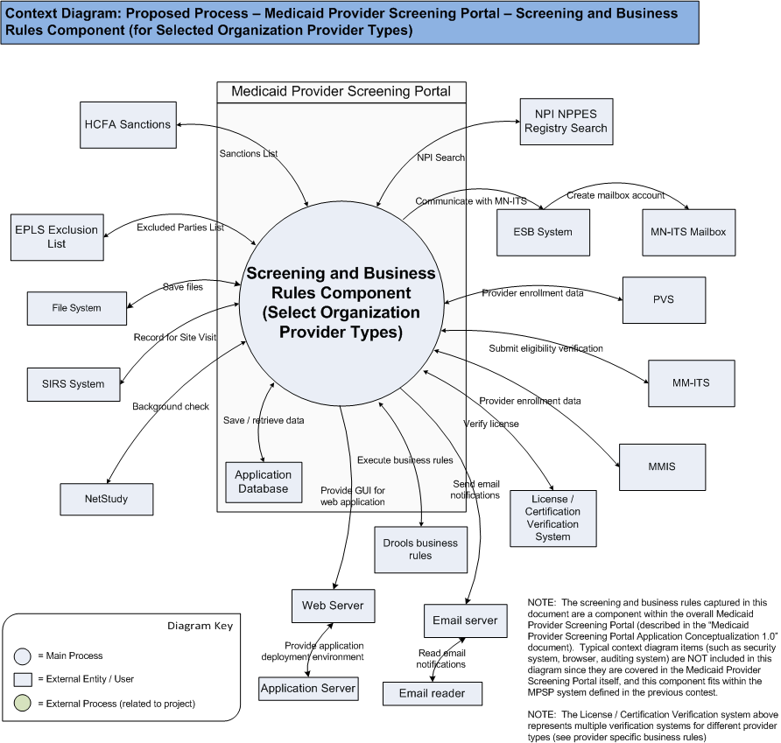

High Level Workflow
The workflow required to complete the primary objectives of the proposed application is described below. The workflow is business-centered, and includes “decision forks” for decisions the business user, or application, must make to achieve the objective. The workflow omits application faults or exceptions. Individual tasks in the workflow are described.

Workflow/Process Map Diagram

Please note that the main workflow has been changed to reflect the functionality described here which was not captured before.

When the provider submits the enrollment details to the system the data will go through automatic screening. After that there will be some verification that needs to be performed by a service admin or admin user which he will be able to see in the Pending Enrollments Tab when he logs in. The service admin or admin user can Reject the enrollment and the provider will be notified. The provider has to correct the enrollment and submit again which will come as another enrollment request.

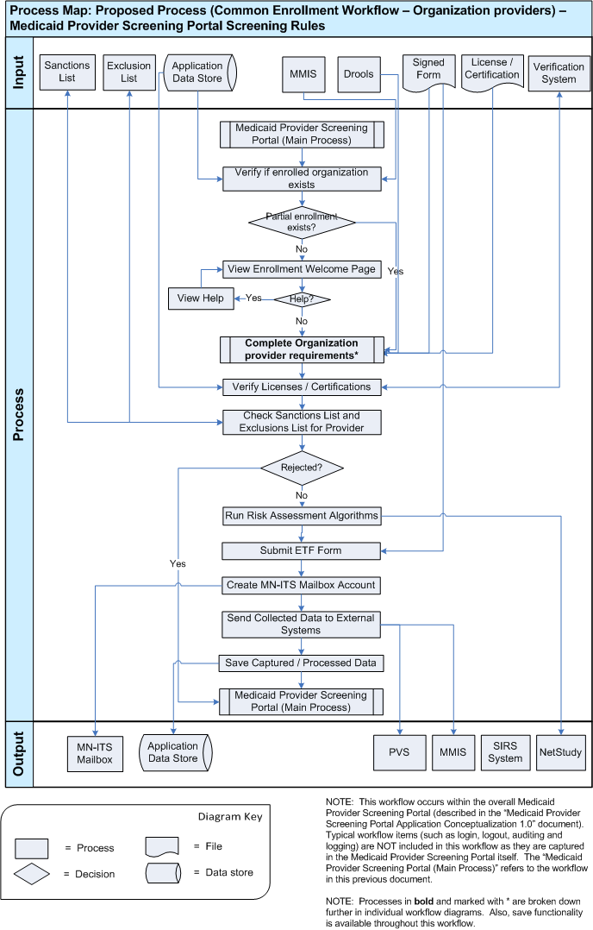

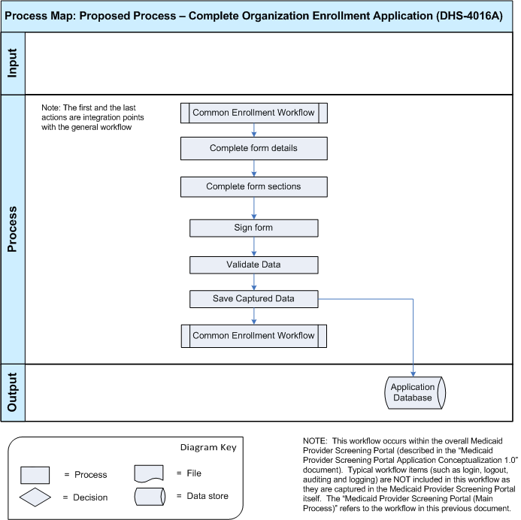

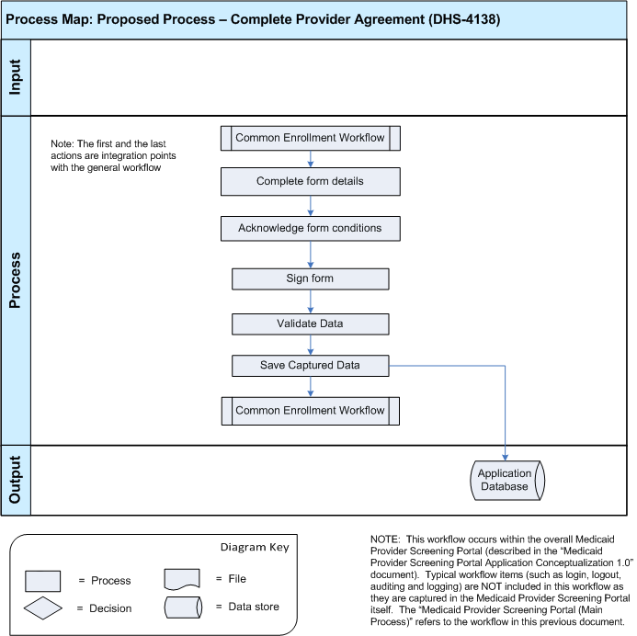

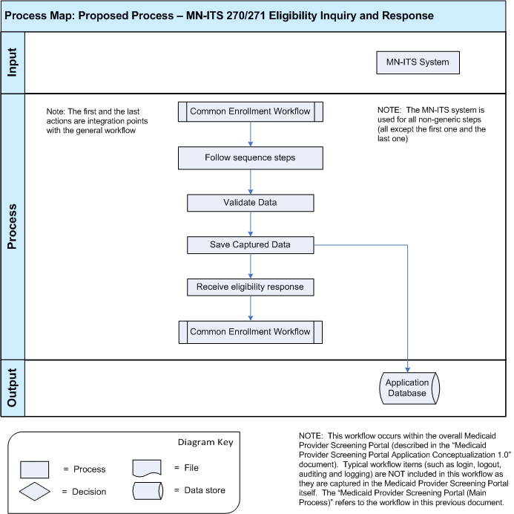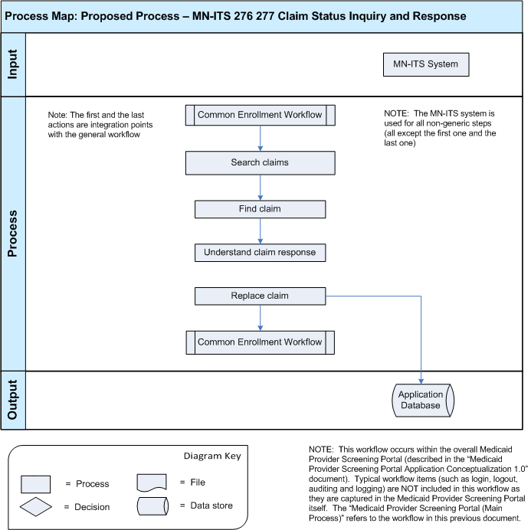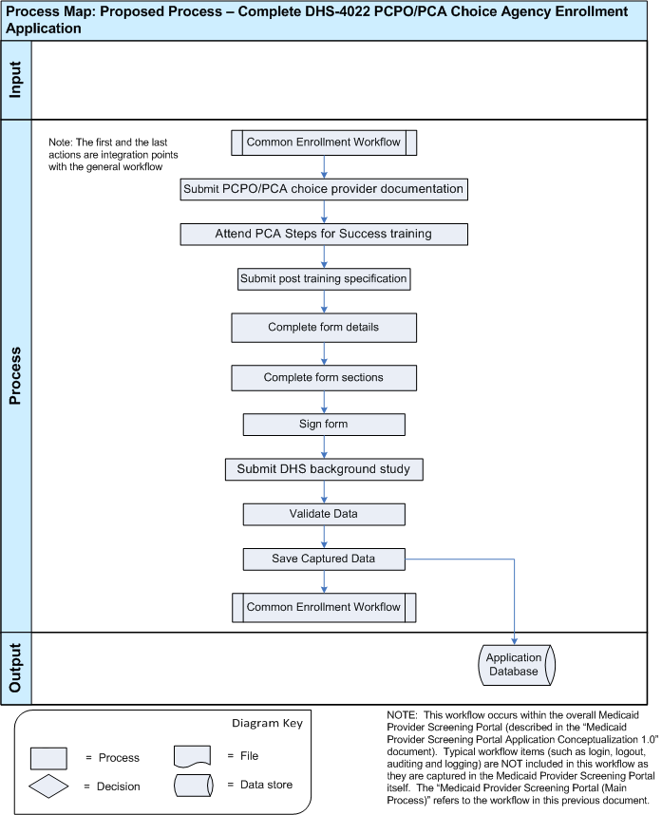

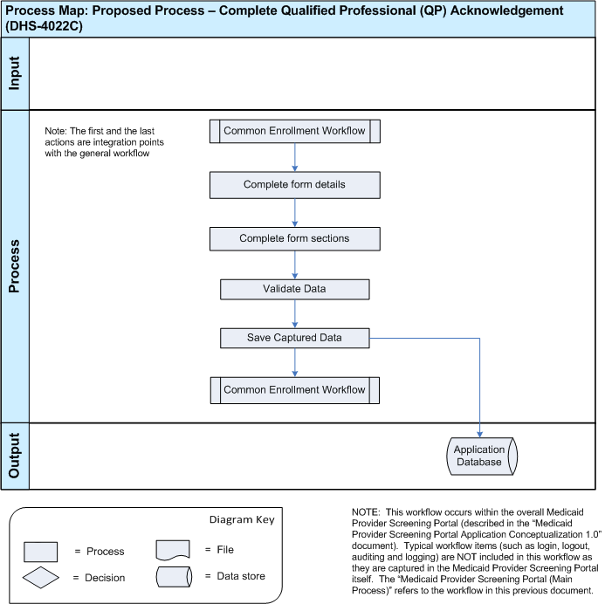

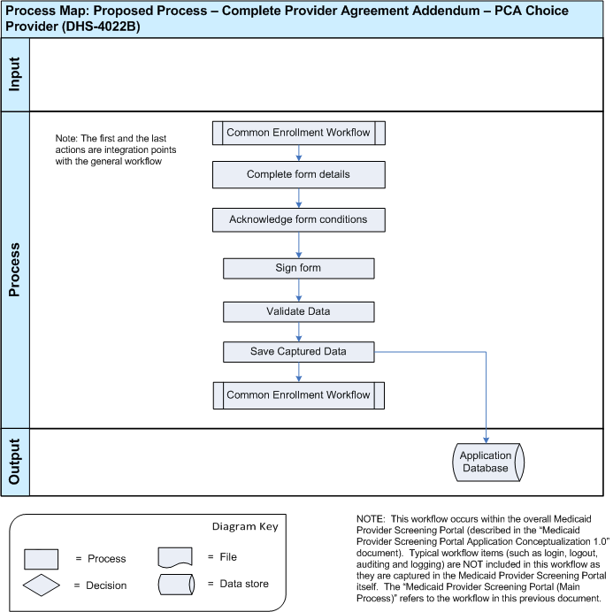

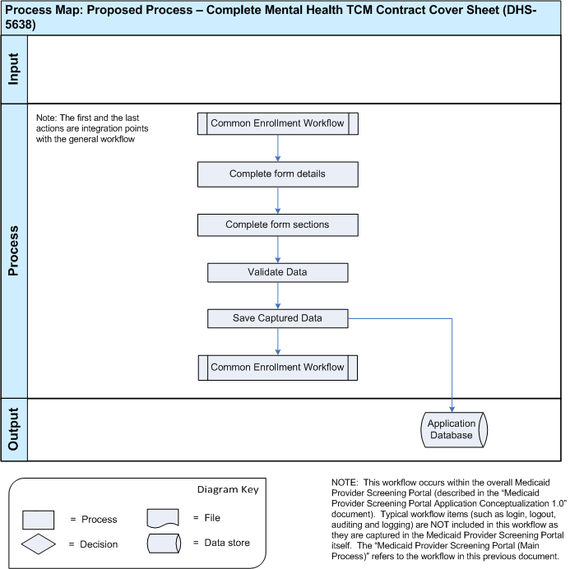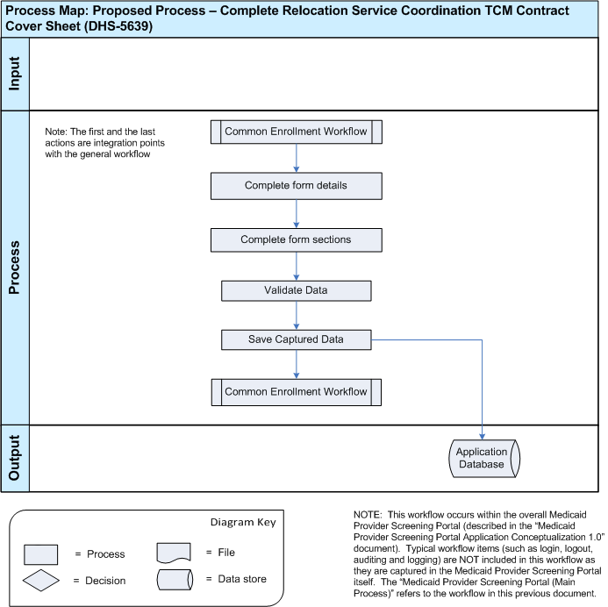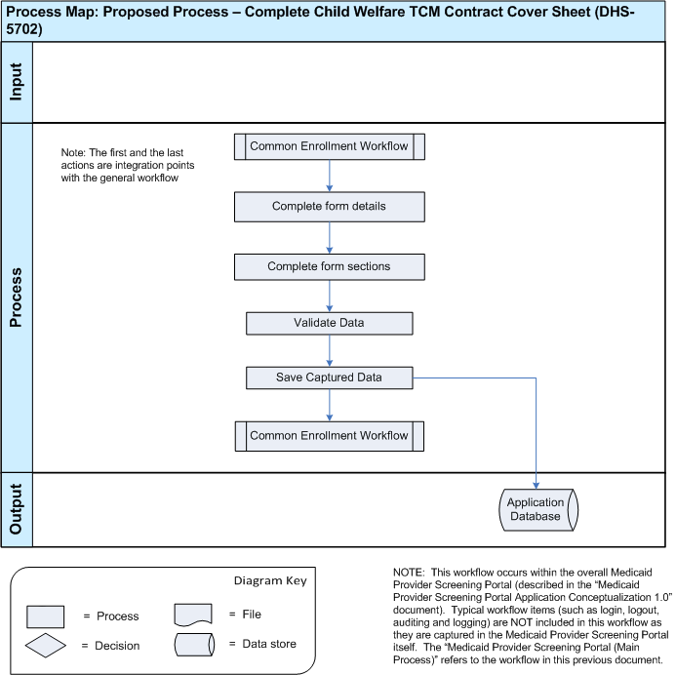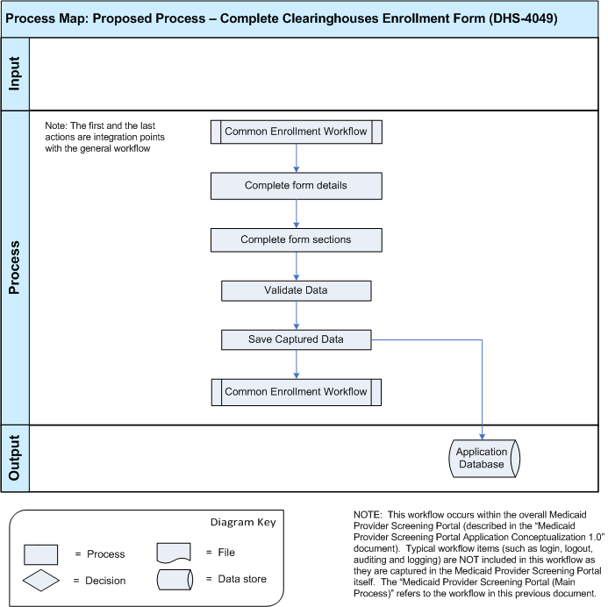

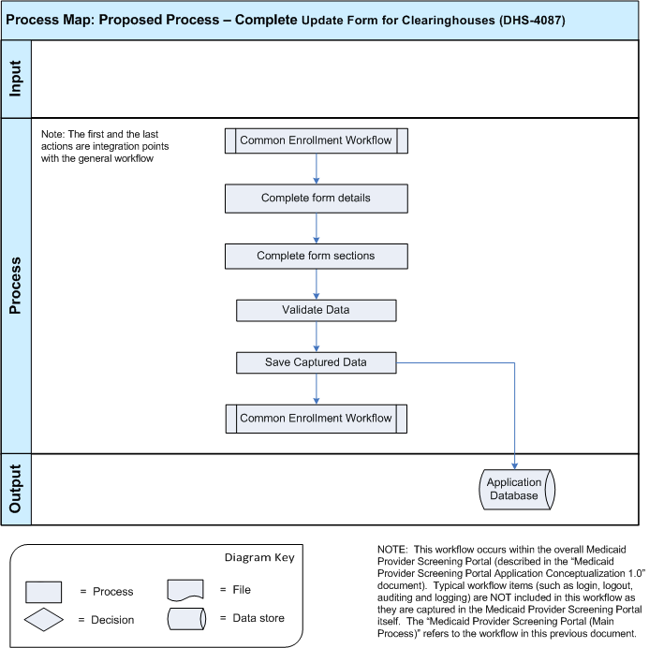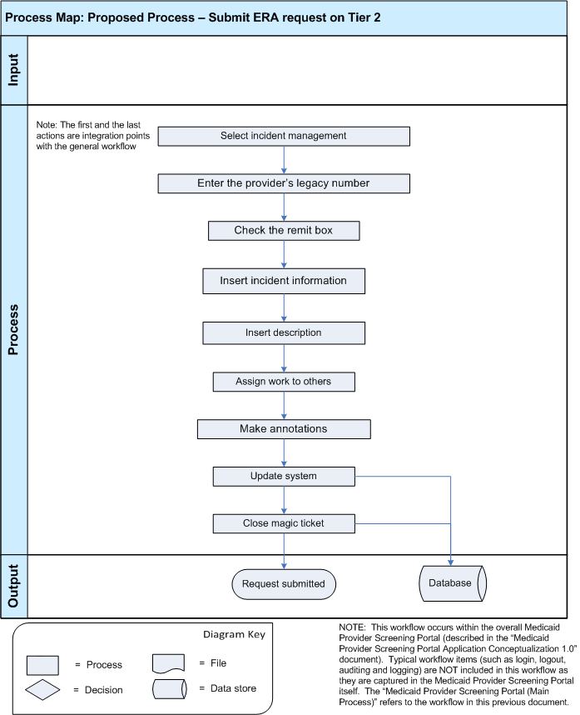

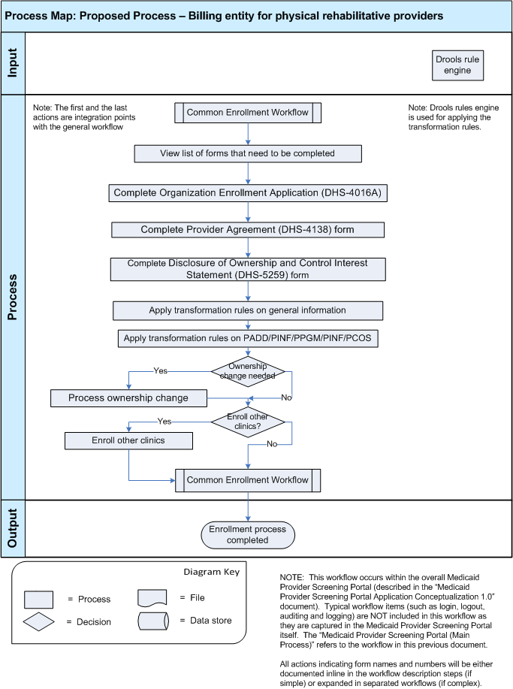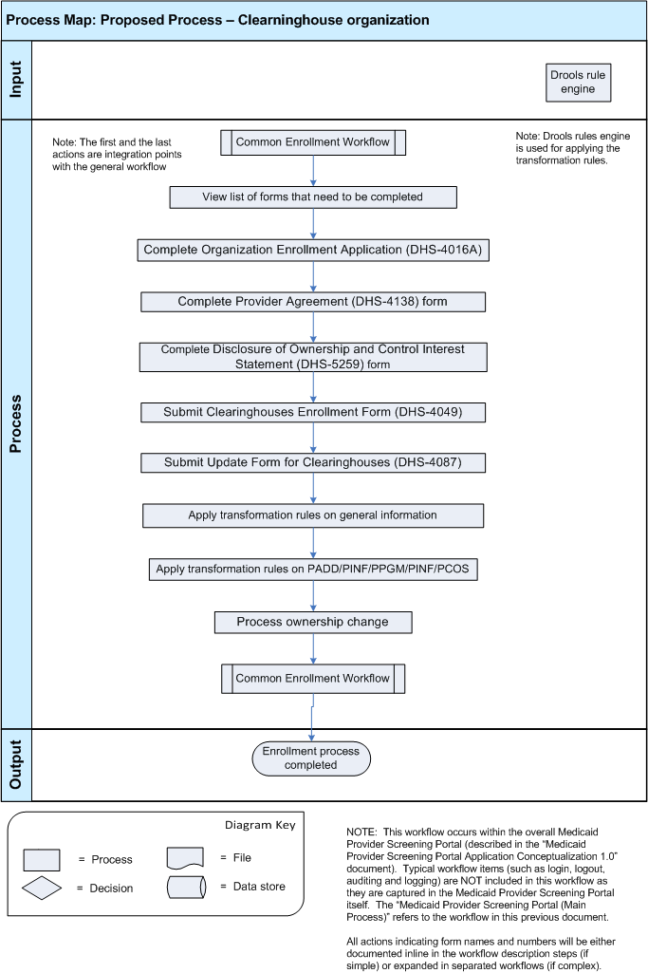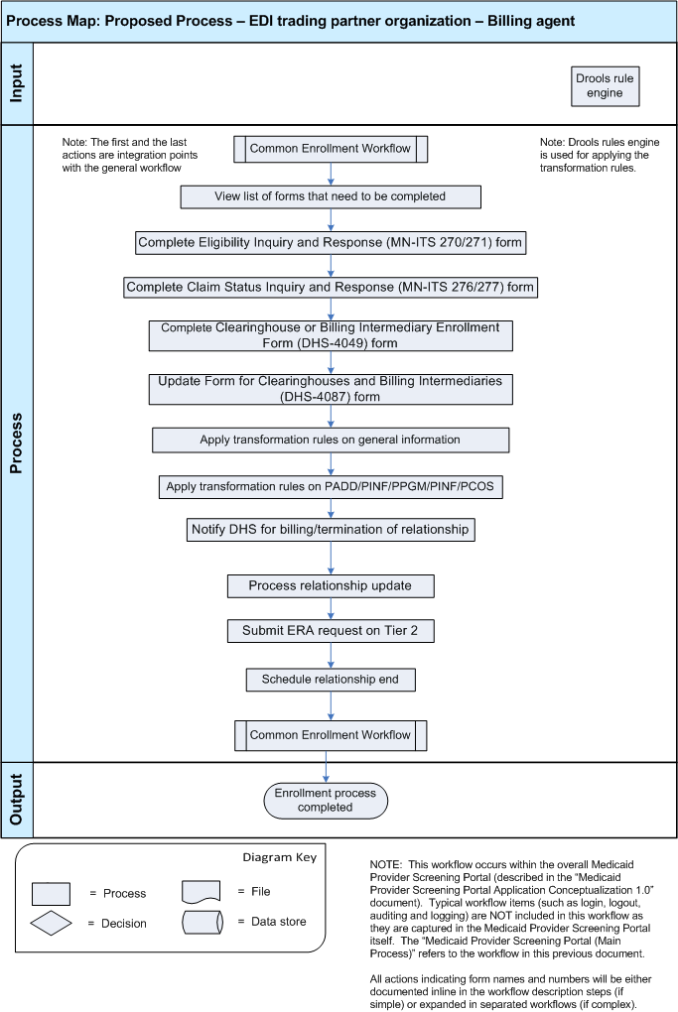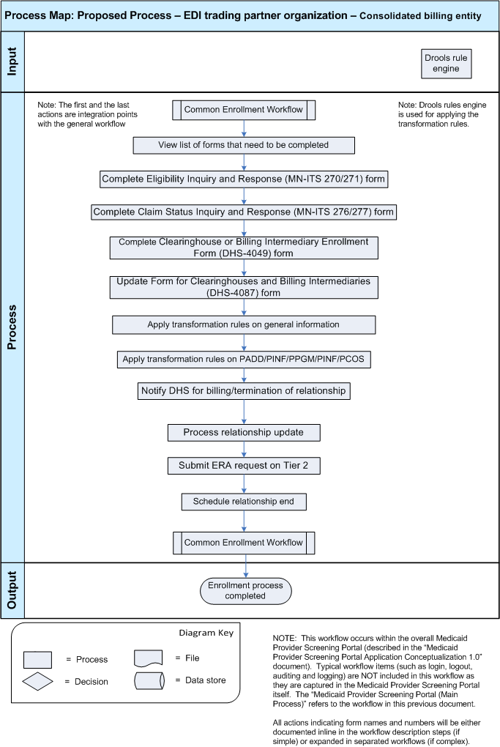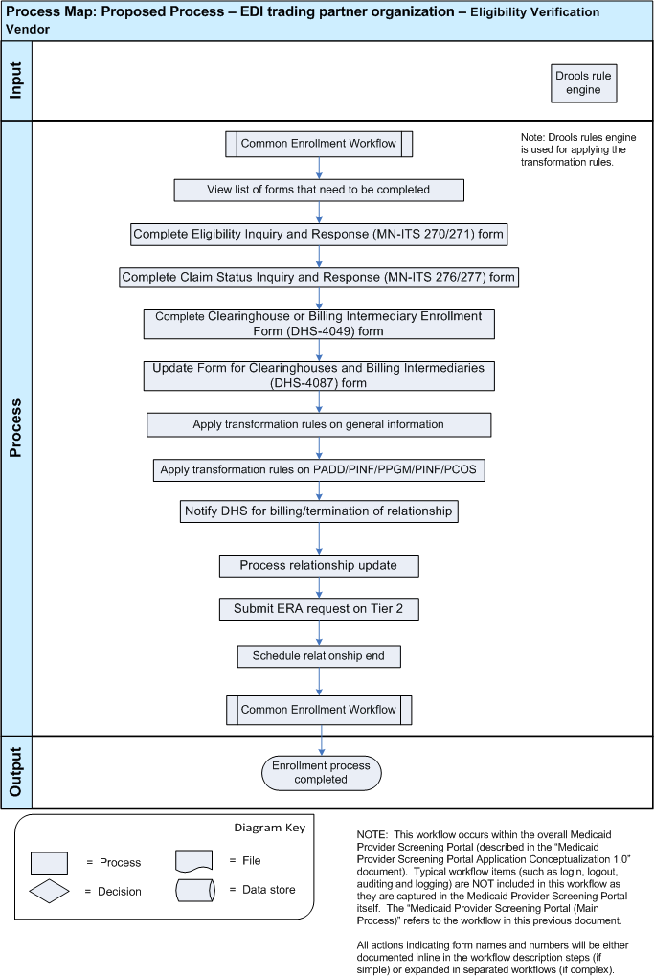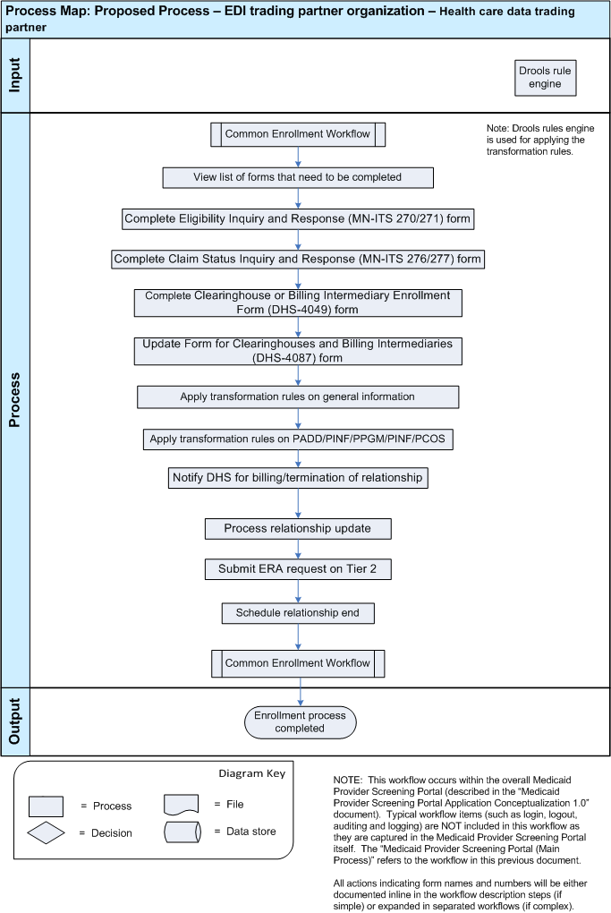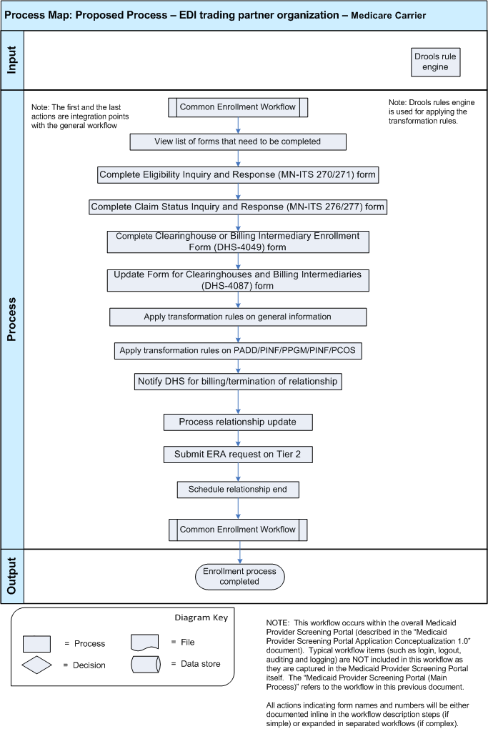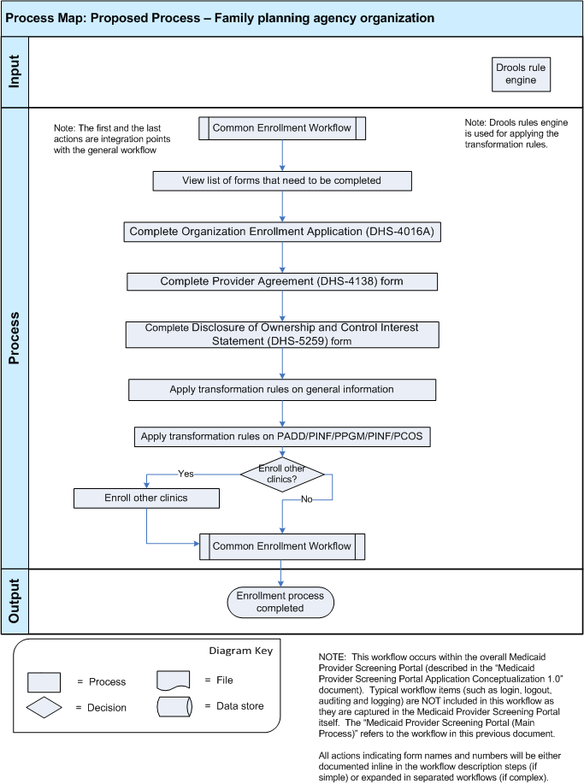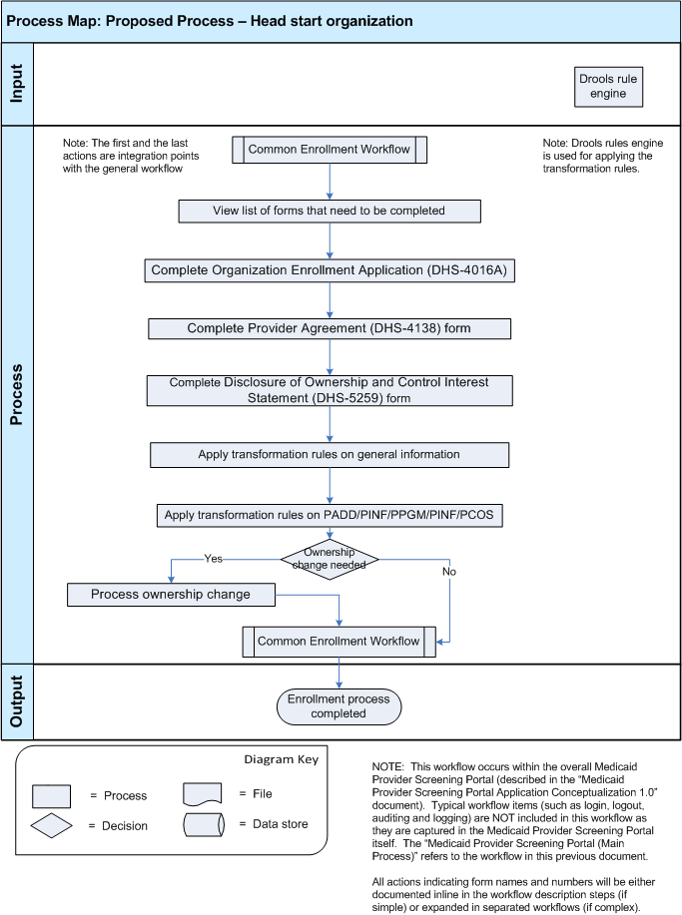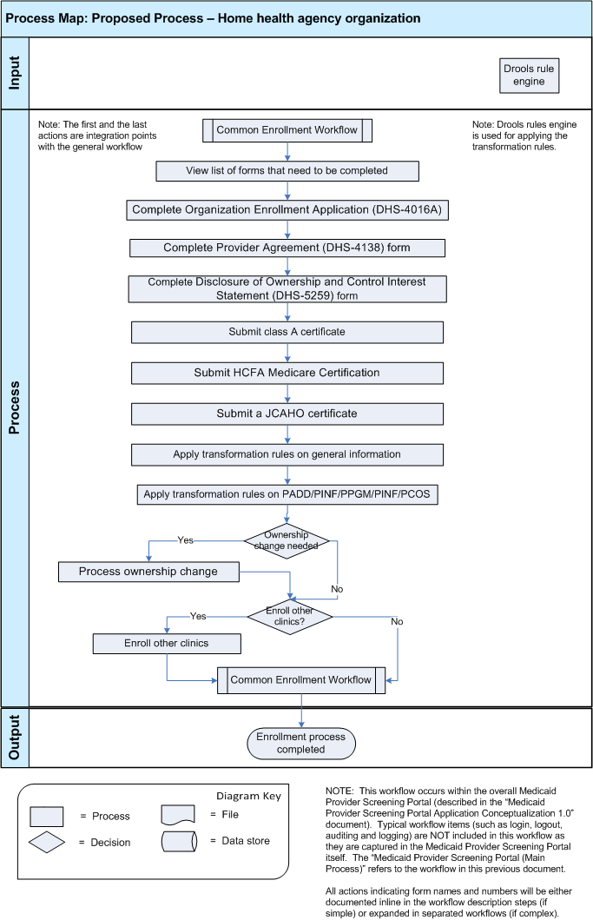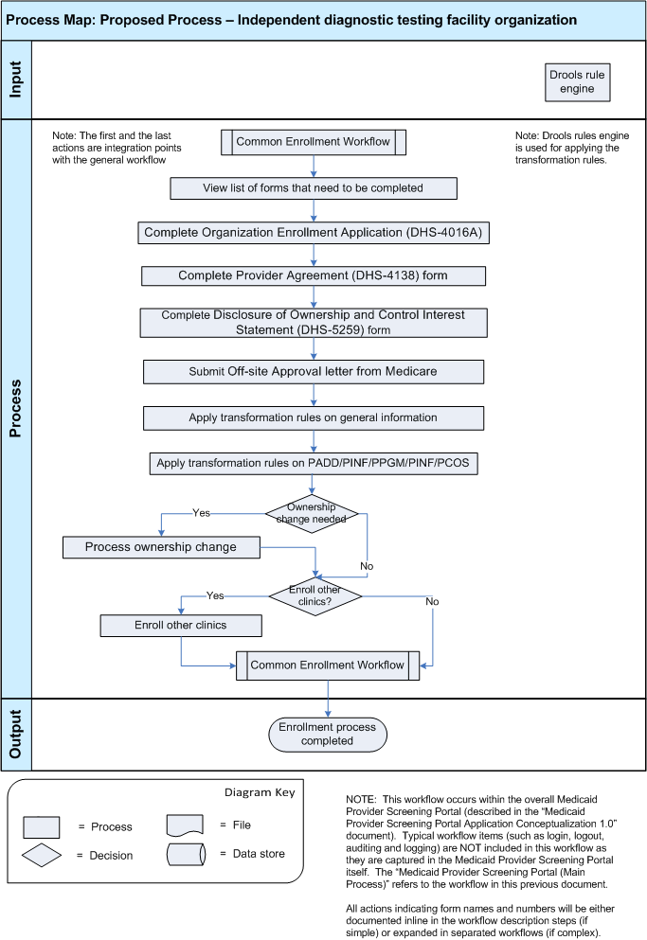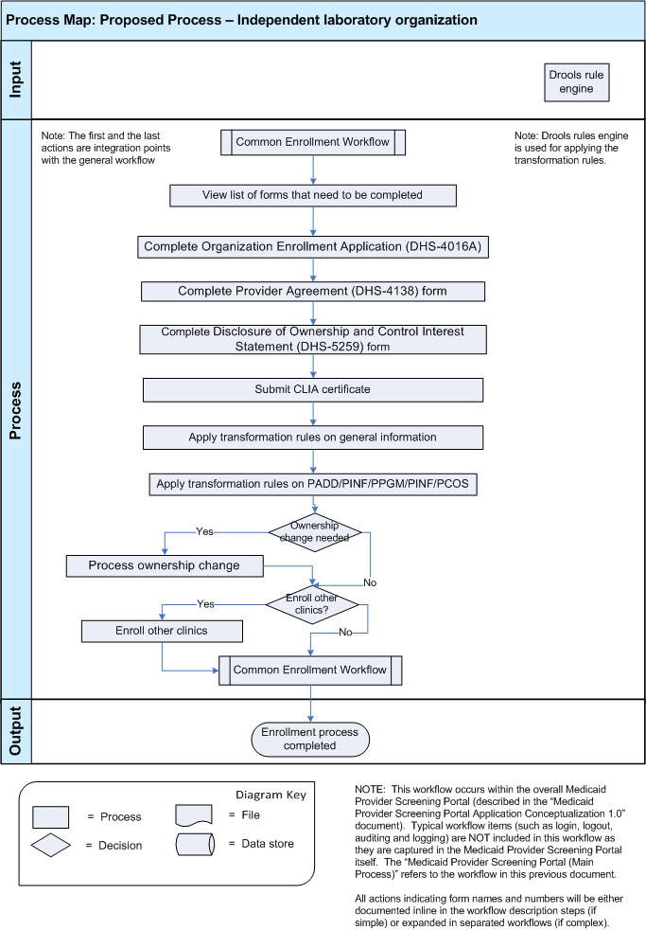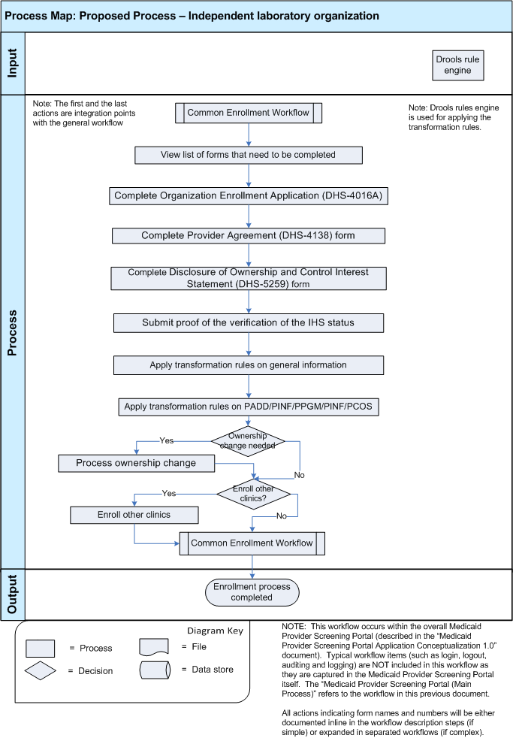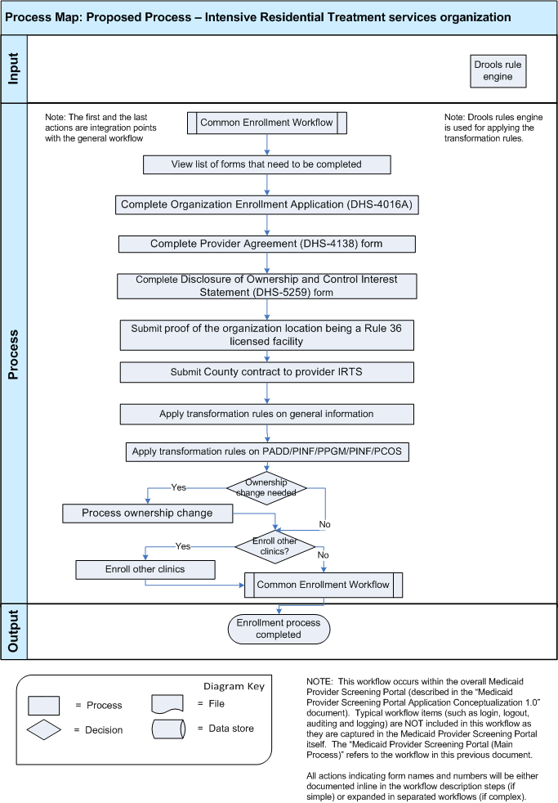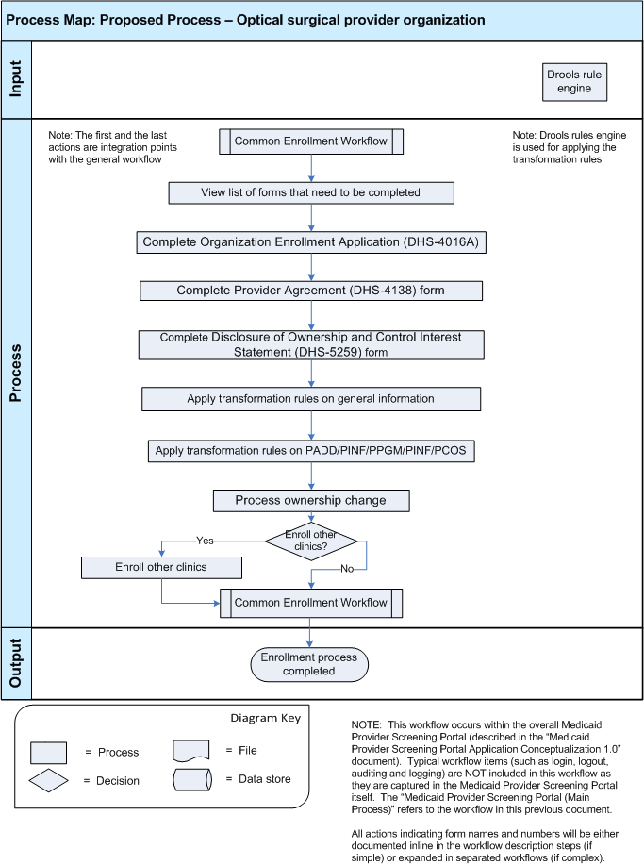

Workflow Description

Main Workflow
- The workflow below is a component of the overall Medicaid Provider Screening Portal application. Users will access the functionality in this workflow from the MPSP application.

- The application will check to see if the organization that the user is trying to enroll already exists in the application. If it does the user can continue updating the enrollment information or if not they can enroll the organization provider themselves

- The application will also check for a saved enrollment application
  - If a partially completed enrollment application is found, the user can select to load this data and continue the enrollment process from where they left off.

- The provider enrollment and screening process begins by displaying a welcome page with basic instructions on how to complete the form.

- If the user needs help to complete the enrollment process, they will have the option to view the help page.

- The user must then complete the Organization provider specific workflows depending on the organization type that they want to create (which is also part of the enrollment process).

This part of the screening and enrollment process will be dynamic, based on a set of business rules for each provider type.
- The provider specific workflows are individually described in detail below (for the specific providers covered in this contest).
- Users will perform the steps required for their provider type (such as submitting licenses, certifications and signed forms).

Please note that specific details based on provider types and/or on provider forms (when the forms are complex enough to warrant a specific workflow) are provided in the following workflows and are also accompanied by corresponding references.

Opportunity: there is an opportunity to synthesize screening rules through Drools (confirmed to be used for the screening rules) so that they can be easily configured and updated as needed by the application business requirements.
- Once the user has completed their provider specific workflow, the application will verify the licenses and certifications they submitted.
- Possible Problem: The system supports a large number of provider types, and each type has multiple licenses or certificates to submit. The ability to verify these licenses and certifications automatically could be very challenging, since each different license could have a different service it needs to connect to for validation. Some of the licensing boards may not even offer a system that is feasible (architecturally) for automatic verification.
- Possible Opportunity: The opportunity exists to allow scanned images of licenses to be uploaded to the server so they can be verified manually by support staff (similar to the process in the current system).
- Possible Opportunity: Another opportunity is to automate as many of the license verifications as possible, while allowing manual verification for the ones that can’t be. This will lighten the workload of support staff, while still allowing all types of licenses to be verified. Additional verifications can be added as soon as it’s possible, so eventually all verification could be automatic.

- Next, the application will check the sanctions and exclusions list to confirm the organization provider is not included on any of them.
- OIG Exclusion List
- EPLS Exclusion List
- Organizations that are found on these lists have had problems in the past, and their application will be rejected.
- Possible Problem: It’s possible that these systems could return false positive results. This could be caused by the provider having a similar name or address to someone else who really is on the list.
- Possible Opportunity: A possible way to solve this problem is to store rejected applications for a certain period of time.

- Depending on the results of these verifications, some of which are automatic and some of which are manually done by the Service Admins and Admins, the enrollment submission can be rejected and organization providers can be notified of the rejection, and have the option to request a review by a support staff member.

Opportunity: A process could be designed so automatically rejected applications are all reviewed (fewer false rejections but more time required).

- After the provider has completed all their required enrollment steps, the application will run the risk assessment rules to calculate the provider’s risk level.
- Based on the risk level calculated, data will be passed to the appropriate systems:
    - High-risk:
      - SIRS (Surveillance & Integrity Review Section)
      - NetStudy Background Check
    - Moderate risk:
      - SIRS (Surveillance & Integrity Review Section)
    - Limited Risk:
      - Neither of the systems above
    - Possible Opportunity: The system can be designed so this risk assessment process can support additional risk checks or calculations in the future (a modular design).

- The provider will also be able to submit an Electronic Funds Transfer (EFT) Authorization form. Please note that this submission as well as the actual electronic payment is an external process for this application.

- The application will then send a request to the MN-ITS system to create a mailbox account for the enrolling provider.

- Finally, the application will apply “Smart Routing” rules to send the collected data to the appropriate systems based on screening results.
    - MMIS
    - PVS

- The application will then save all collected and processed information to the application database (Previously Successfully Screened Provider Database).

- If the enrollment has been rejected, the main process (described in this workflow will be completed again by the organization representative (provider, Service Agent or Admin).

Complete Organization Enrollment Application (DHS-4016A)

- This process will collect enrollment information from the provider for a specific form. This process is one part of an organization enrollment process and will be integrated as such in that bigger workflow. It is presented here separately to limit duplication and to make the submission more usable.

Problem: The current process is not sufficiently automated and a lot of time and effort is wasted on verification and paper handling.
Opportunity: To automate the format validation processes as well as the transformation rules that are applied on the collected data.

- Next, the user will complete the “Organization Enrollment Application (DHS-4016A)” form. All fields for this form are required to be entered unless stated otherwise.

All form details including guidelines on how should the forms be completed, are available in the corresponding pdf document (which can be retrieved from the documentation links).

- The form structure consists of the following main parts:
  - Provider type (automatically completed)
  - Organization Identification and Location Information
  - Ownership structure – identifying the entities that have a share in the ownership structure. This information is quite important to eliminate any conflicts of interests which may arise and is one of the important aspects verified by the screening process.
  - Alternative email addresses
The organization representative (provider, Service Agent or Admin) can configure one or more addresses and choose to send a number of documents to any of these addresses. This comes very handy when the organizations are big and letters of particular interest can be directly sent to the appropriate department.
The following documents can be sent to the configured addresses directly:
    - Send my:
    - Remittance Advice
    - Reimbursement Check
    - Provider Correspondence
    - Authorization Request Notice and Service Agreements
    - Credentials (Enrollment Status)
    - 1099 IRS Form
  - Configuration of the desired remittance sequence
Every two weeks, the Department of Human Services (DHS) will provide you with a report called a Remittance Advice. The Remittance Advice report will inform the provider on the status of any claims they have submitted to the DHS system. The information will be listed alphabetically by enrollee name, unless a different order is requested by the provider explicitly. This is the section of the form where this order can be changed by the provider.
  - Facility licenses/certifications
  - CLIA Certifications
  - Selection of the supported Specialty for Medical Transportation
  - Member affiliations
  - Contact information
    - Contact name
    - Phone number
    - Fax number
    - Email address
  - A forma provider statement that certifies that the information provided on this form is accurate, complete and truthful.
  - The user completing this enrollment form has to agree with the fact that they will notify MHCP Provider Enrollment of any changes to this information.

Opportunity: To document all validation and format rules of the enrollment forms.

- The organization representative (provider, Service Agent or Admin) will finally sign the form and submit it. The signature will be provided as an image.

Opportunity: to have an image editor field that could take the organization representative (provider, Service Agent or Admin) signature directly and create the image file on the go (thus not requiring the user to create the image).

- The system will validate the data inserted by the user. Please note that describing the format of the form fields is out of scope for this competition.

Opportunity: To document all validation and format rules of the enrollment forms.

- Once the user has completed the form enrollment application workflow, they will be returned to the main workflow.

- The enrollment workflow will continue with either a new form that the organization representative (provider, Service Agent or Admin) has to complete or data transformation rules, depending on the organization provider that is being enrolled.

Complete Provider Agreement (DHS-4138)

- This process will collect enrollment information from the provider for a specific form. This process is one part of an organization enrollment process and will be integrated as such in that bigger workflow. It is presented here separately to limit duplication and to make the submission more usable.

Problem: The current process is not sufficiently automated and a lot of time and effort is wasted on verification and paper handling.
Opportunity: To automate the format validation processes as well as the transformation rules that are applied on the collected data.

- Next, the user will complete the “Provider Agreement (DHS-4138)” form. All fields for this form are required to be entered unless stated otherwise.

All form details including guidelines on how should the forms be completed, are available in the corresponding pdf document (which can be retrieved from the documentation links).

- The form structure consists of the following main parts:
As part of the Minnesota Health Care Programs (MHCP) and as a participating provider (Provider) in Minnesota Health Care Programs (MHCP) administered by the Minnesota Department of Human Services (DHS), the Provider has to agrees to a number of rules, of the type:

“2. Comply with all federal and state statutes and rules relating to the delivery of services to individuals and to the submission of claims for such services.”

There are 32 such rules, and some of them have subpoints (A, B etc).

The rules are not dynamic and not enforced directly or verified by the application.

This form’s purpose is just to inform the organization representative (provider, Service Agent or Admin) about the requirements that they have to comply with.

- The organization representative (provider, Service Agent or Admin) will finally sign the form, along with the name, title and date of submission and submit it. The signature will be provided as an image.

Opportunity: to have an image editor field that could take the organization representative (provider, Service Agent or Admin) signature directly and create the image file on the go (thus not requiring the user to create the image).

- The system will validate the data inserted by the user. Please note that describing the format of the form fields is out of scope for this competition.

Opportunity: To document all validation and format rules of the enrollment forms.

- Once the user has completed the form enrollment application workflow, they will be returned to the main workflow.

- The enrollment workflow will continue with either a new form that the organization representative (provider, Service Agent or Admin) has to complete or data transformation rules, depending on the organization provider that is being enrolled.

Complete MN-ITS 270/271 Eligibility Inquiry and Response

This MN-ITS 270/271 Eligibility Inquiry and Response form is designed to verify eligibility on the Single Eligibility Inquiry tab (one at a time) or the Multiple Eligibility Inquiry tab (up to 50 at a time).

A recipient’s eligibility through MHCP may terminate or change. Since there are no eligibility dates on the MHCP ID card, providers are strongly encouraged to verify recipient eligibility prior to rendering services.

- The user process will collect enrollment information from the provider for a specific form. This process is one part of an organization enrollment process and will be integrated as such in that bigger workflow. It is presented here separately to limit duplication and to make the submission more usable.

The form will be accessible from the MN-ITS system.

Problem: The current process is not sufficiently automated and a lot of time and effort is wasted on verification and paper handling.
Opportunity: To automate the format validation processes as well as the transformation rules that are applied on the collected data.

- Next, the user will follow the instructions sequence steps from the namesake pdf file. The steps describe how to use the MN-ITS system to complete the eligibility inquiry steps.

- The organization representative (provider, Service Agent or Admin) completed process will be validated by the system.

- The system will validate the data inserted by the user. Please note that describing the format of the form fields is out of scope for this competition.

Opportunity: To document all validation and format rules of the enrollment forms.

- The user will then or later receive an eligibility response. The way this response is to be interpreted is explained in the corresponding pdf document as well.

- Once the user has completed the form enrollment application workflow, they will be returned to the main workflow.

- The enrollment workflow will continue with either a new form that the organization representative (provider, Service Agent or Admin) has to complete or data transformation rules, depending on the organization provider that is being enrolled.

Complete MN-ITS 276/277 Claim Status Inquiry and Response

- This process will collect enrollment information from the provider for a specific form. This process is one part of an organization enrollment process and will be integrated as such in that bigger workflow. It is presented here separately to limit duplication and to make the submission more usable.

- The 276 transaction allows providers to retrieve and check the status of previously submitted claims within a three year period. If your claim was originally submitted through MN-ITS Interactive, you will have the options to copy, replace or void the claim.

Problem:
There are some limitations to the Request Claim Status function, which include:
  - Claims submitted through X-12 Batch may take up to 72 hours before they are available and only have the option to print or close
  - Claims over three years old cannot be viewed
  - Claims submitted through MN-ITS Interactive may be accessed the next business day using the Quick Search tab or immediately by completing the bolded fields on the Detail Search tab Next, the user will complete the “MN-ITS 276/277 Claim Status Inquiry and Response” form. All fields for this form are required to be entered unless stated otherwise.

Problem: The current process is not sufficiently automated and a lot of time and effort is wasted on verification and paper handling.
Opportunity: To automate the format validation processes as well as the transformation rules that are applied on the collected data.

- The organization representative (provider, Service Agent or Admin) will use the MN-ITS interactive system to find the searched claims.

The details of how the functionality of the MN-ITS system can be accessed are presented in the attached namesake pdf document.

- Once the searched claim has been found, the organization representative (provider, Service Agent or Admin) can view the claim details.
The details of how the functionality of the MN-ITS system can be accessed are presented in the attached namesake pdf document.

- The MN-ITS 276/277 Claim Status Inquiry and Response also contains details on how the claim response can be understood. The organization representative (provider, Service Agent or Admin) will use this information to understand the status of the claim according to the provided response.

- Depending on the read status, the user may want to replace the claim.
The details of how the functionality of the MN-ITS system can be accessed are presented in the attached namesake pdf document.

- Once the user has completed the form enrollment application workflow, they will be returned to the main workflow.

- The enrollment workflow will continue with either a new form that the organization representative (provider, Service Agent or Admin) has to complete or data transformation rules, depending on the organization provider that is being enrolled.

Complete DHS-4022 PCPO/PCA Choice Agency Enrollment Application

- This process will collect enrollment information from the provider for a specific form. This process is one part of an organization enrollment process and will be integrated as such in that bigger workflow. It is presented here separately to limit duplication and to make the submission more usable.

- Next, the user will complete the “DHS-4022 PCPO/PCA Choice Agency Enrollment Application” form. All fields for this form are required to be entered unless stated otherwise.

The form is used by organization representative (provider, Service Agent or Admin) that want to become a Personal Care Provider Organization (PCPO) or Personal Care
Assistant (PCA) Choice provider with Minnesota Health Care Programs (MHCP).

All form details including guidelines on how should the forms be completed, are available in the corresponding pdf document (which can be retrieved from the documentation links).

Problem: The current process is not sufficiently automated and a lot of time and effort is wasted on verification and paper handling.
Opportunity: To automate the format validation processes as well as the transformation rules that are applied on the collected data.

- The form structure consists of the following main parts:
Submit the following to apply as a PCPO/PCA Choice provider:
    - MHCP PCPO/PCA Choice Agency Enrollment Application (DHS-4022)
    - Disclosure of Ownership and Control Interest Addendum to Provider Agreement for Participating
    - Providers (DHS-5259)
    - Qualified Professional (QP) Acknowledgement (DHS-4022C) (Required for PCA Choice provider
    - agencies at the time they first employ a qualified professional)
    - Request for Licensing Agency ID Number
    - Instructions for DHS Background Studies for New Owners/Managers and Qualified Professionals
    - of PCPO/PCA Choice Providers
    - Direct Deposit Authorization for Electronic Funds Transfer (EFT)
    - Minnesota Department of Human Services Provider Agreement (DHS-4138)
    - Provider Agreement Addendum PCPO (DHS-4022A)
    - Provider Agreement Addendum PCA Choice Provider (DHS-4022B)
    - List of personnel and their affiliations to any other home care provider. Use form, PCA Agency
    - Personnel List and Affiliation(s) (DHS-6041)
    - Copy of certificate of registration with the Office of the Secretary of State of Minnesota.
Please note that all these forms have detailed documentation and the purpose of this contest is not to document again all that information.

- Attend PCA Steps for Success training.
The attendance will be external and the proof of attendance is either implied or can be done with a certificate of attendance (no details in this direction have been provided up to now).

- Submit the following after you attend training, to allow MHCP to complete your enrollment process:
    - PCA Agency Applicant Assurance Statement (DHS-6005)
    - Designation of PCA Billing Person (DHS-6000)
    - Copy of certificate of liability insurance
    - Copy of Workers’ Compensation insurance (not required for Medicare Certified or Class A licensed
    - agencies)
    - Copy of fidelity bond in the amount of $20,000
    - Copy of surety bond in the amount of $50,000 or 10% of the provider’s PCA payments received from
    - Medicaid in the previous year, whichever is less (see the template form, PCA Agency Surety Bond
    - (DHS-6033))Provider type (automatically completed)
    - Organization Identification and Location Information
    - Ownership structure – identifying the entities that have a share in the ownership structure. This information is quite important to eliminate any conflicts of interests which may arise and is one of the important aspects verified by the screening process.
    - Alternative email addresses
    - The organization representative (provider, Service Agent or Admin) can configure one or more addresses and choose to send a number of documents to any of these addresses. This comes very handy when the organizations are big and letters of particular interest can be directly sent to the appropriate department.
    - The following documents can be sent to the configured addresses directly:
    - Send my:
    - Remittance Advice
    - Reimbursement Check
    - Provider Correspondence
    - Authorization Request Notice and Service Agreements
    - Credentials (Enrollment Status)
    - 1099 IRS Form
    - Configuration of the desired remittance sequence
    - Every two weeks, the Department of Human Services (DHS) will provide you with a report called a Remittance Advice. The Remittance Advice report will inform the provider on the status of any claims they have submitted to the DHS system. The information will be listed alphabetically by enrollee name, unless a different order is requested by the provider explicitly. This is the section of the form where this order can be changed by the provider.
    - Facility licenses/certifications
    - CLIA Certifications
    - Selection of the supported Specialty for Medical Transportation
    - Member affiliations
    - Contact information
    - Contact name
    - Phone number
    - Fax number
    - Email address
    - A format provider statement that certifies that the information provided on this form is accurate, complete and truthful.
    - The user completing this enrollment form has to agree with the fact that they will notify MHCP Provider Enrollment of any changes to this information.

Please note that all these forms have detailed documentation and the purpose of this contest is not to document again all that information.

Opportunity: To document all validation and format rules of the enrollment forms.

- Next the user will complete the rest of the form.
The form structure consists of the following main parts:
  - Organization Identification and Location Information
  - Configuration of the desired remittance sequence
Every two weeks, the Department of Human Services (DHS) will provide you with a report called a Remittance Advice. The Remittance Advice report will inform the provider on the status of any claims they have submitted to the DHS system. The information will be listed alphabetically by enrollee name, unless a different order is requested by the provider explicitly. This is the section of the form where this order can be changed by the provider.
  - Alternative email addresses
The organization representative (provider, Service Agent or Admin) can configure one or more addresses and choose to send a number of documents to any of these addresses. This comes very handy when the organizations are big and letters of particular interest can be directly sent to the appropriate department.
The following documents can be sent to the configured addresses directly:
    - Send my:
    - Remittance Advice
    - Reimbursement Check
    - Provider Correspondence
    - Authorization Request Notice and Service Agreements
    - Credentials (Enrollment Status)
    - 1099 IRS Form
  - Contact information
    - Contact name
    - Phone number
    - Fax number
    - Email address
  - A forma provider statement that certifies that the information provided on this form is accurate, complete and truthful.
  - The user completing this enrollment form has to agree with the fact that they will notify MHCP Provider Enrollment of any changes to this information.

- Submit DHS background study. New background studies are required for all owners, managers and qualified professionals of new PCPO/PCA Choice applicants, even if a background study was done before for another program.
The functionality is accessible through the NETStudy application (which is out of scope) and describe in this form pdf documentation in detail.

- The organization representative (provider, Service Agent or Admin) will finally sign the form and submit it. The signature will be provided as an image.

Opportunity: to have an image editor field that could take the organization representative (provider, Service Agent or Admin) signature directly and create the image file on the go (thus not requiring the user to create the image).

- The system will validate the data inserted by the user. Please note that describing the format of the form fields is out of scope for this competition.

Opportunity: To document all validation and format rules of the enrollment forms.

- Once the user has completed the form enrollment application workflow, they will be returned to the main workflow.

- The enrollment workflow will continue with either a new form that the organization representative (provider, Service Agent or Admin) has to complete or data transformation rules, depending on the organization provider that is being enrolled.

Complete Qualified Professional (QP) Acknowledgement (DHS-4022C)

- This process will collect enrollment information from the provider for a specific form. This process is one part of an organization enrollment process and will be integrated as such in that bigger workflow. It is presented here separately to limit duplication and to make the submission more usable.

Problem: The current process is not sufficiently automated and a lot of time and effort is wasted on verification and paper handling.
Opportunity: To automate the format validation processes as well as the transformation rules that are applied on the collected data.

- Next, the user will complete the “Qualified Professional (QP) Acknowledgement (DHS-4022C)” form. All fields for this form are required to be entered unless stated otherwise.

All form details including guidelines on how should the forms be completed, are available in the corresponding pdf document (which can be retrieved from the documentation links).

- The form structure consists of rules that need to be acknowledged by the organization representative (provider, Service Agent or Admin).

There are 7 such rules, and some of them have subpoints (A, B etc).

The rules are not dynamic and not enforced directly or verified by the application.

This form’s purpose is just to inform the organization representative (provider, Service Agent or Admin) about the requirements that they have to comply with.

- The organization representative (provider, Service Agent or Admin) will finally sign the form, along with the name, title and date of submission and submit it. The signature will be provided as an image.

Opportunity: to have an image editor field that could take the organization representative (provider, Service Agent or Admin) signature directly and create the image file on the go (thus not requiring the user to create the image).

- The system will validate the data inserted by the user. Please note that describing the format of the form fields is out of scope for this competition.

Opportunity: To document all validation and format rules of the enrollment forms.

- Once the user has completed the form enrollment application workflow, they will be returned to the main workflow.

- The enrollment workflow will continue with either a new form that the organization representative (provider, Service Agent or Admin) has to complete or data transformation rules, depending on the organization provider that is being enrolled.

Complete Provider Agreement Addendum – PCA Choice Provider (DHS-4022B)

- This process will collect enrollment information from the provider for a specific form. This process is one part of an organization enrollment process and will be integrated as such in that bigger workflow. It is presented here separately to limit duplication and to make the submission more usable.

Problem: The current process is not sufficiently automated and a lot of time and effort is wasted on verification and paper handling.
Opportunity: To automate the format validation processes as well as the transformation rules that are applied on the collected data.

- Next, the user will complete the “Provider Agreement Addendum – PCA Choice Provider (DHS-4022B)” form. All fields for this form are required to be entered unless stated otherwise.

All form details including guidelines on how should the forms be completed, are available in the corresponding pdf document (which can be retrieved from the documentation links).

- The form structure consists of rules that need to be acknowledged by the organization representative (provider, Service Agent or Admin).

There are 8 such rules, and some of them have subpoints (A, B etc).

The rules are not dynamic and not enforced directly or verified by the application.

This form’s purpose is just to inform the organization representative (provider, Service Agent or Admin) about the requirements that they have to comply with.

- The organization representative (provider, Service Agent or Admin) will finally sign the form, along with the name, title and date of submission and submit it. The signature will be provided as an image.

Opportunity: to have an image editor field that could take the organization representative (provider, Service Agent or Admin) signature directly and create the image file on the go (thus not requiring the user to create the image).

- The system will validate the data inserted by the user. Please note that describing the format of the form fields is out of scope for this competition.

Opportunity: To document all validation and format rules of the enrollment forms.

- Once the user has completed the form enrollment application workflow, they will be returned to the main workflow.

- The enrollment workflow will continue with either a new form that the organization representative (provider, Service Agent or Admin) has to complete or data transformation rules, depending on the organization provider that is being enrolled.

Complete Mental Health TCM Contract Cover Sheet (DHS-5638)

- This process will collect enrollment information from the provider for a specific form. This process is one part of an organization enrollment process and will be integrated as such in that bigger workflow. It is presented here separately to limit duplication and to make the submission more usable.

Problem: The current process is not sufficiently automated and a lot of time and effort is wasted on verification and paper handling.
Opportunity: To automate the format validation processes as well as the transformation rules that are applied on the collected data.

- Next, the user will complete the “Mental Health TCM Contract Cover Sheet (DHS-5638)” form. All fields for this form are required to be entered unless stated otherwise.

All form details including guidelines on how should the forms be completed, are available in the corresponding pdf document (which can be retrieved from the documentation links).

- The form structure consists of the following main parts:
  - Host country information
    - Country name
    - Contract administrator
    - Phone number
    - Fax number
    - Address
    - City
    - State
    - Zip code
  - Vendor information
    - Country name
    - Contract administrator
    - Phone number
    - Fax number
    - Address
    - City
    - State
    - Zip code
  - Terms of contract
    - Start date
    - End date
  - Contract rates

- The system will validate the data inserted by the user. Please note that describing the format of the form fields is out of scope for this competition.

Opportunity: To document all validation and format rules of the enrollment forms.

- Once the user has completed the form enrollment application workflow, they will be returned to the main workflow.

- The enrollment workflow will continue with either a new form that the organization representative (provider, Service Agent or Admin) has to complete or data transformation rules, depending on the organization provider that is being enrolled.

Complete Relocation Service Coordination TCM Contract Cover Sheet (DHS-5639)

- This process will collect enrollment information from the provider for a specific form. This process is one part of an organization enrollment process and will be integrated as such in that bigger workflow. It is presented here separately to limit duplication and to make the submission more usable.

Problem: The current process is not sufficiently automated and a lot of time and effort is wasted on verification and paper handling.
Opportunity: To automate the format validation processes as well as the transformation rules that are applied on the collected data.

- Next, the user will complete the “Relocation Service Coordination TCM Contract Cover Sheet (DHS-5639)” form. All fields for this form are required to be entered unless stated otherwise.

All form details including guidelines on how should the forms be completed, are available in the corresponding pdf document (which can be retrieved from the documentation links).

- The form structure consists of the following main parts:
  - Host country information
    - Country name
    - Contract administrator
    - Phone number
    - Fax number
    - Address
    - City
    - State
    - Zip code
  - Vendor information
    - Country name
    - Contract administrator
    - Phone number
    - Fax number
    - Address
    - City
    - State
    - Zip code
  - Terms of contract
    - Start date
    - End date
  - Contract rates

- The system will validate the data inserted by the user. Please note that describing the format of the form fields is out of scope for this competition.

Opportunity: To document all validation and format rules of the enrollment forms.

- Once the user has completed the form enrollment application workflow, they will be returned to the main workflow.

- The enrollment workflow will continue with either a new form that the organization representative (provider, Service Agent or Admin) has to complete or data transformation rules, depending on the organization provider that is being enrolled.

Complete Child Welfare TCM Contract Cover Sheet (DHS-5702)

- This process will collect enrollment information from the provider for a specific form. This process is one part of an organization enrollment process and will be integrated as such in that bigger workflow. It is presented here separately to limit duplication and to make the submission more usable.

Problem: The current process is not sufficiently automated and a lot of time and effort is wasted on verification and paper handling.
Opportunity: To automate the format validation processes as well as the transformation rules that are applied on the collected data.

- Next, the user will complete the “Child Welfare TCM Contract Cover Sheet (DHS-5702)” form. All fields for this form are required to be entered unless stated otherwise.

All form details including guidelines on how should the forms be completed, are available in the corresponding pdf document (which can be retrieved from the documentation links).

- The form structure consists of the following main parts:
  - Host country information
    - Country name
    - Contract administrator
    - Phone number
    - Fax number
    - Address
    - City
    - State
    - Zip code
  - Vendor information
    - Country name
    - Contract administrator
    - Phone number
    - Fax number
    - Address
    - City
    - State
    - Zip code
  - Terms of contract
    - Start date
    - End date
  - Contract rates

- The system will validate the data inserted by the user. Please note that describing the format of the form fields is out of scope for this competition.

Opportunity: To document all validation and format rules of the enrollment forms.

- Once the user has completed the form enrollment application workflow, they will be returned to the main workflow.

- The enrollment workflow will continue with either a new form that the organization representative (provider, Service Agent or Admin) has to complete or data transformation rules, depending on the organization provider that is being enrolled.

Complete Clearinghouses Enrollment Form (DHS-4049)

- This process will collect enrollment information from the provider for a specific form. This process is one part of an organization enrollment process and will be integrated as such in that bigger workflow. It is presented here separately to limit duplication and to make the submission more usable.

Problem: The current process is not sufficiently automated and a lot of time and effort is wasted on verification and paper handling.
Opportunity: To automate the format validation processes as well as the transformation rules that are applied on the collected data.

- Next, the user will complete the “Clearinghouses Enrollment Form (DHS-4049)” form. All fields for this form are required to be entered unless stated otherwise.

All form details including guidelines on how should the forms be completed, are available in the corresponding pdf document (which can be retrieved from the documentation links).

- The form structure consists of the following main parts:
  - Organization type selection
  - Organization details
    - Organization name
    - Contact
    - Phone number
    - Fax number
    - Address
    - City
    - State
    - Zip code
    - Federal employee identification (FEIN)
  - The user will need to enter the following information
    - Provider name
    - Provider Title
    - Date
    - Signature
The way the user will sign the statement is still an open issue. It could be some method of e-signature, or it could simply be uploading a copy of the signed form (see section 1.5 for details).

- The system will validate the data inserted by the user. Please note that describing the format of the form fields is out of scope for this competition.

Opportunity: To document all validation and format rules of the enrollment forms.

- Once the user has completed the form enrollment application workflow, they will be returned to the main workflow.

- The enrollment workflow will continue with either a new form that the organization representative (provider, Service Agent or Admin) has to complete or data transformation rules, depending on the organization provider that is being enrolled.

Complete Update Form for Clearinghouses (DHS-4087)

- This process will collect enrollment information from the provider for a specific form. This process is one part of an organization enrollment process and will be integrated as such in that bigger workflow. It is presented here separately to limit duplication and to make the submission more usable.

Problem: The current process is not sufficiently automated and a lot of time and effort is wasted on verification and paper handling.
Opportunity: To automate the format validation processes as well as the transformation rules that are applied on the collected data.

- Next, the user will complete the “Update Form for Clearinghouses (DHS-4087)” form. All fields for this form are required to be entered unless stated otherwise.

All form details including guidelines on how should the forms be completed, are available in the corresponding pdf document (which can be retrieved from the documentation links).

- The form structure consists of the following main parts:
  - Organization details
    - Organization name
    - Contact
    - Phone number
    - Fax number
    - Address
    - City
    - State
    - Zip code
    - Federal employee identification (FEIN)
  - The user will need to enter the following information
    - Provider name
    - Provider Title
    - Date
    - Signature
  - MHCP pay to provider information
    - Provider name
    - Provider contact name
    - NPI/UMPI
    - Phone number
    - Link to clearinghouse billing organization effective start date
    - Link to clearinghouse billing organization effective end date
    - Signature
    - Date
    - Type of request:
      - claim
      - ERA
      - Both
  - MHCP pay to provider information
    - Provider name
    - Provider contact name
    - NPI/UMPI
    - Phone number
    - Link to clearinghouse billing organization effective start date
    - Link to clearinghouse billing organization effective end date
    - Signature
    - Date
    - Type of request:
      - claim
      - ERA
      - Both

  - MHCP pay to provider information
    - Provider name
    - Provider contact name
    - NPI/UMPI
    - Phone number
    - Link to clearinghouse billing organization effective start date
    - Link to clearinghouse billing organization effective end date
    - Signature
    - Date
    - Type of request:
      - claim
      - ERA
      - Both

The way the user will sign the statement is still an open issue. It could be some method of e-signature, or it could simply be uploading a copy of the signed form (see section 1.5 for details).

- The system will validate the data inserted by the user. Please note that describing the format of the form fields is out of scope for this competition.

Opportunity: To document all validation and format rules of the enrollment forms.

- Once the user has completed the form enrollment application workflow, they will be returned to the main workflow.

- The enrollment workflow will continue with either a new form that the organization representative (provider, Service Agent or Admin) has to complete or data transformation rules, depending on the organization provider that is being enrolled.

Submit ERA request on Tier 2
This workflow is specific to all providers that have to submit the form number mentioned in the title as part of the enrollment process.

The following request is sent on the Magic system. Please note that this interaction is out of scope.

Problem: The current process is not sufficiently automated and a lot of time and effort is wasted on verification and paper handling.
Opportunity: To automate the format validation processes as well as the transformation rules that are applied on the collected data.

- Select incident management, and then select provider incident
- Enter the provider’s legacy number
- Check the remit box; if it is a P indicator, go to step 4. If the indicator is R, no action is needed (provider is already set up to receive X12 835)
- Insert incident information: Subject ID drop down the arrow and select RA and click on x12 835.

- Description: enter the provider’s request e.g. “Received a signed ERA request. Provider wants x12 835. Are they in production? If not please add, thanks."
In the space below, right click then select new work order, work order page will appear. You will also see that the information from the provider’s incident is on the work order. Next go to client ID drop down the arrow to find the contact person, name should be the same as on the form. If the contact person is not found, create one by clicking on the people icon on the work order, when page opens enter the contact information and then hit enter to save the contact information you will then see the name appear.
- Go to “assign to” on work order and select group (Tier II) then save and close the work order.

- Make an annotation on the form indicating you’ve sent a ticket to Tier 2. Do not complete the request until you receive a resolution from tier II.
When the organization representative (provider, Service Agent or Admin) receives the resolution from Tier 2, the system will go to provider’s MMIS PINF screen and change the Remit Media indicator from P to R and then save the record. A
Another annotation will be set on the P8 document indicating the remit media indicator has been updated to R as requested.
The work item in P8 can then be closed as well as the Magic ticket.

Billing entity for physical rehabilitative providers – Complete enrollment process

- When starting the enrollment process, the organization representative (provider, Service Agent or Admin) will see a list of the required forms that need to be completed for the enrollment process.
For now the forms will not be completed in any particular order, but in the future (like in the wireframe competition) these decision will be made.
The following forms will need to be completed:

Problem: The current process is not sufficiently automated and a lot of time and effort is wasted on verification and paper handling.
Opportunity: To automate the format validation processes as well as the transformation rules that are applied on the collected data.

- The organization representative (provider, Service Agent or Admin) will need to complete the Organization Enrollment Application (DHS-4016A) form.
Please note that because these forms are sometimes quite complex, they are expanded in a separate workflow diagram.

- The organization representative (provider, Service Agent or Admin) will need to complete the Provider Agreement (DHS-4138) form.
Please note that because these forms are sometimes quite complex, they are expanded in a separate workflow diagram.

- The organization representative (provider, Service Agent or Admin) will need to complete the Disclosure of Ownership and Control Interest Statement (DHS-5259) form.
Please note that because these forms are sometimes quite complex, they are expanded in a separate workflow diagram.

- The following general provider information will be collected by the system:
  - NPI

Please note that the information presented above will be transferred directly to the MMIS system using transformation rules. The definition of these transformation rules is not in the scope of this conceptualization.

- For the enrollment, the PADD information will be collected.
The exact information is the following:
- Provider Type = 48
- Practice Type = 06
- FEIN
- Tax ID name on the Institutional Owner field
- MN Tax ID if provided
- Ownership Code

Please note that the information presented above will be transferred directly to the MMIS system using transformation rules. The definition of these transformation rules is not in the scope of this conceptualization.

- For the enrollment, the PINF information will be collected.
The exact information is the following:
- Major Programs: BB FF IM JJ KK LL MA NM QM RM XX EH DM

Please note that the information presented above will be transferred directly to the MMIS system using transformation rules. The definition of these transformation rules is not in the scope of this conceptualization.

- The verification of the change of ownership will be realized by the system before processing the termination of a record, check the lien, credit, and recoupment balances on PFIN and PPCS;

- Process ownership change
For a pending ownership or an ownership set on hold by SIRS system on PSUM and PSUR.
A termination of record set on hold will also be reported on SIRS.

- The lien and credit balances will be reported to a specific person that will be configurable (not necessarily the name mentioned in the requirements document). This reporting is performed outside and is out of scope.

- Enroll other clinic locations
If there are multiple clinic locations, each one must be enrolled separately, and each must follow the same requirements.
If each location has the same NPI, follow the procedures for enrolling a PT 33 before entering any of the locations into MMIS.

Clearinghouse organization – Complete enrollment process

- When starting the enrollment process, the organization representative (provider, Service Agent or Admin) will see a list of the required forms that need to be completed for the enrollment process.
For now the forms will not be completed in any particular order, but in the future (like in the wireframe competition) these decision will be made.
The following forms will need to be completed:

Problem: The current process is not sufficiently automated and a lot of time and effort is wasted on verification and paper handling.
Opportunity: To automate the format validation processes as well as the transformation rules that are applied on the collected data.

- The organization representative (provider, Service Agent or Admin) will need to complete the Clearinghouses Enrollment Form (DHS-4049) form.
Please note that because these forms are sometimes quite complex, they are expanded in a separate workflow diagram.

- The organization representative (provider, Service Agent or Admin) will need to complete the Update Form for Clearinghouses (DHS-4087) form.
Please note that because these forms are sometimes quite complex, they are expanded in a separate workflow diagram.

- For the enrollment, the PADD information will be collected.
The exact information is the following:
- Provider Type = 95
- Practice Type = blank, default to N/A
- FEIN
- Tax ID name on the Institutional Owner field
- MN Tax ID if provided
- Ownership Code

- For the enrollment, the PINF information will be collected.
The exact information is the following:
- Remit Media = R

The code will be completed only after the provider has registered with MN-ITS and a request for electronic RA has been completed by Tier 2

- Process form update
The Clearinghouses will also use the Update Form to notify DHS of the people they bill for or the termination of their relationship. Follow the same procedures as above except you will need to add an end date when terminating a relationship between a biller and a provider. Another note: If a relationship is to be termed or ended and the RA indicator is Y, you will need to change that Y to an N after the date the relationship is ended. Example: Pay to Provider or Clearinghouses sends in a form indicating a termination of relationship effective 09/01/09. Today’s date is 09/15/09 – place an end date of 09/01/09 in proper span in BILLING AGENTS on PGRP screen and change the RA N vs Y. If the relationship is terming eff 09/30/09 and today’s date is 09/15/09, place the end date on the span; but set up a reminder to go back and change the RA indicator to N after 09/30/09.

- Submit ERA request on tier 2
The ERA request will be submitted on tier 2. Please note that this is an external process that is documented here for completeness purposes and is expanded fully in a special dedicated workflow diagram.

Durable medical equipment organization – Complete enrollment process

- When starting the enrollment process, the organization representative (provider, Service Agent or Admin) will see a list of the required forms that need to be completed for the enrollment process.
For now the forms will not be completed in any particular order, but in the future (like in the wireframe competition) these decision will be made.
The following forms will need to be completed:

Problem: The current process is not sufficiently automated and a lot of time and effort is wasted on verification and paper handling.
Opportunity: To automate the format validation processes as well as the transformation rules that are applied on the collected data.

- The organization representative (provider, Service Agent or Admin) will need to complete the Organization Enrollment Application (DHS-4016A) form.
Please note that because these forms are sometimes quite complex, they are expanded in a separate workflow diagram.

- The organization representative (provider, Service Agent or Admin) will need to complete the Provider Agreement (DHS-4138) form.
Please note that because these forms are sometimes quite complex, they are expanded in a separate workflow diagram.

- The organization representative (provider, Service Agent or Admin) will need to complete the Disclosure of Ownership and Control Interest Statement (DHS-5259) form.
Please note that because these forms are sometimes quite complex, they are expanded in a separate workflow diagram.

- The following general provider information will be collected by the system:
- NPI

Please note that the information presented above will be transferred directly to the MMIS system using transformation rules. The definition of these transformation rules is not in the scope of this conceptualization.

- For the enrollment, the PADD information will be collected.
The exact information is the following:
- Provider Type set to 76
- Practice Type leave blank and will automatically be set by default to N/A
- FEIN
- Tax ID name on the Institutional Owner field
- MN Tax ID if provided
- Ownership Code

Please note that the information presented above will be transferred directly to the MMIS system using transformation rules. The definition of these transformation rules is not in the scope of this conceptualization.

- For the enrollment, the PINF information will be collected.
The exact information is the following:
- Major Programs: AC BB FF GM IM JJ KK LL MA NM QM RM XX EH DM
Please note that the information presented above will be transferred directly to the MMIS system using transformation rules. The definition of these transformation rules is not in the scope of this conceptualization.

- For the enrollment, the PCOS information will be collected.
The exact information is the following:
- Categories of Service: 032 043 076 116

Please note that the information presented above will be transferred directly to the MMIS system using transformation rules. The definition of these transformation rules is not in the scope of this conceptualization.

- The verification of the change of ownership will be realized by the system before processing the termination of a record, check the lien, credit, and recoupment balances on PFIN and PPCS;

- Process ownership change
For a pending ownership or an ownership set on hold by SIRS system on PSUM and PSUR.
A termination of record set on hold will also be reported on SIRS.

- The lien and credit balances will be reported to a specific person that will be configurable (not necessarily the name mentioned in the requirements document). This reporting is performed outside and is out of scope.

- Enroll other clinic locations
If there are multiple clinic locations, each one must be enrolled separately, and each must follow the same requirements.
If each location has the same NPI, follow the procedures for enrolling a PT 33 before entering any of the locations into MMIS.

EDI trading partner organization – Billing agent – Complete enrollment process

An MHCP Billing Agent is an individual or entity who contracts with an MHCP enrolled provider or providers to submit MN-ITS Interactive and/or paper claims and/or authorization requests on the behalf of the provider(s). A provider's employees are not considered billing agents.

There are a number of requirements that Billing agents must meet externally (they have to do this on their own):
  - Billing Agents must submit claims and authorizations electronically or on paper
  - Billing agents must register for MN-ITS as an Interactive User
  - Billing Agents cannot register for MN-ITS as a Batch User (X12 batch transactions)
All these transactions will now be updated and will be executed alternatively (and at a later date exclusively) through the electronic system that has been created now.

Problem: The current process is not sufficiently automated and a lot of time and effort is wasted on verification and paper handling.
Opportunity: To automate the format validation processes as well as the transformation rules that are applied on the collected data.

- When starting the enrollment process, the organization representative (provider, Service Agent or Admin) will see a list of the required forms that need to be completed for the enrollment process.

For now the forms will not be completed in any particular order, but in the future (like in the wireframe competition) these decision will be made.
The following forms will need to be completed:
- The organization representative (provider, Service Agent or Admin) will need to complete the Eligibility Inquiry and Response (MN-ITS 270/271) form.

This MN-ITS 270/271 Eligibility Inquiry and Response form is designed to verify eligibility on the Single Eligibility Inquiry tab (one at a time) or the Multiple Eligibility Inquiry tab (up to 50 at a time).

A recipient’s eligibility through MHCP may terminate or change. Since there are no eligibility dates on the MHCP ID card, providers are strongly encouraged to verify recipient eligibility prior to rendering services.

The form consists of a number of instruction steps that the MN-ITS user (outside of scope) needs to follow.
Please note that because these forms are sometimes quite complex, they are expanded in a separate workflow diagram.

- The organization representative (provider, Service Agent or Admin) will need to complete the Claim Status Inquiry and Response (MN-ITS 276/277) form.
Please note that because these forms are sometimes quite complex, they are expanded in a separate workflow diagram.

- The organization representative (provider, Service Agent or Admin) will need to complete the Clearinghouse or Billing Intermediary Enrollment Form (DHS-4049) form.
Please note that because these forms are sometimes quite complex, they are expanded in a separate workflow diagram.

- The organization representative (provider, Service Agent or Admin) will need to complete the Update Form for Clearinghouses and Billing Intermediaries (DHS-4087) form in case they have any updates to perform to the initial enrollment form.
Please note that because these forms are sometimes quite complex, they are expanded in a separate workflow diagram.

- For the enrollment, the PADD information will be collected.
The exact information is the following:
- Provider Type 28
- Practice Type will be blank and set by default to N/A
- FEIN
- Tax ID name on the Institutional Owner field
- MN Tax ID if provided
- Ownership Code

Please note that the information presented above will be transferred directly to the MMIS system using transformation rules. The definition of these transformation rules is not in the scope of this conceptualization.

- For the enrollment, the PPGM information will be collected.
The exact information is the following specialties depending on the user’s configured specialties:
- BA = Billing Agent
- CB = Consolidated Billing Agency
- EV = Eligibility Verification Vendor
- TP = Health Care Data Trading Partner
- MC = Medicare Carrier

Please note that the information presented above will be transferred directly to the MMIS system using transformation rules. The definition of these transformation rules is not in the scope of this conceptualization.

- For the enrollment, the PGRP screen information will be collected.
The exact information is the following:
- BEGIN DT automatically set to today’s date or as requested on the form (if filled out in the form, that information will be taken)
- END DT automatically set to leave blank, or as requested on update form (if filled out in the form, that information will be taken)
- PROV NBR set to the provider number which is 28
- RA (Y/N) set to:
      - Y if Update Form indicates the Billing Intermediary is to receive a copy of the provider’s Remittance Advice.
      - N if not indicated or if provider has not signed the form.

The information is collected from the Billing Agents screen when the Enrollment change mode activated.

Please note that the information presented above will be transferred directly to the MMIS system using transformation rules. The definition of these transformation rules is not in the scope of this conceptualization.

- Notify DHS for billing/termination of relationship
The Billing Intermediaries will also use the Update Form to notify DHS of the people they bill for or the termination of their relationship.
The procedure is the same as described above (most of the form values will be auto-completed), the following updates need to be done:
- Set the RA indicator to N if it is set to Y, after the date of termination of relationship passed.
- Update the relationship end date field.

Please note that both above functions can be performed automatically by the system.

Example: Pay to Provider or Billing Intermediary sends in a form indicating a termination of relationship effective 09/01/09. Today’s date is 09/15/09 – place an end date of 09/01/09 in proper span in BILLING AGENTS on PGRP screen and change the RA N vs Y. If the relationship is terming eff 09/30/09 and today’s date is 09/15/09, place the end date on the span; but set up a reminder to go back and change the RA indicator to N after 09/30/09.

- Schedule relationship end automatic update by the system.
Please note that both of the previous system functions can be performed automatically. When the user sets the update relationship end date field, a schedule can be set to perform the update.

- When the update time period reached, the status of the enrollment will be automatically updated accordingly without the organization representative (provider, Service Agent or Admin) having to do anything.

- Submit ERA request on tier 2
The ERA request will be submitted on tier 2. Please note that this is an external process that is documented here for completeness purposes and is expanded fully in a special dedicated workflow diagram.

- For the enrollment, the PINF information will be collected.
The exact information is the following:
- Remit Media will be set to Q after provider has registered with MN-ITS and a request for electronic RA has been completed by Tier 2.
- See below for Magic instructions.

Please note that the information presented above will be transferred directly to the MMIS system using transformation rules. The definition of these transformation rules is not in the scope of this conceptualization.

EDI trading partner organization – Consolidated billing entity – Complete enrollment process

An MHCP Consolidated Billing Entity is the designation of one provider record as a means to allow a provider with multiple MN-ITS mailboxes one master mailbox with access to all their associated mailboxes, so that the provider doesn’t have to log in and out of multiple mailboxes to submit claims or retrieve RA’s.

The process of submitting claims is the following (steps are performed externally):
  - Consolidated Billing Entities must submit claims electronically via MN-ITS or through SFTP connection.
  - Consolidated Billing Entities may register as a: 1) MN-ITS Batch User; or 2) MN-ITS Batch and Interactive User. Billing Intermediaries cannot register as only an Interactive User.
  - Consolidated Billing Entity would need to test their 837 batch transactions with the MN HIPAA Collaborative and DHS prior to submitting any transactions for processing. Depending on their business, they may use MN-ITS interactive to resubmit denied claims or submit replacement claims.
Depending on their business needs, they may choose to receive X12 835, PDF, both, or neither RA formats in their MN-ITS mailbox.
Consolidated Billing Entities may perform recipient eligibility verification and can receive that data from MHCP one or both of the following ways:
  - Real Time connection (similar to POS – one transaction at a time, but one continual feed). This method does not require testing with MHCP.
  - X12 270/271 MN-ITS batch transaction.
All these transactions will now be updated and will be executed alternatively (and at a later date exclusively) through the electronic system that has been created now.

Problem: The current process is not sufficiently automated and a lot of time and effort is wasted on verification and paper handling.
Opportunity: To automate the format validation processes as well as the transformation rules that are applied on the collected data.

- When starting the enrollment process, the organization representative (provider, Service Agent or Admin) will see a list of the required forms that need to be completed for the enrollment process.

For now the forms will not be completed in any particular order, but in the future (like in the wireframe competition) these decision will be made.
The following forms will need to be completed:

- The organization representative (provider, Service Agent or Admin) will need to complete the Clearinghouse or Billing Intermediary Enrollment Form (DHS-4049) form.
Please note that because these forms are sometimes quite complex, they are expanded in a separate workflow diagram.

- The organization representative (provider, Service Agent or Admin) will need to complete the Update Form for Clearinghouses and Billing Intermediaries (DHS-4087) form in case they have any updates to perform to the initial enrollment form.
Please note that because these forms are sometimes quite complex, they are expanded in a separate workflow diagram.

- For the enrollment, the PADD information will be collected.
The exact information is the following:
- Provider Type 28
- Practice Type will be blank and set by default to N/A
- FEIN
- Tax ID name on the Institutional Owner field
- MN Tax ID if provided
- Ownership Code

Please note that the information presented above will be transferred directly to the MMIS system using transformation rules. The definition of these transformation rules is not in the scope of this conceptualization.

- For the enrollment, the PPGM information will be collected.
The exact information is the following specialties depending on the user’s configured specialties:
- BA = Billing Agent
- CB = Consolidated Billing Agency
- EV = Eligibility Verification Vendor
- TP = Health Care Data Trading Partner
- MC = Medicare Carrier

Please note that the information presented above will be transferred directly to the MMIS system using transformation rules. The definition of these transformation rules is not in the scope of this conceptualization.

- For the enrollment, the PGRP screen information will be collected.
The exact information is the following:
- BEGIN DT automatically set to today’s date or as requested on the form (if filled out in the form, that information will be taken)
- END DT automatically set to leave blank, or as requested on update form (if filled out in the form, that information will be taken)
- PROV NBR set to the provider number which is 28
- RA (Y/N) set to:
      - Y if Update Form indicates the Billing Intermediary is to receive a copy of the provider’s Remittance Advice.
      - N if not indicated or if provider has not signed the form.

The information is collected from the Billing Agents screen when the Enrollment change mode activated.

Please note that the information presented above will be transferred directly to the MMIS system using transformation rules. The definition of these transformation rules is not in the scope of this conceptualization.

- Notify DHS for billing/termination of relationship
The Billing Intermediaries will also use the Update Form to notify DHS of the people they bill for or the termination of their relationship.
The procedure is the same as described above (most of the form values will be auto-completed), the following updates need to be done:
- Set the RA indicator to N if it is set to Y, after the date of termination of relationship passed.
- Update the relationship end date field.

Please note that both above functions can be performed automatically by the system.

Example: Pay to Provider or Billing Intermediary sends in a form indicating a termination of relationship effective 09/01/09. Today’s date is 09/15/09 – place an end date of 09/01/09 in proper span in BILLING AGENTS on PGRP screen and change the RA N vs Y. If the relationship is terming eff 09/30/09 and today’s date is 09/15/09, place the end date on the span; but set up a reminder to go back and change the RA indicator to N after 09/30/09.

- Submit ERA request on tier 2
The ERA request will be submitted on tier 2. Please note that this is an external process that is documented here for completeness purposes and is expanded fully in a special dedicated workflow diagram.

- For the enrollment, the PINF information will be collected.
The exact information is the following:
- Remit Media will be set to Q after provider has registered with MN-ITS and a request for electronic RA has been completed by Tier 2.
- See below for Magic instructions.

Please note that the information presented above will be transferred directly to the MMIS system using transformation rules. The definition of these transformation rules is not in the scope of this conceptualization.

EDI trading partner organization – Eligibility Verification Vendor – Complete enrollment process

An MHCP Eligibility Verification Vendor is an entity that provides MHCP recipient eligibility information to a provider in batch mode or a real time connection. The function of an Eligibility Verification Vendor is limited to acting as a conduit by receiving eligibility verification data and transmitting that data to providers, without altering or retaining any of that data en route.

Depending on their business needs, they may choose to receive X12 835, PDF, both, or neither RA formats in their MN-ITS mailbox.
They may perform recipient eligibility verification and can receive that data from MHCP one or both of the following ways:
- Eligibility Verification Vendors may receive recipient eligibility verification data from MHCP one or both of the following ways:
- Real Time connection (similar to POS – one transaction at a time, but one continual feed). This method does not require testing with MHCP.
- X12 270/271 MN-ITS batch transaction. The clearinghouses would need to test their 270/271 with the MN HIPAA Collaborative and DHS prior to submitting any transactions for processing.
- SFTP connection.
All these transactions will now be updated and will be executed alternatively (and at a later date exclusively) through the electronic system that has been created now.

Problem: The current process is not sufficiently automated and a lot of time and effort is wasted on verification and paper handling.
Opportunity: To automate the format validation processes as well as the transformation rules that are applied on the collected data.

- When starting the enrollment process, the organization representative (provider, Service Agent or Admin) will see a list of the required forms that need to be completed for the enrollment process.
For now the forms will not be completed in any particular order, but in the future (like in the wireframe competition) these decision will be made.
The following forms will need to be completed:

- The organization representative (provider, Service Agent or Admin) will need to complete the Clearinghouse or Billing Intermediary Enrollment Form (DHS-4049) form.
Please note that because these forms are sometimes quite complex, they are expanded in a separate workflow diagram.

- The organization representative (provider, Service Agent or Admin) will need to complete the Update Form for Clearinghouses and Billing Intermediaries (DHS-4087) form in case they have any updates to perform to the initial enrollment form.
Please note that because these forms are sometimes quite complex, they are expanded in a separate workflow diagram.

- The following general provider information will be collected by the system:

Please note that the information presented above will be transferred directly to the MMIS system using transformation rules. The definition of these transformation rules is not in the scope of this conceptualization.

- For the enrollment, the PADD information will be collected.
The exact information is the following:
- Provider Type 28
- Practice Type will be blank and set by default to N/A
- FEIN
- Tax ID name on the Institutional Owner field
- MN Tax ID if provided
- Ownership Code

Please note that the information presented above will be transferred directly to the MMIS system using transformation rules. The definition of these transformation rules is not in the scope of this conceptualization.

- For the enrollment, the PPGM information will be collected.
The exact information is the following specialties depending on the user’s configured specialties:
- BA = Billing Agent
- CB = Consolidated Billing Agency
- EV = Eligibility Verification Vendor
- TP = Health Care Data Trading Partner
- MC = Medicare Carrier

Please note that the information presented above will be transferred directly to the MMIS system using transformation rules. The definition of these transformation rules is not in the scope of this conceptualization.

- For the enrollment, the PGRP screen information will be collected.
The exact information is the following:
- BEGIN DT automatically set to today’s date or as requested on the form (if filled out in the form, that information will be taken)
- END DT automatically set to leave blank, or as requested on update form (if filled out in the form, that information will be taken)
- PROV NBR set to the provider number which is 28
- RA (Y/N) set to:
      - Y if Update Form indicates the Billing Intermediary is to receive a copy of the provider’s Remittance Advice.
      - N if not indicated or if provider has not signed the form.

The information is collected from the Billing Agents screen when the Enrollment change mode activated.

Please note that the information presented above will be transferred directly to the MMIS system using transformation rules. The definition of these transformation rules is not in the scope of this conceptualization.

- Notify DHS for billing/termination of relationship
The Billing Intermediaries will also use the Update Form to notify DHS of the people they bill for or the termination of their relationship.
The procedure is the same as described above (most of the form values will be auto-completed), the following updates need to be done:
- Set the RA indicator to N if it is set to Y, after the date of termination of relationship passed.
- Update the relationship end date field.

Please note that both above functions can be performed automatically by the system.

Example: Pay to Provider or Billing Intermediary sends in a form indicating a termination of relationship effective 09/01/09. Today’s date is 09/15/09 – place an end date of 09/01/09 in proper span in BILLING AGENTS on PGRP screen and change the RA N vs Y. If the relationship is terming eff 09/30/09 and today’s date is 09/15/09, place the end date on the span; but set up a reminder to go back and change the RA indicator to N after 09/30/09.

- Schedule relationship end automatic update by the system.
Please note that both of the previous system functions can be performed automatically. When the user sets the update relationship end date field, a schedule can be set to perform the update.

- When the update time period reached, the status of the enrollment will be automatically updated accordingly without the organization representative (provider, Service Agent or Admin) having to do anything.

- Submit ERA request on tier 2
The ERA request will be submitted on tier 2. Please note that this is an external process that is documented here for completeness purposes and is expanded fully in a special dedicated workflow diagram.

- For the enrollment, the PINF information will be collected.
The exact information is the following:
- Remit Media will be set to Q after provider has registered with MN-ITS and a request for electronic RA has been completed by Tier 2.
- See below for Magic instructions.

Please note that the information presented above will be transferred directly to the MMIS system using transformation rules. The definition of these transformation rules is not in the scope of this conceptualization.

EDI trading partner organization – Medicare Carrier – Complete enrollment process

A Medicare Carrier is an entity who contracts with Medicare to pay Medicare Part A and some Medicare Part B claims; or only Medicare Part B claims.
MHCP receives 837 claims via MN-ITS Batch and processes the claims for coinsurance only. MHCP staff retrieve the 837 transactions from the Medicare Carrier’s MN-ITS mailbox.
All these transactions will now be updated and will be executed alternatively (and at a later date exclusively) through the electronic system that has been created now.
All these transactions will now be updated and will be executed alternatively (and at a later date exclusively) through the electronic system that has been created now.

Problem: The current process is not sufficiently automated and a lot of time and effort is wasted on verification and paper handling.
Opportunity: To automate the format validation processes as well as the transformation rules that are applied on the collected data.

- When starting the enrollment process, the organization representative (provider, Service Agent or Admin) will see a list of the required forms that need to be completed for the enrollment process.
For now the forms will not be completed in any particular order, but in the future (like in the wireframe competition) these decision will be made.
The following forms will need to be completed:

- The organization representative (provider, Service Agent or Admin) will need to complete the Clearinghouse or Billing Intermediary Enrollment Form (DHS-4049) form.
Please note that because these forms are sometimes quite complex, they are expanded in a separate workflow diagram.

- The organization representative (provider, Service Agent or Admin) will need to complete the Update Form for Clearinghouses and Billing Intermediaries (DHS-4087) form in case they have any updates to perform to the initial enrollment form.
Please note that because these forms are sometimes quite complex, they are expanded in a separate workflow diagram.

- The following general provider information will be collected by the system:

Please note that the information presented above will be transferred directly to the MMIS system using transformation rules. The definition of these transformation rules is not in the scope of this conceptualization.

- For the enrollment, the PADD information will be collected.
The exact information is the following:
- Provider Type 28
- Practice Type will be blank and set by default to N/A
- FEIN
- Tax ID name on the Institutional Owner field
- MN Tax ID if provided
- Ownership Code

Please note that the information presented above will be transferred directly to the MMIS system using transformation rules. The definition of these transformation rules is not in the scope of this conceptualization.

- For the enrollment, the PPGM information will be collected.
The exact information is the following specialties depending on the user’s configured specialties:
- BA = Billing Agent
- CB = Consolidated Billing Agency
- EV = Eligibility Verification Vendor
- TP = Health Care Data Trading Partner
- MC = Medicare Carrier

Please note that the information presented above will be transferred directly to the MMIS system using transformation rules. The definition of these transformation rules is not in the scope of this conceptualization.

- For the enrollment, the PGRP screen information will be collected.
The exact information is the following:
- BEGIN DT automatically set to today’s date or as requested on the form (if filled out in the form, that information will be taken)
- END DT automatically set to leave blank, or as requested on update form (if filled out in the form, that information will be taken)
- PROV NBR set to the provider number which is 28
- RA (Y/N) set to:
      - Y if Update Form indicates the Billing Intermediary is to receive a copy of the provider’s Remittance Advice.
      - N if not indicated or if provider has not signed the form.

The information is collected from the Billing Agents screen when the Enrollment change mode activated.

Please note that the information presented above will be transferred directly to the MMIS system using transformation rules. The definition of these transformation rules is not in the scope of this conceptualization.

- Notify DHS for billing/termination of relationship
The Billing Intermediaries will also use the Update Form to notify DHS of the people they bill for or the termination of their relationship.
The procedure is the same as described above (most of the form values will be auto-completed), the following updates need to be done:
- Set the RA indicator to N if it is set to Y, after the date of termination of relationship passed.
- Update the relationship end date field.

Please note that both above functions can be performed automatically by the system.

Example: Pay to Provider or Billing Intermediary sends in a form indicating a termination of relationship effective 09/01/09. Today’s date is 09/15/09 – place an end date of 09/01/09 in proper span in BILLING AGENTS on PGRP screen and change the RA N vs Y. If the relationship is terming eff 09/30/09 and today’s date is 09/15/09, place the end date on the span; but set up a reminder to go back and change the RA indicator to N after 09/30/09.

- Schedule relationship end automatic update by the system.
Please note that both of the previous system functions can be performed automatically. When the user sets the update relationship end date field, a schedule can be set to perform the update.

- When the update time period reached, the status of the enrollment will be automatically updated accordingly without the organization representative (provider, Service Agent or Admin) having to do anything.

- Submit ERA request on tier 2
The ERA request will be submitted on tier 2. Please note that this is an external process that is documented here for completeness purposes and is expanded fully in a special dedicated workflow diagram.

- For the enrollment, the PINF information will be collected.
The exact information is the following:
- Remit Media will be set to Q after provider has registered with MN-ITS and a request for electronic RA has been completed by Tier 2.
- See below for Magic instructions.

Please note that the information presented above will be transferred directly to the MMIS system using transformation rules. The definition of these transformation rules is not in the scope of this conceptualization.

EDI trading partner organization – Health care data trading partner – Complete enrollment process

A Health Care Data Trading Partner is an entity including, but not limited to, state-contracted vendors, state and federal agencies, and federally-contracted vendors, with whom there is a need to exchange health care-related data.
The data is exchanged via the MN-ITS mailbox or through SFTP connection.
HCDTP does not submit claims or verify MHCP recipient eligibility.
HCDTP does not receive RAs.
  - CDMI – MHCP sends Suspended Authorizations reports to CDMI
  - Aristone, Sue Ankeny, State Ombudsman group, Toyon Associates: these entities send “disproportionate share” files that contain admission and discharge information, which MHCP uses to look up eligibility and determine payment.
  - MHCP staff retrieve the data from the HCDTP’s MN-ITS mailbox. HCDTP’s do not receive RAs or use MN-ITS for any other reason.
All these transactions will now be updated and will be executed alternatively (and at a later date exclusively) through the electronic system that has been created now.

Problem: The current process is not sufficiently automated and a lot of time and effort is wasted on verification and paper handling.
Opportunity: To automate the format validation processes as well as the transformation rules that are applied on the collected data.

- When starting the enrollment process, the organization representative (provider, Service Agent or Admin) will see a list of the required forms that need to be completed for the enrollment process.
For now the forms will not be completed in any particular order, but in the future (like in the wireframe competition) these decision will be made.
The following forms will need to be completed:

- The organization representative (provider, Service Agent or Admin) will need to complete the Clearinghouse or Billing Intermediary Enrollment Form (DHS-4049) form.
Please note that because these forms are sometimes quite complex, they are expanded in a separate workflow diagram.

- The organization representative (provider, Service Agent or Admin) will need to complete the Update Form for Clearinghouses and Billing Intermediaries (DHS-4087) form in case they have any updates to perform to the initial enrollment form.
Please note that because these forms are sometimes quite complex, they are expanded in a separate workflow diagram.

- The following general provider information will be collected by the system:

Please note that the information presented above will be transferred directly to the MMIS system using transformation rules. The definition of these transformation rules is not in the scope of this conceptualization.

- For the enrollment, the PADD information will be collected.
The exact information is the following:
- Provider Type 28
- Practice Type will be blank and set by default to N/A
- FEIN
- Tax ID name on the Institutional Owner field
- MN Tax ID if provided
- Ownership Code

Please note that the information presented above will be transferred directly to the MMIS system using transformation rules. The definition of these transformation rules is not in the scope of this conceptualization.

- For the enrollment, the PPGM information will be collected.
The exact information is the following specialties depending on the user’s configured specialties:
- BA = Billing Agent
- CB = Consolidated Billing Agency
- EV = Eligibility Verification Vendor
- TP = Health Care Data Trading Partner
- MC = Medicare Carrier

Please note that the information presented above will be transferred directly to the MMIS system using transformation rules. The definition of these transformation rules is not in the scope of this conceptualization.

- For the enrollment, the PGRP screen information will be collected.
The exact information is the following:
- BEGIN DT automatically set to today’s date or as requested on the form (if filled out in the form, that information will be taken)
- END DT automatically set to leave blank, or as requested on update form (if filled out in the form, that information will be taken)
- PROV NBR set to the provider number which is 28
- RA (Y/N) set to:
      - Y if Update Form indicates the Billing Intermediary is to receive a copy of the provider’s Remittance Advice.
      - N if not indicated or if provider has not signed the form.

The information is collected from the Billing Agents screen when the Enrollment change mode activated.

Please note that the information presented above will be transferred directly to the MMIS system using transformation rules. The definition of these transformation rules is not in the scope of this conceptualization.

- Notify DHS for billing/termination of relationship
The Billing Intermediaries will also use the Update Form to notify DHS of the people they bill for or the termination of their relationship.
The procedure is the same as described above (most of the form values will be auto-completed), the following updates need to be done:
- Set the RA indicator to N if it is set to Y, after the date of termination of relationship passed.
- Update the relationship end date field.

Please note that both above functions can be performed automatically by the system.

Example: Pay to Provider or Billing Intermediary sends in a form indicating a termination of relationship effective 09/01/09. Today’s date is 09/15/09 – place an end date of 09/01/09 in proper span in BILLING AGENTS on PGRP screen and change the RA N vs Y. If the relationship is terming eff 09/30/09 and today’s date is 09/15/09, place the end date on the span; but set up a reminder to go back and change the RA indicator to N after 09/30/09.

- Schedule relationship end automatic update by the system.
Please note that both of the previous system functions can be performed automatically. When the user sets the update relationship end date field, a schedule can be set to perform the update.

- When the update time period reached, the status of the enrollment will be automatically updated accordingly without the organization representative (provider, Service Agent or Admin) having to do anything.

- Submit ERA request on tier 2
The ERA request will be submitted on tier 2. Please note that this is an external process that is documented here for completeness purposes and is expanded fully in a special dedicated workflow diagram.

- For the enrollment, the PINF information will be collected.
The exact information is the following:
- Remit Media will be set to Q after provider has registered with MN-ITS and a request for electronic RA has been completed by Tier 2.
- See below for Magic instructions.

Please note that the information presented above will be transferred directly to the MMIS system using transformation rules. The definition of these transformation rules is not in the scope of this conceptualization.

Family planning agency organization – Complete enrollment process

- When starting the enrollment process, the organization representative (provider, Service Agent or Admin) will see a list of the required forms that need to be completed for the enrollment process.
For now the forms will not be completed in any particular order, but in the future (like in the wireframe competition) these decision will be made.
The following forms will need to be completed:

Problem: The current process is not sufficiently automated and a lot of time and effort is wasted on verification and paper handling.
Opportunity: To automate the format validation processes as well as the transformation rules that are applied on the collected data.

- The organization representative (provider, Service Agent or Admin) will need to complete the Organization Enrollment Application (DHS-4016A) form.
Please note that because these forms are sometimes quite complex, they are expanded in a separate workflow diagram.

- The organization representative (provider, Service Agent or Admin) will need to complete the Provider Agreement (DHS-4138) form.
Please note that because these forms are sometimes quite complex, they are expanded in a separate workflow diagram.

- The organization representative (provider, Service Agent or Admin) will need to complete the Disclosure of Ownership and Control Interest Statement (DHS-5259) form.
Please note that because these forms are sometimes quite complex, they are expanded in a separate workflow diagram.

- The following general provider information will be collected by the system:
- NPI
- Enrollment of one licenses physician (there is a requirement that at least one licensed enrolled physician exist so this is a condition for going further).

Please note that the information presented above will be transferred directly to the MMIS system using transformation rules. The definition of these transformation rules is not in the scope of this conceptualization.

- For the enrollment, the PADD information will be collected.
The exact information is the following:
- Provider Type set to #
- Practice Type leave blank and will automatically be set by default to N/A
- FEIN
- Tax ID name on the Institutional Owner field
- MN Tax ID if provided
- Ownership Code

Please note that the information presented above will be transferred directly to the MMIS system using transformation rules. The definition of these transformation rules is not in the scope of this conceptualization.

- For the enrollment, the PINF information will be collected.
The exact information is the following:
- Major Programs: BB FF GM IM JJ KK LL MA NM QM RM XX EH FP DM

Please note that the information presented above will be transferred directly to the MMIS system using transformation rules. The definition of these transformation rules is not in the scope of this conceptualization.

- For the enrollment, the PCOS information will be collected.
The exact information is the following:
- 032
- 043
- 079
- 116
- Possibly COS 030 (Pharmacy) for Planned Parenthood

Please note that the information presented above will be transferred directly to the MMIS system using transformation rules. The definition of these transformation rules is not in the scope of this conceptualization.

- For the enrollment, the PLAB information will be collected.
The exact information is the following:
- 032
- 043
- 079
- 116
- Possibly COS 030 (Pharmacy) for Planned Parenthood

Please note that the information presented above will be transferred directly to the MMIS system using transformation rules. The definition of these transformation rules is not in the scope of this conceptualization.

- The process will be repeated for each clinic location. When there are multiple clinic locations, each one must be enrolled separately, and each must follow the same requirements.
When the same NPI code (as one previously provided) is used in another enrollment, the system will automatically set PT to 33 before entering location data in MMIS.

Head start organization – Complete enrollment process

Head start in general is a program to help the children of low-income families prepare and enter school so they have more success with their education.

Head start in the scope of this document, is the organization providing all the related services for the Head start program. The Department of Education determines if they meet the guidelines, so as long as they have the Head Start Agency certification they are eligible as a head start provider type.

Problem: The current process is not sufficiently automated and a lot of time and effort is wasted on verification and paper handling.
Opportunity: To automate the format validation processes as well as the transformation rules that are applied on the collected data.

- When starting the enrollment process, the organization representative (provider, Service Agent or Admin) will see a list of the required forms that need to be completed for the enrollment process.
For now the forms will not be completed in any particular order, but in the future (like in the wireframe competition) these decision will be made.
The following forms will need to be completed:

- The organization representative (provider, Service Agent or Admin) will need to complete the Organization Enrollment Application (DHS-4016A) form.
Please note that because these forms are sometimes quite complex, they are expanded in a separate workflow diagram.

- The organization representative (provider, Service Agent or Admin) will need to complete the Provider Agreement (DHS-4138) form.
Please note that because these forms are sometimes quite complex, they are expanded in a separate workflow diagram.

- The organization representative (provider, Service Agent or Admin) will need to complete the Disclosure of Ownership and Control Interest Statement (DHS-5259) form.
Please note that because these forms are sometimes quite complex, they are expanded in a separate workflow diagram.

- The organization representative (provider, Service Agent or Admin) will need to submit the Head Start Agency certification from the MN Department of Education certification.
This form will simply be submitted and verified manually.

- The following general provider information will be collected by the system:
- NPI

Please note that the information presented above will be transferred directly to the MMIS system using transformation rules. The definition of these transformation rules is not in the scope of this conceptualization.

- For the enrollment, the PADD information will be collected.
The exact information is the following:
- Provider Type set to 74
- Practice Type set to 06
- FEIN
- Tax ID name on the Institutional Owner field
- MN Tax ID if provided
- Ownership Code

Please note that the information presented above will be transferred directly to the MMIS system using transformation rules. The definition of these transformation rules is not in the scope of this conceptualization.

- For the enrollment, the PINF information will be collected.
The exact information is the following:
- Major Programs: BB CC DD FF GM HH IM JJ KK LL MA NM RM EH DM

Please note that the information presented above will be transferred directly to the MMIS system using transformation rules. The definition of these transformation rules is not in the scope of this conceptualization.

- For the enrollment, the PCOS information will be collected.
The exact information is the following:
- Categories of Service: 043 045

Please note that the information presented above will be transferred directly to the MMIS system using transformation rules. The definition of these transformation rules is not in the scope of this conceptualization.

- The verification of the change of ownership will be realized by the system before processing the termination of a record, check the lien, credit, and recoupment balances on PFIN and PPCS;

- Process ownership change
For a pending ownership or an ownership set on hold by SIRS system on PSUM and PSUR.
A termination of record set on hold will also be reported on SIRS.

- The lien and credit balances will be reported to a specific person that will be configurable (not necessarily the name mentioned in the requirements document). This reporting is performed outside and is out of scope.

Home health agency organization – Complete enrollment process

- When starting the enrollment process, the organization representative (provider, Service Agent or Admin) will see a list of the required forms that need to be completed for the enrollment process.
For now the forms will not be completed in any particular order, but in the future (like in the wireframe competition) these decision will be made.
The following forms will need to be completed:

Problem: The current process is not sufficiently automated and a lot of time and effort is wasted on verification and paper handling.
Opportunity: To automate the format validation processes as well as the transformation rules that are applied on the collected data.

- The organization representative (provider, Service Agent or Admin) will need to complete the Organization Enrollment Application (DHS-4016A) form.
Please note that because these forms are sometimes quite complex, they are expanded in a separate workflow diagram.

- The organization representative (provider, Service Agent or Admin) will need to complete the Provider Agreement (DHS-4138) form.
Please note that because these forms are sometimes quite complex, they are expanded in a separate workflow diagram.

- The organization representative (provider, Service Agent or Admin) will need to complete the Disclosure of Ownership and Control Interest Statement (DHS-5259) form.
Please note that because these forms are sometimes quite complex, they are expanded in a separate workflow diagram.

- The organization representative (provider, Service Agent or Admin) will need to submit a Class A Professional Home Care License. Out of state providers must have an equivalent.

- The organization representative (provider, Service Agent or Admin) will need to submit a HCFA Medicare Certification.

- The following general provider information will be collected by the system:
- NPI

Please note that the information presented above will be transferred directly to the MMIS system using transformation rules. The definition of these transformation rules is not in the scope of this conceptualization.

- For the enrollment, the PADD information will be collected.
The exact information is the following:

Please note that the information presented above will be transferred directly to the MMIS system using transformation rules. The definition of these transformation rules is not in the scope of this conceptualization.

- For the enrollment, the PINF information will be collected.
The exact information is the following:
- Major Programs: AC BB FF JJ KK LL MA NM QM RM XX EH DM

Please note that the information presented above will be transferred directly to the MMIS system using transformation rules. The definition of these transformation rules is not in the scope of this conceptualization.

- For the enrollment, the PCOS information will be collected.
The exact information is the following:
- Categories of Service:
020 032 034 035 043 044 080 088 089 092 093 094 096 097 109 114 116 118 121 122 124 125

If the HCFA certification is included, the following categories of service can be added:
051 053 054

If the provider has completed the PCPO enrollment (out of scope), the following categories of service can be added:
038 119

If provider has housing services (licensed for Housing with Services through the MN Department of Health) the following categories of service can be added:
105 108

If requested, the following categories of service can be added:
033
095 - must meet requirements (assurance statement TBD)
107

Please note that the information presented above will be transferred directly to the MMIS system using transformation rules. The definition of these transformation rules is not in the scope of this conceptualization.

- For the enrollment, the PLIC information will be collected.
License Type:
99 if the provider has a Class A License
60 if the provider has a Medicare Certification

- For the enrollment, the PINS information will be collected.
The exact information is the following:
Insurance and bonding information is only required if provider has applied and been approved for PCA services.

The insurance types that the provider can add are:
- liability insurance
- fidelity bond
- surety bond
- worker's compensation insurance
The Agency ID must be set as well.

- The verification of the change of ownership or DBA name change will be realized by the system before processing the termination of a record, check the lien, credit, and recoupment balances on PFIN and PPCS.
The information on the DBA change will be retrieved from the disclosure documents.

- Process ownership change
For a pending ownership or an ownership set on hold by SIRS system on PSUM and PSUR.
A termination of record set on hold will also be reported on SIRS.

- The lien and credit balances will be reported to a specific person that will be configurable (not necessarily the name mentioned in the requirements document). This reporting is performed outside and is out of scope.

- A private duty provider record can be submitted as well by the provider.
Private Duty Nursing services under COS 089. A separate provider record is not necessary.
In many cases, a Personal Care Provider Organization will be submitting an application to change their provider type to Home Health Agency, once they have received Medicare certification. As long as the ownership, business name, tax id’s etc. remain the same, the PCPO’s provider number should be retained, the provider type changed, and the file updated.

- If there are multiple clinic locations, each one must be enrolled separately, and each must follow the same requirements. If each location has the same NPI, follow the procedures for enrolling a PT 33 before entering any of the locations into MMIS.

- The provider can also submit a JCAHO certificate instead of a Medicare one. If a provider is requesting that a JCAHO certification is submitted in place of a Medicare certification, the provider must send a JCAHO Deemed Approval Letter and Medicare Application to the Department of Health. It will be forwarded to CMS (Centers for Medicare/Medicaid Services B replaced HCFA) and a Medicare provider number will be issued on the basis of JCAHO certification.

Independent diagnostic testing facility organization – Complete enrollment process

- When starting the enrollment process, the organization representative (provider, Service Agent or Admin) will see a list of the required forms that need to be completed for the enrollment process.
For now the forms will not be completed in any particular order, but in the future (like in the wireframe competition) these decision will be made.
The following forms will need to be completed:

Problem: The current process is not sufficiently automated and a lot of time and effort is wasted on verification and paper handling.
Opportunity: To automate the format validation processes as well as the transformation rules that are applied on the collected data.

- The organization representative (provider, Service Agent or Admin) will need to complete the Organization Enrollment Application (DHS-4016A) form.
Please note that because these forms are sometimes quite complex, they are expanded in a separate workflow diagram.

- The organization representative (provider, Service Agent or Admin) will need to complete the Provider Agreement (DHS-4138) form.
Please note that because these forms are sometimes quite complex, they are expanded in a separate workflow diagram.

- The organization representative (provider, Service Agent or Admin) will need to complete the Disclosure of Ownership and Control Interest Statement (DHS-5259) form.
Please note that because these forms are sometimes quite complex, they are expanded in a separate workflow diagram.

- The organization representative (provider, Service Agent or Admin) will need to complete the Off-site Approval letter from Medicare.

- The following general provider information will be collected by the system:
- NPI

Please note that the information presented above will be transferred directly to the MMIS system using transformation rules. The definition of these transformation rules is not in the scope of this conceptualization.

- For the enrollment, the PADD information will be collected.
The exact information is the following:
- Provider Type set to 32
- Practice Type leave blank and will automatically be set by default to N/A
- FEIN
- Tax ID name on the Institutional Owner field
- MN Tax ID if provided
- Ownership Code

Please note that the information presented above will be transferred directly to the MMIS system using transformation rules. The definition of these transformation rules is not in the scope of this conceptualization.

- For the enrollment, the PINF information will be collected.
The exact information is the following:
- Major Programs: BB FF GM IM JJ KK LL MA NM QM RM XX EH DM

Please note that the information presented above will be transferred directly to the MMIS system using transformation rules. The definition of these transformation rules is not in the scope of this conceptualization.

- For the enrollment, the PCOS information will be collected.
The exact information is the following:
- Categories of Service: 007 032 043 056 058 079

Please note that the information presented above will be transferred directly to the MMIS system using transformation rules. The definition of these transformation rules is not in the scope of this conceptualization.

- The verification of the change of ownership will be realized by the system before processing the termination of a record, check the lien, credit, and recoupment balances on PFIN and PPCS;

- Process ownership change
For a pending ownership or an ownership set on hold by SIRS system on PSUM and PSUR.
A termination of record set on hold will also be reported on SIRS.

- The lien and credit balances will be reported to a specific person that will be configurable (not necessarily the name mentioned in the requirements document). This reporting is performed outside and is out of scope.

- Enroll other clinic locations
If there are multiple clinic locations, each one must be enrolled separately, and each must follow the same requirements.
If each location has the same NPI, follow the procedures for enrolling a PT 33 before entering any of the locations into MMIS.

Independent laboratory organization – Complete enrollment process

- When starting the enrollment process, the organization representative (provider, Service Agent or Admin) will see a list of the required forms that need to be completed for the enrollment process.
For now the forms will not be completed in any particular order, but in the future (like in the wireframe competition) these decision will be made.
The following forms will need to be completed:

Problem: The current process is not sufficiently automated and a lot of time and effort is wasted on verification and paper handling.
Opportunity: To automate the format validation processes as well as the transformation rules that are applied on the collected data.

- The organization representative (provider, Service Agent or Admin) will need to complete the Organization Enrollment Application (DHS-4016A) form.
Please note that because these forms are sometimes quite complex, they are expanded in a separate workflow diagram.

- The organization representative (provider, Service Agent or Admin) will need to complete the Provider Agreement (DHS-4138) form.
Please note that because these forms are sometimes quite complex, they are expanded in a separate workflow diagram.

- The organization representative (provider, Service Agent or Admin) will need to complete the Disclosure of Ownership and Control Interest Statement (DHS-5259) form.
Please note that because these forms are sometimes quite complex, they are expanded in a separate workflow diagram.

- The organization representative (provider, Service Agent or Admin) will need to complete the CLIA Certificate.

- The following general provider information will be collected by the system:
- NPI

Please note that the information presented above will be transferred directly to the MMIS system using transformation rules. The definition of these transformation rules is not in the scope of this conceptualization.

- For the enrollment, the PADD information will be collected.
The exact information is the following:
- Provider Type set to 80
- Practice Type leave blank and will automatically be set by default to N/A
- FEIN
- Tax ID name on the Institutional Owner field
- MN Tax ID if provided
- Ownership Code

Please note that the information presented above will be transferred directly to the MMIS system using transformation rules. The definition of these transformation rules is not in the scope of this conceptualization.

- For the enrollment, the PINF information will be collected.
The exact information is the following:
- Major Programs: BB FF GM IM JJ KK LL MA NM QM RM XX EH FP DM
Please note that the information presented above will be transferred directly to the MMIS system using transformation rules. The definition of these transformation rules is not in the scope of this conceptualization.

- For the enrollment, the PCOS information will be collected.
The exact information is the following:
- Categories of Service: 043 080

Please note that the information presented above will be transferred directly to the MMIS system using transformation rules. The definition of these transformation rules is not in the scope of this conceptualization.

- For the enrollment, the PLAB information will be collected.
The exact information is the following:
- CLIA ID

Exception: Please note that Washington & New York are exempt from HCFA CLIA certification.

Please note that the information presented above will be transferred directly to the MMIS system using transformation rules. The definition of these transformation rules is not in the scope of this conceptualization.

- The verification of the change of ownership will be realized by the system before processing the termination of a record, check the lien, credit, and recoupment balances on PFIN and PPCS;

- Process ownership change
For a pending ownership or an ownership set on hold by SIRS system on PSUM and PSUR.
A termination of record set on hold will also be reported on SIRS.

- The lien and credit balances will be reported to a specific person that will be configurable (not necessarily the name mentioned in the requirements document). This reporting is performed outside and is out of scope.

- The process will be repeated for each clinic location. When there are multiple clinic locations, each one must be enrolled separately, and each must follow the same requirements.
When the same NPI code (as one previously provided) is used in another enrollment, the system will automatically set PT to 33 before entering location data in MMIS.

Indian health service facility organization – Complete enrollment process

- When starting the enrollment process, the organization representative (provider, Service Agent or Admin) will see a list of the required forms that need to be completed for the enrollment process.
For now the forms will not be completed in any particular order, but in the future (like in the wireframe competition) these decision will be made.
The following forms will need to be completed:

Problem: The current process is not sufficiently automated and a lot of time and effort is wasted on verification and paper handling.
Opportunity: To automate the format validation processes as well as the transformation rules that are applied on the collected data.

- The organization representative (provider, Service Agent or Admin) will need to complete the Organization Enrollment Application (DHS-4016A) form.
Please note that because these forms are sometimes quite complex, they are expanded in a separate workflow diagram.

- The organization representative (provider, Service Agent or Admin) will need to complete the Provider Agreement (DHS-4138) form.
Please note that because these forms are sometimes quite complex, they are expanded in a separate workflow diagram.

- The organization representative (provider, Service Agent or Admin) will need to complete the Disclosure of Ownership and Control Interest Statement (DHS-5259) form.
Please note that because these forms are sometimes quite complex, they are expanded in a separate workflow diagram.

- The organization representative (provider, Service Agent or Admin) must submit proof of the verification of the IHS status.
Please note that IHS facilities in Minnesota are already enrolled. Tribal facilities which are not IHS facilities but have a “638” contract or agreement with an IHS office (in Bemidji for MN, WI, and MI; in Aberdeen for SD and ND) can be enrolled as IHS facilities.

- The following general provider information will be collected by the system:
- NPI

Please note that the information presented above will be transferred directly to the MMIS system using transformation rules. The definition of these transformation rules is not in the scope of this conceptualization.

- For the enrollment, the PADD information will be collected.
The exact information is the following:
- Provider Type set to 51
- Practice Type set to 06
- FEIN
- Tax ID name on the Institutional Owner field
- MN Tax ID if provided
- Ownership Code

Please note that the information presented above will be transferred directly to the MMIS system using transformation rules. The definition of these transformation rules is not in the scope of this conceptualization.

- For the enrollment, the PINF information will be collected.
The exact information is the following:
- Facility type set to 5 if the clinic is hospital based
- Set the being date to the effective enrollment date
- Major programs: BB FF GM HH IM JJ KK LL MA NM RM XX EH FP DM

Please note that the information presented above will be transferred directly to the MMIS system using transformation rules. The definition of these transformation rules is not in the scope of this conceptualization.

- For the enrollment, the PLIC information will be collected.
The exact information is the following:
- Tribal license for the services that require such a license.

- For the enrollment, the PCOS information will be collected.
The exact information is the following:
- Categories of Service: 034 040 043 056 079 080 097

Exception: Other COS can be added upon written request from facility, or from Policy Staff.

Please note that the information presented above will be transferred directly to the MMIS system using transformation rules. The definition of these transformation rules is not in the scope of this conceptualization.

- For the enrollment, the PLAB information will be collected.
The exact information is the following:
- CLA ID

Exception: Please note that Washington & New York are exempt from HCFA CLIA certification.

Please note that the information presented above will be transferred directly to the MMIS system using transformation rules. The definition of these transformation rules is not in the scope of this conceptualization.

- The verification of the change of ownership will be realized by the system before processing the termination of a record, check the lien, credit, and recoupment balances on PFIN and PPCS;

- Process ownership change
For a pending ownership or an ownership set on hold by SIRS system on PSUM and PSUR.
A termination of record set on hold will also be reported on SIRS.

- The lien and credit balances will be reported to a specific person that will be configurable (not necessarily the name mentioned in the requirements document). This reporting is performed outside and is out of scope.

- The process will be repeated for each clinic location. When there are multiple clinic locations, each one must be enrolled separately, and each must follow the same requirements.
When the same NPI code (as one previously provided) is used in another enrollment, the system will automatically set PT to 33 before entering location data in MMIS.

Intensive Residential Treatment services organization – Complete enrollment process

- When starting the enrollment process, the organization representative (provider, Service Agent or Admin) will see a list of the required forms that need to be completed for the enrollment process.
For now the forms will not be completed in any particular order, but in the future (like in the wireframe competition) these decision will be made.
The following forms will need to be completed:

Problem: The current process is not sufficiently automated and a lot of time and effort is wasted on verification and paper handling.
Opportunity: To automate the format validation processes as well as the transformation rules that are applied on the collected data.

- The organization representative (provider, Service Agent or Admin) will need to complete the Organization Enrollment Application (DHS-4016A) form.
Please note that because these forms are sometimes quite complex, they are expanded in a separate workflow diagram.

- The organization representative (provider, Service Agent or Admin) will need to complete the Provider Agreement (DHS-4138) form.
Please note that because these forms are sometimes quite complex, they are expanded in a separate workflow diagram.

- The organization representative (provider, Service Agent or Admin) will need to complete the Disclosure of Ownership and Control Interest Statement (DHS-5259) form.
Please note that because these forms are sometimes quite complex, they are expanded in a separate workflow diagram.

- The organization representative (provider, Service Agent or Admin) will need to provide the County contract to provider IRTS.
The contract does not have a predefined template and will be specific for each case.

- The organization representative (provider, Service Agent or Admin) will need to provide proof of the organization location being a Rule 36 licensed facility. There are a number of license documents that can be submitted to prove this and the verification of these documents will be done manually.

- The following general provider information will be collected by the system:
- NPI

Please note that the information presented above will be transferred directly to the MMIS system using transformation rules. The definition of these transformation rules is not in the scope of this conceptualization.

- For the enrollment, the PADD information will be collected.
The exact information is the following:
- Provider Type set to 50
- Practice Type leave blank and will automatically be set by default to N/A
- FEIN
- Tax ID name on the Institutional Owner field
- MN Tax ID if provided
- Ownership Code

Please note that the information presented above will be transferred directly to the MMIS system using transformation rules. The definition of these transformation rules is not in the scope of this conceptualization.

- For the enrollment, the PINF information will be collected.
The exact information is the following:
- Major Programs: BB CC DD FF GM IM JJ KK LL MA NM RM XX YY EH DM
Please note that the information presented above will be transferred directly to the MMIS system using transformation rules. The definition of these transformation rules is not in the scope of this conceptualization.

- For the enrollment, the PCOS information will be collected.
The exact information is the following:
- Categories of Service: 043 046

Please note that the information presented above will be transferred directly to the MMIS system using transformation rules. The definition of these transformation rules is not in the scope of this conceptualization.

- For the enrollment, the PLIC information will be collected.
The exact information is the following:
- License type set to 50

Please note that the information presented above will be transferred directly to the MMIS system using transformation rules. The definition of these transformation rules is not in the scope of this conceptualization.

- The verification of the change of ownership will be realized by the system before processing the termination of a record, check the lien, credit, and recoupment balances on PFIN and PPCS;

- Process ownership change
For a pending ownership or an ownership set on hold by SIRS system on PSUM and PSUR.
A termination of record set on hold will also be reported on SIRS.

- The lien and credit balances will be reported to a specific person that will be configurable (not necessarily the name mentioned in the requirements document). This reporting is performed outside and is out of scope.

- Verify contract compliance
If a new contract has not been received, a letter must be sent to the provider along with an end date on the categories of service.
The letter should acknowledge the contracted services, the dates that the provider may bill for those services, and that participation is contingent upon a current contract. When the new contract is received, enter information in MMIS notes, stating the name of the contracting county, the services specified on the contract, and the date spans of the contract.

Please note that forward copies of the IRTS contracts to rates and policy.

Exception: Intensive Residential Treatment categories of services may not be added to a currently enrolled Community Mental Health Center or Day Treatment Provider’s record, nor to an enrolled Mental Health Rehabilitative Services provider’s records. Assign a cloned number instead.

- The process will be repeated for each clinic location. When there are multiple clinic locations, each one must be enrolled separately, and each must follow the same requirements.
When the same NPI code (as one previously provided) is used in another enrollment, the system will automatically set PT to 33 before entering location data in MMIS.

Optical surgical provider organization – Complete enrollment process

- When starting the enrollment process, the organization representative (provider, Service Agent or Admin) will see a list of the required forms that need to be completed for the enrollment process.
For now the forms will not be completed in any particular order, but in the future (like in the wireframe competition) these decision will be made.
The following forms will need to be completed:

Problem: The current process is not sufficiently automated and a lot of time and effort is wasted on verification and paper handling.
Opportunity: To automate the format validation processes as well as the transformation rules that are applied on the collected data.

- The organization representative (provider, Service Agent or Admin) will need to complete the Organization Enrollment Application (DHS-4016A) form.
Please note that because these forms are sometimes quite complex, they are expanded in a separate workflow diagram.

- The organization representative (provider, Service Agent or Admin) will need to complete the Provider Agreement (DHS-4138) form.
Please note that because these forms are sometimes quite complex, they are expanded in a separate workflow diagram.

- The organization representative (provider, Service Agent or Admin) will need to complete the Disclosure of Ownership and Control Interest Statement (DHS-5259) form.
Please note that because these forms are sometimes quite complex, they are expanded in a separate workflow diagram.

- The following general provider information will be collected by the system:
- NPI

Please note that the information presented above will be transferred directly to the MMIS system using transformation rules. The definition of these transformation rules is not in the scope of this conceptualization.

- For the enrollment, the PADD information will be collected.
The exact information is the following:
- Provider Type set to 75
- Practice Type set to 06
- FEIN
- Tax ID name on the Institutional Owner field
- MN Tax ID if provided
- Ownership Code

Please note that the information presented above will be transferred directly to the MMIS system using transformation rules. The definition of these transformation rules is not in the scope of this conceptualization.

- For the enrollment, the PINF information will be collected.
The exact information is the following:
- Major Programs: BB FF GM IM JJ KK LL MA NM QM RM XX EH DM

Please note that the information presented above will be transferred directly to the MMIS system using transformation rules. The definition of these transformation rules is not in the scope of this conceptualization.

- For the enrollment, the PCOS information will be collected.
The exact information is the following:
- Categories of Service: 043 075 076 078

Please note that the information presented above will be transferred directly to the MMIS system using transformation rules. The definition of these transformation rules is not in the scope of this conceptualization.

- The verification of the change of ownership will be realized by the system before processing the termination of a record, check the lien, credit, and recoupment balances on PFIN and PPCS;

- Process ownership change
For a pending ownership or an ownership set on hold by SIRS system on PSUM and PSUR.
A termination of record set on hold will also be reported on SIRS.

- The lien and credit balances will be reported to a specific person that will be configurable (not necessarily the name mentioned in the requirements document). This reporting is performed outside and is out of scope.

- The process will be repeated for each clinic location. When there are multiple clinic locations, each one must be enrolled separately, and each must follow the same requirements.
When the same NPI code (as one previously provided) is used in another enrollment, the system will automatically set PT to 33 before entering location data in MMIS.

Use Case Diagrams
Use case diagrams are helpful illustrations of how the application’s users interact with the system. Use case “bubbles” correlate to distinct task domains and are useful in determining user roles, module boundaries, shared tasks, etc. The use case diagrams are intentionally high level, and exclude activity details such as for example “submit shopping cart.” The diagram below should be used to verify that the required functionality of the application is covered.

The use case diagrams use the next coloring schema for bubbles:

Color | Description
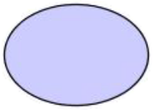 | Regular use case (concrete)
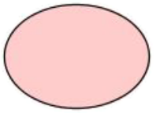 | Aggregate use case
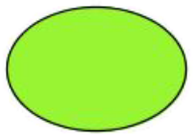 | External use case (not in scope)

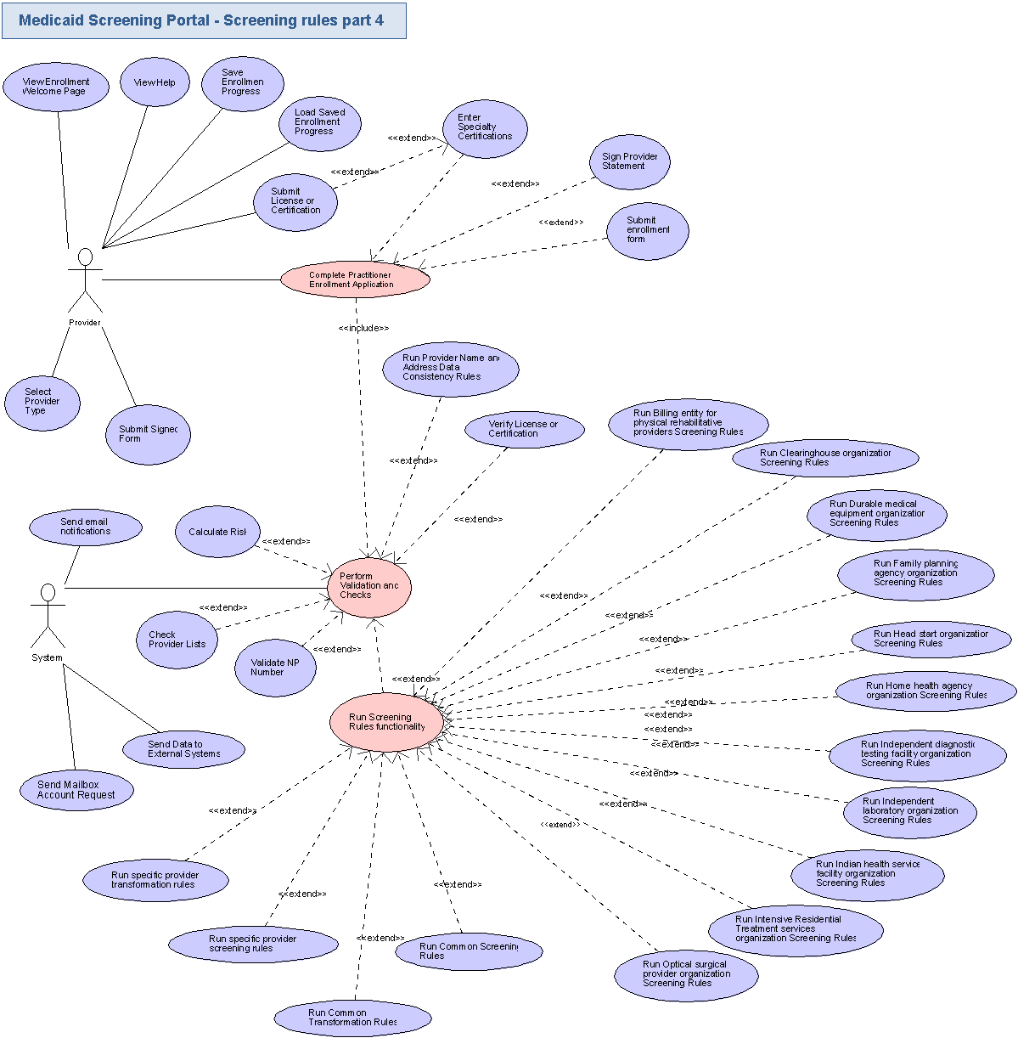

Business Requirements

This section identifies, enumerates and explores the business requirements that must be met by the application. Business requirements include capturing the types of users, the basic inputs and outputs, the system’s dependencies, and the tasks the system should accomplish. Some business requirement for a web-based retail site might include:

Users: “The system supports public browsers, registered members, customer service administrators, and system administrators.”
Tasks: “Users have personalized accounts,” “shopping carts expire in a configurable period, and the default is 10 days”, etc.

It is important to confirm that Task Requirements include all the tasks required to meet the business objectives.

Users
All applications have users and most have several users of different types. This section identifies, at a high level, the types of users of the system.

Provider
The registered user refers to any provider who is logged in and using the application. There are different provider types, and although the business rules differ for each, all Provider users have the same access level in the system.

System
The system is a non-human actor in the application. It represents processes which are initiated by the application (although they may be triggered by user input).

Inputs/Outputs
This section identifies and describes the inputs to and outputs from the new application. Inputs can include electronic inputs, like RSS and EDI feeds, updates from external databases, etc, as well as human inputs, like “user X keys in results from report Y.” Output can include electronic feeds, printed reports, etc. In this section, all electronic inputs and outputs are captured. Human inputs are omitted from this section.

NOTE: For all the licenses and certifications included below, their method of input (typing in the number or submitting a scanned copy) is still an open issue. Please see section 1.5 for details.

Inputs

Enrollment application forms
All the enrollment application form data is input to this application.
Note that the data is too varied to be mentioned individually.

NPI Verification Status
The system will receive a response from the NPI NPPES Registry Search system with the status of the NPI number being checked.

OIG Exclusion List Results
The system will receive a response from the OIG Exclusion List with results from the provider check.

EPLS Exclusion List Results
The system will receive a response from the EPLS Exclusion List system with results from the provider check.

MMIS
The component will read in provider data from the MMIS system (such as if the provider already exists in the system).

Saved Enrollment Data
The application will load previously saved enrollment data entered by a provider.

Signed Forms
The user will need to sign and submit the various forms into the system.
The forms used are:
  - MN-ITS 270/271
  - MN-ITS 276/277
  - DHS-4022

License or Certification Verification Results
The system will receive a response from the verification system confirming (or not) that the provider’s license or certification is valid. This input may come from different systems (or even manual approval) since there are many different types of licenses and certifications that must be verified. The details of this verification process are an open issue (see section 1.5). However, where the verification system is known it is included below as specific input.

Certifications
The organization representative (provider, Service Agent or Admin) will provide certifications as inputs.

Licenses
The organization representative (provider, Service Agent or Admin) will provide licenses as inputs.

Form information
The provided forms contain useful information which will be available to the organization representative (provider, Service Agent or Admin) and will be used as guidelines during form submission/completion.

Outputs

NPI Verification Request
The system will send a request for NPI verification to the NPI NPPES Registry Search system.

OIG Exclusion List Check Request
The system will send a request to the OIG Exclusion List to check for the enrolling provider.

EPLS Exclusion List Check Request
The system will send a request to the EPLS Exclusion List system to check for the enrolling provider.

License or Certification Verification Request
The system will send a request to the verification system to confirm (or not) that the enrolling provider’s license or certification is valid. This output may be sent to different systems since there are many different types of licenses and certifications that must be verified. The details of this verification process are an open issue (see section 1.5). However, where the verification system is known for a specific license of certification the output request is included.

Help
The application displays help output to the user when requested.

MMIS
The component will output provider data to the MMIS system (existing)

Email account requests
The system will send email account requests.

Email notifications
The system will send email notifications through the MN-ITS system.

SIRS System
The component will send provider data to the SIRS System if site visits are required (based on risk level).

NetStudy
The component will send provider data to NetStudy for participants who require a background check (based on risk level).

Enrollment Data to Save
The application will save the enrollment data entered by a provider when they complete enrollment or save the progress of their application.

Verification Requests
The verification results will be outputted to the providers.

Dependencies
Human inputs are also categorized as dependencies. List all dependencies:

Medicaid Provider Screening Portal Application
The screening and business rules captured in this document are a component within the overall Medicaid Provider Screening Portal. It is dependent on this application for its functionality.

Application Database
The component will save application data into an application database.

Web Server
The application will provide its entire GUI through the web server.

Web Browser
The users will access the application through the web-browser.

Email system
This project will use an email system to send notifications to users.

Email reader
The users will use an email reader application to read the emails sent by the application.

File system
The application will save the submitted files on a file system.

Transformation rules engine (Drools)
The application will be integrated with the transformation rules engine that has been developed for the other modules.

Please note that the confirmed rules engine to be used for this application is Drools (http://www.jboss.org/drools/).

ESB system
An ESB system will be used to connect to the MN-ITS mailbox system and automate functionality.

MN-ITS System
The component is dependent on the MN-ITS system for the submission of some types of forms like the eligibility verification which is done directly in that system.

MN-ITS Mailbox
The component is dependent on the MN-ITS Mailbox system to create accounts for enrolling providers.

NPI NPPES Registry Database
The component depends on the NPI NPPES Registry database in order to run NPI verification. This database is available here: NPPES database.

OIG Exclusion List
The component is dependent on the OIG Exclusion List (http://exclusions.oig.hhs.gov/search.aspx) to check providers against the sanctions / exclusion list.

EPLS Exclusion List
The component depends on the EPLS Exclusion List system (https://www.epls.gov/epls/search.do) in order to check and see if providers are included on the list.

MN-Chiroboard Website
The component is dependent on the website of the Minnesota Board of Chiropractic Examiners (for license verification results).

SIRS System
The component depends on the SIRS System to transfer information about provider site visits.

NetStudy
The component depends on the NetStudy system to transfer data for participants who require a background check.

PVS
The component will share provider data with the PVS system.

MMIS
The component will share provider data with the MMIS system (existing)

License / Certification Verification Systems
The component is dependent on a number of systems to verify the status of provider licenses and certificates (exact systems are still an open issue).

Human Dependencies:

Please refer to section 4.1 for details.

Task Requirements
Task Requirements correlate to the use cases, above. There should be at least one task for each use case bubble. Each use case should be briefly described. If there are specific requirements related to the use case, they should also be listed. This section captures high-level, basic functional requirements. Detailed requirements will be defined during the Requirements Specification contests.

User Functionality

NOTE: This is a non-standard conceptualization contest with a focus on business rules and workflow. This section expands upon the screening and enrollment component (for selected provider types) contained in the conceptualization document from the previous Medicaid Provider Screening Portal Application contest. The functionality and material from that document (including common functionality such as log in, log out, logging, and auditing) applies here unless it has been modified in this document.

View Help
- This use case is triggered when a user requests to view help.
- The application will display help content for the user to browse through
- Help content will include instructions of how to complete various tasks in the application (how to complete the enrollment forms, how to submit signed forms, contact information if additional help is needed, etc.).
- The help page will also outline the steps in the enrollment process so the user knows what they will have to complete.
- The help page will be setup FAQ style, with sections for both common application functionality as well as provider specific questions.

View Enrollment Welcome Page
- This use case is triggered when a user selects to being the provider enrollment and screening process.
- The provider enrollment and screening process begins by displaying a welcome page with basic instructions on how to complete the form.
  - Welcome message
  - Contact details
- The application will check the database to determine if the provider is currently enrolled.
- The application will also check for any previously saved application data and allow the user to resume the process where they last saved.
- Once the user is ready to complete the process they will select to begin.

Save Enrollment Progress
- This use case will allow a user to save the current status of their enrollment process while they are working on it.
- The user can choose to save their progress at any point in the process.
- The information the user has currently entered will be saved so they can return to it later.

Load Saved Enrollment Progress
- This use case is triggered when a user requests to load their previously saved enrollment data.
- The system will load the currently saved data and bring the user to the next step they need to complete.

Select Provider Type
- This use case is triggered at the start of the enrollment and screening process.
- The application will request the user enter what type of provider they are.
- The user will then select their “Provider Type” value. Based on the value selected, the application will keep track of their provider type code (listed below next to each type of provider).

Enter Specialty Certifications
- This use case is triggered if the enrolling provider was required to select a specialty.
- If the provider has a specialty, they will need to enter details for their Individual Practitioner's Specialty Certifications.
  - Type of Specialty (populated automatically from above selection)
  - Certification
  - Number
  - Original Issue
  - Date
  - Renewal End
  - Date
  - Issuing
  - State
- The application will save the certification details.
- See appendix for list of specialty codes associated to each specialty.

Submit License or Certification
- This use case allows providers to submit a certification along with their application
- Certifications are required under the following conditions:
  - If the enrolling provider was required to select a specialty they must upload a certification
  - If the provider specific rules require a certification to be submitted
- The user will select the certification (image file) to upload.
- The application will upload the certification to the application server

Sign Provider Statement
- This use case is triggered once the enrollment form has been completed.
- The user must read the Provider Statement and agree the information they are submitting is accurate, complete and truthful.
- The user will need to enter the following information
  - Provider name
  - Provider Title
  - Date
  - Signature
- The way the user will sign the statement is still an open issue. It could be some method of e-signature, or it could simply be uploading a copy of the signed form (see section 1.5 for details).

Submit form
- This use case allows providers to submit a signed form along with their application
- Signed forms are required for certain provider types (see business rules).
- The user will select which available form to sign depending on the organization provider type for the organization they want to sign.
- All the possible forms are addressed in the workflow chapters, when the form is complex and in the other workflows as part of the step documentation when the form is not complex.

System Functionality

Check Provider Lists
- This use case is triggered when the organization provider application has been completed.
- The system will connect to the sanctions list to verify the user is not on it.
- The system will connect to the exclusions list and verify the provider is not on it.
  - If the provider is found on one of these two lists, their applications will be rejected (and possibly marked for further review based on business rules).

Send email notifications
- The system will send emails on specific events like:
  - A change that requires reporting to an external user.
- The email contains detailed information about the processed event.

Validate NPI Number
- This use case is triggered when provider NPI is entered.
- The application will connect to the NPI NPPES (National Plan & Provider Enumeration System website) Registry Search Database.
- The system will confirm if the user’s NPI number is valid or not.

Verify License or Certification
- This use case is triggered when the organization provider application has been completed.
- Licenses or certifications submitted by the user must be verified.
- Based on the licenses / certifications submitted, the application will connect to the appropriate external system to verify them.
- The application will request verification for the license or certificate.

Calculate Risk
- This use case is triggered by the system when an application is complete.
- The application will calculate the user’s risk level
- Risk level will be calculated based on provider type and answers to the risk assessment questionnaire.
- The system will determine the risk level (high, moderate, or low) of the applying provider.

Send Data to External Systems
- This use case is triggered by the system after risk has been calculated.
- Based on the provider’s risk level, the application will forward data to external systems
  - PVS
  - MMIS
  - SIRS System
  - NetStudy (when background checks are required)
  - MN-ITS
- The details of where each risk level data is sent to is still and open issue (please see section 1.5)

Send Mailbox Account Request
- This use case is triggered by the system when an application is complete.
- The application will connect to the MN-ITS Mailbox system and request a mailbox account is created for the user.

Run Provider Name and Address Data Consistency Rules
- This use case is triggered when provider name or address data is entered.
- The application will run the Name and Address Data Consistency rules to make sure the data entered conforms to these standards
- Full details of these data consistency rules are defined in section 3.1.

Run Common Screening Rules
- This use case is triggered along with the provider specific screening rules.
- The application will run all common screening rules (rules that apply to all provider types)
- The provider status for enrollment will be updated in the system based on the results of the screening rules.
- Full details of these provider specific screening rules and the screening process steps are defined in chapter 3.3.2, one workflow for each provider type.

Run Common Transformation Rules
- This use case is triggered along with the provider specific transformation rules.
- The application will run all common transformation rules (rules that apply to all provider types)
- The provider status for enrollment will be updated in the system based on the results of the transformation rules.
- Full details of these provider specific transformation rules and the transformation process steps are defined in chapter 3.3.2, one workflow for each provider type.

Run specific provider screening rules
- This use case is triggered for users depending on their configured screening rules.
- The application will run all screening rules specific to this provider type.
- The provider status for enrollment and the data stored in the backend systems will be updated in the system based on the results of the screening rules.
- The application will confirm all required documents have been submitted.
- The application will verify all signed forms have been submitted.
- The application will confirm that the provider meets the criteria to enroll for their provider type.
- Full details of these provider specific screening rules and the screening process steps are defined in chapter 3.3.2, one workflow for each provider type.

Run specific provider transformation rules
- This use case is triggered for users depending on their configured transformation rules.
- The application will run all transformation rules specific to this provider type.
- The provider status for enrollment and the data stored in the backend systems will be updated in the system based on the results of the transformation rules.
- Full details of these provider specific screening rules and the screening process steps are defined in chapter 3.3.2, one workflow for each provider type.

Run Billing entity for physical rehabilitative providers Screening Rules
- This use case is triggered for users who are provider type “Billing entity for physical rehabilitative providers”.
- The application will run all screening rules specific to this provider type.
- Billing entity for physical rehabilitative providers are required to complete the following items as part of the enrollment process:
  - Complete the Organization Practitioner Enrollment Application (DHS-4016A)
  - Complete the Provider Agreement (DHS-4138)
  - Submit a copy of their current licenses and/or certifications
  - During this workflow, provider specific data will need to be entered and exceptions may occur (please see the corresponding workflow for full details on provider’s business rules).
- The provider status for enrollment will be updated in the system based on the results of the screening rules.

Run Clearinghouse organization Screening Rules
- This use case is triggered for users who are provider type “Clearinghouse organization”.
- The application will run all screening rules specific to this provider type.
- Clearinghouse organization providers are required to complete the following items as part of the enrollment process:
  - Complete the Clearinghouses Enrollment Form (DHS-4049)
  - Complete the Update Form for Clearinghouses (DHS-4087)
  - Submit a copy of their current licenses and/or certifications
  - During this workflow, provider specific data will need to be entered and exceptions may occur (please see the corresponding workflow for full details on provider’s business rules).
- The provider status for enrollment will be updated in the system based on the results of the screening rules.

Run Durable medical equipment organization Screening Rules
- This use case is triggered for users who are provider type “Durable medical equipment organization”.
- The application will run all screening rules specific to this provider type.
- Durable medical equipment organization providers are required to complete the following items as part of the enrollment process:
  - Complete the Organization Practitioner Enrollment Application (DHS-4016A)
  - Complete the Provider Agreement (DHS-4138)
  - Complete the Disclosure of Ownership and Control Interest Statement (DHS-5259)
  - Submit a copy of their current licenses and/or certifications
  - During this workflow, provider specific data will need to be entered and exceptions may occur (please see the corresponding workflow for full details on provider’s business rules).
- The provider status for enrollment will be updated in the system based on the results of the screening rules.

Run EDI trading partner organization Screening Rules
- This use case is triggered for users who are provider type “EDI trading partner organization”.
- The application will run all screening rules specific to this provider type.
- EDI trading partner organization providers are required to complete the following items as part of the enrollment process:
  - Complete the Eligibility Inquiry and Response (MN-ITS 270/271)
  - Complete the Claim Status Inquiry and Response (MN-ITS 276/277)
  - Complete the Clearinghouse or Billing Intermediary Enrollment Form (DHS-4049) form
  - Complete the Update Form for Clearinghouses and Billing Intermediaries (DHS-4087) form
  - Submit a copy of their current licenses and/or certifications
  - During this workflow, provider specific data will need to be entered and exceptions may occur (please see the corresponding workflow for full details on provider’s business rules).
- The provider status for enrollment will be updated in the system based on the results of the screening rules.

Run Family planning agency organization Screening Rules
- This use case is triggered for users who are provider type “Family planning agency organization”.
- The application will run all screening rules specific to this provider type.
- Family planning agency organization providers are required to complete the following items as part of the enrollment process:
  - Complete the Organization Practitioner Enrollment Application (DHS-4016A)
  - Complete the Provider Agreement (DHS-4138)
  - Complete the Disclosure of Ownership and Control Interest Statement (DHS-5259)
  - Submit a copy of their current licenses and/or certifications
  - During this workflow, provider specific data will need to be entered and exceptions may occur (please see the corresponding workflow for full details on provider’s business rules).
- The provider status for enrollment will be updated in the system based on the results of the screening rules.

Run Head start organization Screening Rules
- This use case is triggered for users who are provider type “Head start organization”.
- The application will run all screening rules specific to this provider type.
- Head start organization providers are required to complete the following items as part of the enrollment process:
  - Complete the Organization Practitioner Enrollment Application (DHS-4016A)
  - Complete the Provider Agreement (DHS-4138)
  - Complete the Disclosure of Ownership and Control Interest Statement (DHS-5259)
  - Submit a copy of their current licenses and/or certifications
  - During this workflow, provider specific data will need to be entered and exceptions may occur (please see the corresponding workflow for full details on provider’s business rules).
- The provider status for enrollment will be updated in the system based on the results of the screening rules.

Run Home health agency organization Screening Rules
- This use case is triggered for users who are provider type “Home health agency organization”.
- The application will run all screening rules specific to this provider type.
- Home health agency organization providers are required to complete the following items as part of the enrollment process:
  - Complete the Organization Practitioner Enrollment Application (DHS-4016A)
  - Complete the Provider Agreement (DHS-4138)
  - Complete the Disclosure of Ownership and Control Interest Statement (DHS-5259)
  - Submit a copy of their current licenses and/or certifications
  - During this workflow, provider specific data will need to be entered and exceptions may occur (please see the corresponding workflow for full details on provider’s business rules).
- The provider status for enrollment will be updated in the system based on the results of the screening rules.

Run Independent diagnostic testing facility organization Screening Rules
- This use case is triggered for users who are provider type “Independent diagnostic testing facility organization”.
- The application will run all screening rules specific to this provider type.
- Independent diagnostic testing facility organization providers are required to complete the following items as part of the enrollment process:
  - Complete the Organization Practitioner Enrollment Application (DHS-4016A)
  - Complete the Provider Agreement (DHS-4138)
  - Complete the Disclosure of Ownership and Control Interest Statement (DHS-5259)
  - Submit a copy of their current licenses and/or certifications
  - During this workflow, provider specific data will need to be entered and exceptions may occur (please see the corresponding workflow for full details on provider’s business rules).
- The provider status for enrollment will be updated in the system based on the results of the screening rules.

Run Independent laboratory organization Screening Rules
- This use case is triggered for users who are provider type “Independent laboratory organization”.
- The application will run all screening rules specific to this provider type.
- Independent laboratory organization providers are required to complete the following items as part of the enrollment process:
  - Complete the Organization Practitioner Enrollment Application (DHS-4016A)
  - Complete the Provider Agreement (DHS-4138)
  - Complete the Disclosure of Ownership and Control Interest Statement (DHS-5259)
  - Submit the CLIA Certificate
  - Submit a copy of their current licenses and/or certifications
  - During this workflow, provider specific data will need to be entered and exceptions may occur (please see the corresponding workflow for full details on provider’s business rules).
- The provider status for enrollment will be updated in the system based on the results of the screening rules.

Run Indian health service facility organization Screening Rules
- This use case is triggered for users who are provider type “Indian health service facility organization”.
- The application will run all screening rules specific to this provider type.
- Indian health service facility organization providers are required to complete the following items as part of the enrollment process:
  - Complete the Organization Practitioner Enrollment Application (DHS-4016A)
  - Complete the Provider Agreement (DHS-4138)
  - Complete the Disclosure of Ownership and Control Interest Statement (DHS-5259)
  - Submit a copy of their current licenses and/or certifications
  - During this workflow, provider specific data will need to be entered and exceptions may occur (please see the corresponding workflow for full details on provider’s business rules).
- The provider status for enrollment will be updated in the system based on the results of the screening rules.

Run Intensive Residential Treatment services organization Screening Rules
- This use case is triggered for users who are provider type “Intensive Residential Treatment services organization”.
- The application will run all screening rules specific to this provider type.
- Intensive Residential Treatment services organization providers are required to complete the following items as part of the enrollment process:
  - Complete the Organization Practitioner Enrollment Application (DHS-4016A)
  - Complete the Provider Agreement (DHS-4138)
  - Complete the Disclosure of Ownership and Control Interest Statement (DHS-5259)
  - Submit a copy of their current licenses and/or certifications
  - During this workflow, provider specific data will need to be entered and exceptions may occur (please see the corresponding workflow for full details on provider’s business rules).
- The provider status for enrollment will be updated in the system based on the results of the screening rules.

Run Optical surgical provider organization Screening Rules
- This use case is triggered for users who are provider type “Optical surgical provider organization”.
- The application will run all screening rules specific to this provider type.
- Optical surgical provider organization providers are required to complete the following items as part of the enrollment process:
  - Complete the Organization Practitioner Enrollment Application (DHS-4016A)
  - Complete the Provider Agreement (DHS-4138)
  - Complete the Disclosure of Ownership and Control Interest Statement (DHS-5259)
  - Submit a copy of their current licenses and/or certifications
  - During this workflow, provider specific data will need to be entered and exceptions may occur (please see the corresponding workflow for full details on provider’s business rules).
- The provider status for enrollment will be updated in the system based on the results of the screening rules.

Security Requirements
This section documents, at a high level, the basic security requirements of the application. For example, does the system require the user to log in? Should the user’s identity be authenticated on just this system, or against a central authority? Are there any special or unusual security requirements, like fingerprint scanning?

User Logged in to MPSP
- This project is for a component of the Medicaid Provider Screening Portal Application, which includes the security requirements that also apply to this project. The business process and screening rules from this document are built into the overall Medicaid Provider Screening Portal application so all security requirements will be handled there (including login and authorization).

Performance Requirements
Performance Requirements for the application are defined at a high level below. If there are specific requirements for specific features to perform at a quantifiable level, they too are listed below. These requirements will be developed in more detail when the Requirements Specification is written, in a later phase

The application will achieve a 99.5% uptime

The application will have 24x7 availability

All pages in the application should be loaded in 5 seconds or less after the initial hit.

Medicaid Provider Screening Portal Application Performance
- This project is for a component of the Medicaid Provider Screening Portal Application. The business process and screening rules in this document are built into the overall Medicaid Provider Screening Portal application so they will follow the performance requirements for the overall application.

Data Migration
Data Migration describes the data that needs to be moved from an older or external system to the new system, in order for it to operate at launch. Migration also includes data that must be transferred from the new system to another external system. Any data migration requirements are listed below.

No data migration is required for this project.

Appendix

Data values that are important to this project or used for many different business rules are contained in this section.

Tribal Codes
A common exception in the provider business rules is that providers at a Public Health Service (PHS) Indian Hospital may have current licensure from any state. In these cases, one of the following Tribal Codes should be added to the provider’s Specialties:

- Reservation:
  - FL = Fond Du Lac Indian Reservation
  - GP = Grand Portage Indian Reservation
  - LL = Leech Lake Indian Reservation
  - ML = Mille Lacs Indian Reservation
  - NL = Net Lake Indian Reservation
  - PI = Prairie Island Indian Reservation
  - RL = Red Lake Reservation
  - US = Upper Sioux Indian Reservation
  - WE = White Earth Indian Reservation
  - LS = Lower Sioux Indian Reservation

Categories of Service Codes
Below is a full list of Categories of Service Codes:

Categories of Service
Code | Description
001 | INPATIENT HOSPITAL GENERAL
003 | INPATIENT HOSP PSYCHIATRY
005 | CHILD WLFR TARGETED CASE MGMNT
006 | INPATIENT HOSP REHABILITATION
007 | OUTPATIENT HOSPITAL SERVICES
011 | NURSING FACILITY LEVEL I
013 | ICF-DD
014 | INPATIENT HOSPITAL IMD
015 | INPATIENT LONG TERM HOSPITAL
017 | NURSING FACILITY LEVEL II
019 | DAY TRAINING AND HABILITATION
020 | HOME HEALTH SERVICES
021 | CONSUMER DIRECTED CARE
022 | TRANSITIONAL SERVICES
025 | BIRTH-CENTER-FACILITY-FEE
028 | RTC - DEV DISABILITIES
029 | RTC - MENTAL HEALTH
030 | PHARMACY SERVICES
032 | MEDICAL SUPPLY/DME
033 | MODIFICATIONS AND ADAPTATIONS
034 | FAMILY COUNSELING & TRAINING
035 | BEHAVIORAL PROGRAM SERVICES
036 | TRANSPORT, SPECIAL
037 | TRANSPORT, AMBULANCE
038 | PERSONAL CARE SERVICES
039 | CHILD & TEEN CHECKUP OUTREACH
040 | CHILD AND TEEN CHECKUP
041 | ANESTHESIA
042 | PRIM CARE UTILIZATION REVIEW
043 | PHYSICIAN SERVICES
044 | CASE MANAGEMENT OTHER
045 | DENTAL
046 | MENTAL HEALTH
050 | COGNITIVE THERAPY
051 | PHYSICAL THERAPY
052 | IEP
053 | SPEECH THERAPY
054 | OCCUPATIONAL THERAPY
055 | PODIATRY
056 | AMBULATORY SURGERY
057 | CHIROPRACTIC
058 | AUDIOLOGY
062 | CONSOLIDATED TREATMENT FUND
063 | CTF EXTND CARE/HALFWAY HOUSE
071 | CASE MANAGEMENT MENTAL HEALTH
072 | HOSPICE
073 | INPATIENT HOSP NEO-NATAL ICU
074 | INPT HOSPITAL NON DRG
075 | EYEGLASSES/CONTACT LENSES
076 | PROSTHETICS AND ORTHOTICS
077 | HEARING AIDS
078 | VISION
079 | RADIOLOGY, TECHNICAL COMPONENT
080 | LABORATORY
082 | FED QUALIFIED HEALTH CNTR SVC
083 | RURAL HEALTH CLINIC SERVICES
084 | SWING BED SERVICES
086 | OUTPATIENT HOSP EMERGENCY SVC
087 | END-STAGE RENAL DIALYSIS
088 | PUBLIC HEALTH NURSING
089 | PRIVATE DUTY NURSING
090 | NURSE MIDWIFE SERVICES
091 | NURSE PRACTITIONER SERVICES
092 | NUTRITION SERVICES
093 | CHORE
094 | COMPANION SERVICES
095 | HOME DELIVERED MEALS
096 | HOMEMAKER SERVICES
097 | CARE GIVER TRAINING
100 | ACCESS SERVICES
101 | ACCESS TO APPEAL
102 | ADULT DAY CARE
103 | FOSTER CARE
104 | SUPPORTED EMPLOYMENT SERVICES
105 | SUPPORTED LIVING SERVICES
106 | STRUCTURED DAY PROGRAM SVC
107 | RESPITE CARE
108 | ASSISTED LIVING SERVICES
109 | INDEPENDENT LIVING SKILLS
110 | IN-HOME FAMILY SUPPORT
111 | DEV DISABILITIES SCREENING
112 | PASARR - DD
113 | PASARR - MENTAL HEALTH
114 | EXTENDED HOME HEALTH AIDE
115 | LTC CONSULTATION-PAS
116 | EXTENDED MEDICAL SUPPLIES/DME
117 | EXTENDED MENTAL HEALTH
118 | EXTENDED OCCUPATIONAL THERAPY
119 | EXTENDED PERSONAL CARE
120 | EXTENDED PHARMACY
121 | EXTENDED PHYSICAL THERAPY
122 | EXTENDED PRIVATE DUTY NURSING
124 | EXTENDED RESPIRATORY THERAPY
125 | EXTENDED SPEECH THERAPY
126 | EXTENDED TRANSPORTATION
127 | PPHP - DPA
128 | PPHP - GA
129 | PPHP - MANDATORY
130 | PPHP - SOCIAL HMO
131 | PPHP - SUPPLEMENTAL HMO
132 | PPHP - VOLUNTARY AFDC
133 | PPHP - MSHO
134 | COST EFFECTIVE HEALTH INS
135 | CO PAY - MEDICAL SUPPLY/DME
136 | CO PAY - MENTAL HEALTH
137 | CO PAY - PHARMACY
138 | CO PAY - PHYSICIAN
139 | COLLECTIONS, MISCELLANEOUS
140 | FINANCIAL TRANSACTION
141 | SPENDDOWN COLLECTIONS
142 | BUY-IN PART A
143 | BUY-IN PART B
144 | PREMIUM PAYMENTS/COLLECTIONS
999 | UNABLE TO DEFINE

Specialty Codes
Below is a full list of all available Specialty Codes:

Specialty Codes
Code | Description
001 | GENERAL PRACTICE
002 | FED QUALIFIED COMM HLTH CLIN
003 | FED QUALIFIED MIGRANT HLTH CL
004 | FED QUALIFIED CLINIC HOMELESS
005 | EMERGENCY SERVICES
006 | DIABETES
007 | INPATIENT HOSPITAL PEDIATRIC
008 | INPATIENT HOSPITAL PSYCH
009 | INPATIENT HOSPITAL IMD
010 | STATE PPO
011 | ALLERGY
012 | CARDIOVASCULAR DISEASE
013 | DERMATOLOGY
014 | GASTROENTEROLOGY
015 | INTERNAL MEDICINE
016 | PEDIATRICS
017 | PHYSICAL MEDICINE AND REHAB
018 | PREVENTIVE MEDICINE
019 | PULMONARY DISEASES
020 | COMP OUTPATIENT REHAB FACLTY
021 | CHILD PSYCHIATRY
022 | NEUROLOGY
023 | PSYCHIATRY
024 | PRE-PAID HEALTH PLAN, MED MAN
025 | PRE-PAID HEALTH PLAN, VOLNTRY
026 | PRE-PAID HEALTH PLAN, GAMC
027 | REGIONAL TRT CTR-DEV DISAB
028 | REGIONAL TREATMENT CTR, IMD
029 | REGIONAL TRT CTR, MENTAL ILL
030 | REGIONAL TRT CTR, NURSE FACIL
031 | PATHOLOGY
032 | RADIOLOGY
033 | GERIATRIC NURSE PRACTITIONER
034 | PEDIATRIC NURSE PRACTITIONER
035 | FAMILY NURSE PRAC
036 | LPN, LICENSED PRACTICAL
037 | NURSE PRACTITIONER, ADULT
038 | NURSE, REGISTERED
039 | COMMUNITY HEALTH CLINIC
040 | PUBLIC HEALTH CLINIC
041 | ANESTHESIOLOGY
042 | ENDOCRINOLOGY
043 | GERIATRICS
044 | IMMUNOLOGY
045 | NUTRITION
046 | OBSTETRICS
047 | GYNECOLOGY
048 | RURAL HEALTH CLINIC FREE STND
049 | RURAL HEALTH CLINIC PROV BSED
050 | COLON AND RECTAL SURGERY
051 | GENERAL SURGERY
052 | NEUROLOGICAL SURGERY
053 | OBSTETRICS AND GYNECOLOGY
054 | OPTHALMOLOGY
055 | ORTHOPEDIC SURGERY
056 | OTOLARYNGOLOGY
057 | PLASTIC SURGERY
058 | THORACIC SURGERY
059 | UROLOGY
060 | ONCOLOGY
061 | ORAL SURGEON (DENTISTS)
062 | DENTAL-GENERAL PRACTITIONER
063 | ORTHODONTIA
064 | PEDODONTIST
065 | PERIODONTICS
066 | INDEPENDENT DIAGNOSTIC TESTING
067 | PHARMACY, HOME CARE
068 | PHARMACY, HOSPITAL
069 | PHARMACY, NUCLEAR
070 | PHARMACY, COMMUNITY
071 | PHARMACY, NURSING FACILTY
072 | INFECTIOUS DISEASES
073 | PROSTHODONTICS
074 | PERIPHERAL VASCULAR DIS/SURG
075 | PREVENTIVE MEDICINE
076 | RADIOLOGY & RADIATION THERAPY
077 | FAMILY PRACTICE
078 | FAMILY COUNSELING
079 | FAMILY TRAINING
080 | NURSE PRACTIONER OBGYN
081 | NEUROPSYCHOLOGY
082 | NURSE MENTAL HEALTH
083 | PERSONAL CARE ATTENDANT
084 | SERV FOR CHILD W/HANDICAP PRV
085 | SER FOR CHLD W/HANDICAP FAM M
086 | MEDICAL TRANSPORTATION - AIR
087 | MEDICAL TRANSPORTATION - ALS
088 | MEDICAL TRANSPORTATION - BLS
089 | MEDICAL TRANSPORTATION - SPEC
090 | RHEUMATOLOGY
091 | CARDIOVASCULAR SURGERY
092 | NEPHROLOGY
093 | JOINT COMMISSION ACCREDITED
094 | NURSE PRACTITIONER NEONATAL
095 | PCA CHOICE
096 | NURSE PRACTITIONER WOMENS HLTH
097 | NURSE PRACTITIONER ACUTE CARE
098 | PSYCH 21 OPTION
099 | OTHER
AB | ADULT DAY CARE, BATH
AD | ADULT DAY CARE SERVICES
AL | CD ADOLESCENT
AP | ACUPUNCTURE CERTIFIED
AS | TRIBAL ASSURANCE STATEMENT
AT | ASSISTANT TECHNOLOGY
AV | CAREGIVER ASSESSMENT
BA | BILLING AGENT
BC | CDCS BACKGROUND CHECK
BD | BEHAVIOR PROGRAM BY AIDE
BN | BEHAVIOR PROGRAM BY ANALYST
BP | BEHAVIOR PROGRAM BY PROFESSION
BS | BEHAVIOR PROGRAM BY SPECIALIST
BT | BEHAVIORAL THERAPY
C2 | CD CO-OCCURRING
CA | CASE MANAGEMENT AIDE
CB | CONSOLIDATED BILLING AGENCY
CC | CRITICAL CARE
CD | CONSUMER DIRECTED COMM SUPP
CE | CONSUMER TRAINING AND EDUCATI
CF | CUSTOMIZED LIVING CLASS F
CG | 24HR CUSTOMIZED LIVING CLASS F
CH | 24 HOUR CUSTOMIZED LIVING CL A
CI | CONTRACTED INDIVIDUAL
CL | CUSTOMIZED LIVING CLASS A
CM | CDCS MANDATORY CASE MGT
CN | COMPANION CARE/SERVICES
CO | CASE MANAGEMENT ONGOING
CP | CRISIS RESPITE, SPECIALIZED
CR | CRISIS RESPITE
CS | CHORE SERVICES
CT | CAREGIVER TRAINING AND EDUCAT
CV | CASE MANAGEMENT CONVERSION
CW | CD CLIENT WITH CHILD
DA | DT&H PILOT RATE A
DB | DT&H PILOT RATE B
DC | DT&H PILOT RATE C
DD | DT&H PILOT RATE D
DO | AC DISCRETIONARY SERVICES
DS | MED SUPPLY DAILYSIS
DT | DT&H TRANSPORTATION
EA | 24HR EMERGENCY ASSISTANCE
ED | ENDODONTISTS
EV | ELIGIBILITY VERIFICATION VEND
FA | FOSTER CARE CORPORATE
FC | FAMILY COUNSELING
FF | FOSTER CARE ADULT FAMILY
FK | FOSTER CARE CHILD
FL | FOND DU LAC INDIAN RESRV
FT | FAMILY TRAINING
GP | GRAND PORTAGE INDIAN RESRV
GT | GAMBLING TREATMENT
HA | HOUSING ACCESS COORDINATION
HB | CD HOSPITAL BASED INPATIENT
HD | HOME DELIVERY MEALS
HF | 24HR CUSTOMIZED CLASS F FADS
HH | HOME HEALTH - AIDE AND EXTEND
HI | HOME INFUSION PHARMACY
HM | HOMEMAKER SERVICES
HS | 24HR CUSTOMIZED CLASS A FADS R
IC | INDEP LIV SKILLS, COUNSELING
IF | IN-HOME FAMILY SUPPORT
IG | INDEP LIV SKILLS, GRP THERAPY
II | INDEP LIV SKILLS, IND THERAPY
IM | INDEP LIV SKILLS, MAINTENANCE
IN | PERSONAL INSTALLATION
LC | LIVE-IN CAREGIVE EXPENSES
LL | LEECH LAKE INDIAN RESRV
LS | LOWER SIOUX
M1 | CD MEDICATION ASST THER-METH
M2 | CD MEDICATION ASST THER-OTHER
M3 | CD MEDICATN ASST THER-METH+
M4 | CD MEDICATN ASST THER-OTHER+
MC | MEDICARE CARRIER
MD | MODIFICATIONS/ADAPTATIONS
ML | MILLE LACS INDIAN RESRV
MS | CD MEDICAL SERVICE
ND | DONT-PUBLISH-IN-DIRECTORY
NL | NETT LAKE INDIAN RESRV
NP | DT&H PILOT WAIVER NON-PILOT
NR | CD NON-RESIDENTIAL TREATMENT
NS | NIGHT SUPERVISION
NT | NUTRITIONAL SERVICES
OA | OCCUPATIONAL THERAPY,ASST EXT
OT | OCCUPATIONAL THERAPY, EXTENDED
PA | PHYSICAL THERAPY,ASST EXTENDED
PC | PERSONAL CARE PROVIDER ORG
PD | RN AND LPN, NON-EXTENDED
PI | PRAIRIE ISLAND INDIAN RESRV
PR | PRIMARY CARE
PS | PERSONAL SUPPORT
PT | PHYSICAL THERAPY, EXTENDED
PU | PERSONAL PURCHASE
PV | PREVOCATIONAL SERVICES
QS | QUALIFIED SUPERVISOR
R1 | CD RESIDENTIAL TREATMENT-HIGH
R2 | CD RESIDENTIAL TREATMENT-MED
R3 | CD RESIDENTIAL TREATMENT-LOW
RB | CD RM & BOARD W/TRMT ONE LOCAT
RC | RESPITE, CERTFIED FACILITY
RH | RESPITE, HOSPITAL
RI | RESPITE CARE SERVICES, IN HOME
RL | RED LAKE INDIAN RESRV
RM | CD RM & BOARD W/TRMT TWO LOCAT
RO | RESPITE CARE SERVICES,OUT HOME
RS | RESIDENTIAL CARE SERVICES
RT | RESPIRATORY THERAPY, EXTENDED
S1 | CD SPECIAL POPULATIONS
SA | SLS, CHILD
SC | SLS, ADULT, CORPORATE AFC
SD | STRUCTURED DAY
SE | SUPPORTED EMPLOYMENT
SL | SUPPORTED LIVING SVCS, ADULT
SM | SHAKOPEE MDEWAKANTON SIOUX
SN | SKILLED NURSING
SP | NOT APPLICABLE
SR | PERSONAL SERVICE FEE
SS | SPECIALIST SERVICE
ST | SPEECH THERAPY, EXTENDED
SU | SUPPLIES/ EQUIPMENT (AC)
SX | SUPPLIES/ EQUIPMENT EXTENDED
TA | TRANSPORTATION - EXTRA ATTDT
TD | TELEMEDICINE
TE | TELEHOMECARE
TF | TRANSITIONAL SVCS,FURNITURE
TH | TRANSITIONAL SVCS,HOUSELD FURN
TL | TELERADIOLOGY
TM | TRANSPORTATION - MILEAGE COM
TN | TRANSPORTATION - MILEAGE (NON)
TP | HEALTHCARE DATA TRADING PART
TR | TRANSPORTATION - AC 1 WAY TRIP
TS | TRANSITIONAL
TW | TRANSPORTATION - WAIVER TRIP
US | UPPER SIOUX INDIAN RESRV
WC | WHEELCHAIR TRANSPORT
WE | WHITE EARTH INDIAN RESRV

License Codes
Below is a full list of all available License Codes:

License Codes
Code | Description
01 | INPATIENT HOSPTITAL CERT
02 | OUT PATIENT CERTIFIED
03 | HOSPICE CERTIFIED
04 | RENAL DIALYSIS CENTER CERT
05 | ICF DD CERTIFIED
06 | NURSING FACILITY I CERT
07 | NURSING FACILITY II CERT
08 | NURSING FACILITY I AND II CERT
10 | RULE 29 LICENSE
11 | REHABITATION AGENCY CERT
12 | COMPRHNSV OUTPTNT REHAB FACLTY
13 | COMMUNITY HEALTH WORKERS
14 | LICSW LICENSE
15 | NUTRITION PROFESSIONAL
17 | REGIONAL TREATMENT CENTER CERT
19 | DAY TRAINING AND REHAB (RULE 3
20 | PHYSICIAN LICENSE
21 | PHYSICIAN ASSISTANT
22 | AMBULATORY SURGICAL CNTR CERT
25 | MARRIAGE AND FAMILY THERAPIST
26 | MENTAL HEALTH REHAB SPECIALIST
29 | OCCUPATIONAL THERAPIST IND PRA
30 | DENTAL LICENSE
31 | DENTAL HYGIENIST
35 | OPTOMETRY LICENSE
36 | PODIATRY LICENSE
37 | CHIROPRACTIC LICENSE
38 | PCA BACKGROUND CLEARANCE
39 | PHYSICAL THERAPIST IND PRAC CE
40 | CERTIFICATE OF CLINICAL COMPET
41 | MAMMOGRAM CERTIFICATION
42 | PSYCHOLOGY LICENSE
43 | AUDIOLOGIST
44 | CASE MANAGEMENT (RULE 74)
47 | PHARMACIST LICENSE
50 | INTENSIVE RESIDENTIAL TRTMT SV
52 | FEDERALLY QUALIFIED HEALTH CTR
53 | RURAL HEALTH CLINIC CERTIFICTN
59 | CLASS A HOME CARE
60 | HOME HEALTH AGENCY CERT
61 | PUBLIC HEALTH NURSING
62 | CONSOLIDATED FUND OUTPATIENT
63 | CONSOLIDATED FUND RESIDENTIAL
64 | RN LICENSE
65 | ADULT NURSE PRACTITIONER CERT
66 | MIDWIFE CERTIFICATION
67 | CRNA CERTIFICATION
68 | CLINICAL NURSE SPEC IN MH NURS
69 | LPN LICENSE
70 | PHARMACY LICENSE
71 | GERIATRIC NURSE PRACTITIONER C
72 | PEDIATRIC NURSE PRACTITIONER C
73 | FAMILY NURSE PRACTITIONER CERT
74 | OBGYN NURSE PRACTITIONER CERT
75 | NEONATAL NURS PRAC CERT
76 | WOMENS HLTH CARE NP
77 | HEARING AID DISPENSE CERT
78 | ACUTE CARE NP
80 | INDEPENDANT LAB CERTIFICATION
81 | PORTABLE X-RAY CERTIFICATION
82 | MEDICAL TRANSPORTATION LICENSE
83 | BIRTH CENTER LICENSE
84 | BIRTH CENTER CERTIFICATION
85 | MIDWIFE LICENSE
86 | FOSTER CARE
99 | OTHER
AA | LEAD AGENCY APPROVED
AC | ADVANCED DENTAL THER CERT
AD | ADC LICENSE
AF | AFC LIC 9555.5050 TO 9555.6265
AP | ACUPUNCTURIST
AT | REGIST ART THERAPIST PLUS EDUC
BA | BEHAVIOR ANALYST PLUS EXPERIEN
BC | SOCIAL WORK BACCALAUREATE DEGR
BS | ASSOCIATES-DEGREE PLUS EXPERIE
C0 | AL-CLASS F-1-4 UNDER AGE 55
C1 | CLS CLASS A HWS>3 UNITS
C2 | CLS CLASS A HWS 1-5 PEOPLE AFC
C3 | CLS CLASS A HWS 5 OR MORE PEOP
C4 | CLS CLASS F HWS>3 UNITS
C5 | CLS CLASS F HWS 1-5 PEOPLE AFC
C6 | CLS CLASS F HWS 5 OR MORE PEOP
C7 | AL-CLASS A-BEFORE 5/1/2001
C8 | AL-CLASS F-BEFORE 5/1/2001
C9 | AL-CLASS A-1-4 UNDER AGE 55
CB | MINIMUM TRAINING PLUS PSYCHOLO
CC | LIC PROFESS CLINICAL COUNCELOR
CF | CHILD FC LICENSE PLUS CERTIFIC
CH | CHAPTER 245B LICENSE
CL | AGY-CLASS-B,C,F
CM | COMMUNITY-MENTAL-HEALTH-CENTER
CN | CORP FOR NAT & COMMUNITY SERV
CT | CARF-CERTIFICATION
DA | DHS APPROVED
DC | DHS CERTIFIED
DD | MEDICAL VENDORS
DT | DENTAL THERAPIST LICENSE
ET | 144A.43-144A.46 & RULE 9565.12
EV | MEDICAID ENROLLED VENDORS
EW | AFC LIC 9555.5050 TO 9555.6265
EX | STATUTE 157.17 PLUS CADI,BI
FA | FAMILY ADC LICENSE 245A.143
FS | FISCAL-SUPPORT-ENTITY
HC | HEALTH CARE PROF PLUS EXPERIEN
HO | HOSPITAL LIC 144.50 TO 144.58
HS | CERTIFICATION OF HLTH, SAFETY,
L1 | 24HR AL CLASS A AFC <5
L2 | 24HR AL CLASS F AFC <5
LA | LEAD AGENCY (CNTY, TRIBAL,HP)
LC | AFC LIC PLUS CERTIFICATION
LH | LICENSED HOME CARE AGENCY UNDE
MT | CERTIFIED MUSIC THERAPIST PLUS
OR | NATIONAL DISEASE ORGANIZATIONS
P1 | ONLINE PCA TRAINING
PA | PCA
PC | PCA CHOICE PROVIDER
PO | PERSON CARE PROVIDER ORGANIZAT
PS | LICENSE OR CERTIFICATE PLUS ST
PY | PSYCHOLOGIST LICENCE UNDER MN
QD | QUALIFIED DIETICIAN
QM | QUALIFIED DEVELOPMNT DISABLTES
QR | QUAL DD PROFES MEETS 9525.1850
RA | REHABILITATION AGENCY
RD | REGISTERED DIETICIAN
RS | MEETS STATUTE 157.17 & CAP 4OR
SP | STRUCTURED PEST CONTROLLED APP
SR | PROVIDER-COMPLIANCE W STATUES
ST | MEETS STATUTE 157.17 & CAP GT4
TR | CERTIFIED THERA REC SPECIALIST
VA | COUNTY APROVE VARIANCE
VT | VOCATIONAL/TECHNICAL COLLEGE
ZW | COMMON CARRIERS OR SPEC TRANS
ZX | OUT OF HOME FACILITY
ZY | HOME DELIVERED MEAL VENDOR
ZZ | PROFESSIONAL STAFF

Provider codes
A list of provider codes has been offered by the customer. This list can be found in the file named “Provider Types - Master 20120919.xlsx”.

Rules on the context in which the provider is required to submit a new provider number
An existing home health agency must apply for a new provider number if the following occur:
- the Federal Employer Identification Number (FEIN) changes, and one or more of the following:
- there is one or more owners or a change of ownership;
- the provider’s physical location changes
If the business entity changes FEIN, the business will have to apply for a new provider number unless:
- the business is owned by one owner holding 100% control interest and that ownership has not changed.
- the business has not physically moved location
Assuming the above criteria have been met, simply change the FEIN and business name in MMIS to reflect the changes in the business entity. The provider needs to send an address change form indicating the FEIN and business entity have changed. Moreover, the owner needs to indicate that ownership has not changed, despite the change in FEIN and business entity type.
The best general indicator regarding whether a provider needs a new provider number comes from the Minnesota Department of Health. Contact the Licensing Unit of Department of Health (Carol Hirschfeld, 5-8719) for direction on whether the Centers for Medicare and Medicaid Services (HCFA) considers the provider change a change of ownership that warrants a new Medicare certification and provider number. If CMS (and therefore the Minnesota Department of Health) requires a new certification number, there has been a significant change enough to warrant a new MHCP provider number.

Rules on organization ownership
Applicants that are not individuals must disclose all entities having at least a five-percent ownership or control interest in the provider. The specialist must ensure that the requirement is met and that all such owners are not excluded from participation in federal health care programs (do not appear on the sanction list).
Governmental entities and nonprofit organizations have no owners and are exempt from disclosure. All other non-individual entities must disclose ownership. The fact that an organization has millions of shares of stock that are traded in the public equities markets (New York Stock Exchange, Nasdaq, and so forth) does not excuse the company from disclosing all five-percent owners of which it is aware. Nor does the fact that an investor is merely passive – that is, has no role in management of the business. The federal regulations at 42 CFR Section 455.100 and following make no distinction between active and passive investors.
The federal regulations provide excellent guidance for determination of ownership or control percentages. See 42 CFR Section 455.102 and review the examples below, which are nearly identical to those in the regulation.
To determine indirect ownership interest, multiply the percentages of ownership in each entity.
EXAMPLE: A owns 10 % of B Corp., which owns 80% of C Corp. (the enrolling provider). A has an 8% interest in C Corp. and must be disclosed.
EXAMPLE: A owns 80 % of B Corp., which owns 5% of C Corp. (the enrolling provider). A has a 4% interest in C Corp. Because the interest is smaller than 5%, A’s ownership does not have to be disclosed by C Corp.
To determine control interest, multiply the entity’s percentage ownership in an obligation by the percentage of the disclosing entity’s assets used to secure the obligation. The obligation may be a mortgage, deed of trust, note, or some other financial obligation.
EXAMPLE: A owns 10% of a note that is secured by 60% of the enrolling provider’s assets. A has a control interest of 6%, and must be disclosed as an owner.
To provide additional guidance, assume that Feelgood Hospital is a wholly owned subsidiary of Health for Profit Inc., which in turn is a wholly owned subsidiary of Health for Profit International, Inc. (HPII). This latter company is publicly traded. Out of 1 billion outstanding shares, ABC Inc. owns 52 million shares, or 5.2 %. On its enrollment application, Feelgood must disclose ABC’s ownership. In addition, Polly Woggins holds a note for payment of X amount by Health for Profit International, which is secured by 50,000,003 shares of HPII’s stock, or just a fraction more than 5%. Although Woggins has no ownership interest, the security for the note she holds gives her a control interest in more than 5% of the company. Feelgood also must disclose her control interest.
What to do when the applicant does not make full disclosure. Suppose the applicant indicates that it is a wholly owned subsidiary of ABC Corp., but merely discloses ABC as the 100% owner. This is insufficient. The applicant must further disclose who holds at least a 5% ownership or control interest.
Contact the applicant and inform its representative that 42 CFR Section 455.100 and following require disclosure of all entities holding at least a 5% ownership or control interest in the applicant. Request that the applicant supplement its answers. When the supplemental answers are received, review them for completeness. If the answers account for less than 100%, determine whether all 5% owners have been disclosed.
If the applicant fails to provide the information, try to obtain it by reviewing the investor relations pages of the relevant corporate websites, if any. If the information is unavailable or, after a reasonable effort on the specialist’s part, is difficult to determine, make one last request, in writing, for disclosure by the applicant. State a deadline of 30 days from the date of the request and warn that failure to provide the information will lead to denial of enrollment. If the applicant fails or refuses to comply, deny the application on MMIS, using status P (Other), and send a letter to the contact stating the reason for denial.

Rules on accepting a JCAHO certification
JCAHO represents the Joint Commission on Accreditation of Health Organizations Certification
Per Linda Tallaksen, Department of Health, 7/30/01, if a provider is requesting that a JCAHO certification is submitted in place of a Medicare certification, the provider must send a JCAHO Deemed Approval Letter and Medicare Application to the Department of Health. It will be forwarded to CMS (Centers for Medicare/Medicaid Services B replaced HCFA) and a Medicare provider number will be issued on the basis of JCAHO certification.
The deemed JCAHO status allows provider to circumvent the initial and future surveys that would usually be done by the Dept of Health. The surveys will instead be conducted by JCAHO.
JCAHO certification does not replace Medicare certification. An applying Home Health Agency MUST have Medicare certification and a Medicare provider number. Additionally, it is not acceptable for a provider to “meet the requirements of Medicare” without having Medicare certification.

Major Program Codes
Below is a full list of all available Major Program Codes:

Major Programs
Code | Description
AC | ALTERNATIVE CARE
BB | MINNESOTACARE ADULTS=<200% FEDERAL POVERTY GUIDELINES
CC | CHILDRENHEALTH PLAN *
DD | CHILDRENHEALTH PLAN/SCH COMBINED *
DM | DEMONSTRATION TO MAINTAIN INDEPENDENCE AND EMPLOYMENT
EC | STATE PAID EMERGENCY GENERAL ASST MED *
EE | MN CHILDREN W SPECIAL HEALTH NEEDS EVALUATION (HLTH DEPT) *
EH | FEDERALLY PAID EMERGENCY MEDICAID
FF | MINNESOTACARE PARENTS=<275% FEDERAL POVERTY GUIDELINES
FP | FAMILY PLANNING PROGRAM
GM | GENERAL ASSISTANCE MED CARE *
HH | INS EXTENSION PGM (STATE-ADM)
IM | IMD: INST FOR MENTAL DISEASE
JJ | MCRE NONCITIZEN PARENTS=< 275% FEDERAL POVERTY GUIDELINES
KK | MINNESOTACARE NONCITIZEN KIDS/PWS
LL | MINNESOTACARE CITZ KIDS/PHYSICIAN WELLNESS SERVICES
MA | FEDERALLY PAID MEDICAL ASSIST
NM | STATE-PAID MEDICAL ASSISTANCE
OO | CONSOLIDATED TREATMENT FUND
P | PREPAID HEALTH PLAN - MA *
QM | QUALIFIED MEDICARE BENEFICIARY
RM | REFUGEE
SL | PART B PREMIUMS ONLY (SERVICE LIMITED MEDICARE BENEFICIARY)
TT | MN CHILDREN W SPECIAL HEALTH NEEDS TREATMENT (HEALTH DEPT)*
UN | SCREENED--NOT PLACED ON WAIVER/ALTERNATIVE CARE
VV | PRESCRIPTION DRUG PROGRAM *
WD | QUALIFIED WORKING DISABLED
XX | MINNESOTACARE ADULTS>200% FEDERAL POVERTY GUIDELINES
YY | MINNESOTACARE/SCH COMBINATION*
ZZ | PREPAID HEALTH PLAN - GENERAL ASSISTANCE MEDICAL CARE *

Definitions
Agent means any person who has been delegated the authority to obligate or act on behalf of the provider.
Managing employee means a person who exercises operational or managerial control over, or who directly or indirectly conducts or manages the day-to-day operations of an institution, organization, agency or school, such as a general manager, business manager, administrator, director.
Ownership or control interest means any person, business or organization to which any one or more of the following apply:
- Direct ownership of 5% or more in the disclosing entity
- Indirect ownership interest equal to 5% or more in a disclosing entity (meaning ownership in another entity that has an ownership interest in the disclosing entity)
Determine the amount of indirect ownership interest by multiplying the percentages of ownership in each entity.
For example, if A owns 10% of the stock in a corporation which owns 80% of the stock of the disclosing entity,
A’s interest equals an 8% indirect ownership interest in the disclosing entity and must be reported. Conversely, if B owns 80% of the stock of a corporation which owns 5% of the stock of the disclosing entity, B’s interest equals a 4% indirect ownership interest in the disclosing entity and need not be reported
- A combination of direct and indirect ownership interest equal to 5% or more in the disclosing entity
- Owns an interest of 5% or more in any mortgage, deed of trust, note or other obligation secured by the disclosing entity if that interest equals at least 5% of the value of the property or assets of the disclosing entity.
Determine the percentage of ownership, mortgage, deed of trust, note, or other obligation by multiplying the percentage of interest owned in the obligation by the percentage of the disclosing entity’s assets used to secure the obligation. For example: If A owns 10% of a note secured by 60% of the provider’s assets, A’s interest in the provider’s assets equals 6% and must be reported. If B owns 40% of a note secured by 10% of the provider’s assets, B’s interest in the provider’s assets equals 4% and need not be reported
- Is an officer or director of a disclosing entity that is organized as a corporation (for profit or non-profit)
- Is a partner in a disclosing entity that is organized as a partnership.
Subcontractor means an individual, agency, or organization to which a disclosing entity has contracted or delegated some of its management functions or responsibilities of providing medical care to its patients.

